Advanced topics

# 1. Aggregate Operations

<https://docs.oracle.com/javase/tutorial/collections/streams/index.html>

### Aggregate operations, pipelines, iterators

A ***pipeline*** is a sequence of aggregate operations. The following example prints the male members contained in the collection roster with a pipeline that consists of the aggregate operations filter and forEach:

Q: A sequence of aggregate operations is known as a ___ .   
A: Pipeline

roster

       .stream()

       .filter(e -> e.getGender() == Person.Sex.MALE)

       .forEach(e -> System.*out*.println(e.getName()));

A pipeline contains the following components:

* **A source**: This could be a collection, an array, a generator function, or an I/O channel. In this example, the source is the collection roster.
* **Zero or more intermediate operations**. An intermediate operation, such as filter, produces a new stream.

A stream is a sequence of elements. Unlike a collection, it is not a data structure that stores elements. Instead, a stream carries values from a source through a pipeline. This example creates a stream from the collection roster by invoking the method stream.

The filter operation returns a new stream that contains elements that match its predicate (this operation's parameter). In this example, the predicate is the lambda expression e -> e.getGender() == Person.Sex.MALE. It returns the boolean value true if the gender field of object e has the value Person.Sex.MALE. Consequently, the filter operation in this example returns a stream that contains all male members in the collection roster.

* A terminal operation. A terminal operation, such as forEach, produces a non-stream result, such as a primitive value (like a double value), a collection, or in the case of forEach, no value at all. In this example, the parameter of the forEach operation is the lambda expression e -> System.out.println(e.getName()), which invokes the method getName on the object e. (The Java runtime and compiler infer that the type of the object e is Person.)

double average = roster

.stream() //beginning of pipeline

.filter(p -> p.getGender() == Person.Sex.MALE) //intermediate operation

.mapToInt(Person::getAge) //intermediate operation

.average() //terminal operation

.getAsDouble(); //terminal operation

**Differences Between Aggregate Operations and Iterators**

Aggregate operations, like forEach, appear to be like iterators. However, they have several fundamental differences:

* **They use internal iteration**: Aggregate operations do not contain a method like next to instruct them to process the next element of the collection. With *internal delegation*, your application determines *what* collection it iterates, but the JDK determines *how* to iterate the collection. With *external iteration*, your application determines both what collection it iterates and how it iterates it. However, external iteration can only iterate over the elements of a collection sequentially. Internal iteration does not have this limitation. It can more easily take advantage of parallel computing, which involves dividing a problem into subproblems, solving those problems simultaneously, and then combining the results of the solutions to the subproblems. See the section [Parallelism](https://docs.oracle.com/javase/tutorial/collections/streams/parallelism.html) for more information.
* **They process elements from a stream**: Aggregate operations process elements from a stream, not directly from a collection. Consequently, they are also called *stream operations*.

**They support behavior as parameters**: You can specify [lambda expressions](https://docs.oracle.com/javase/tutorial/java/javaOO/lambdaexpressions.html) as parameters for most aggregate operations. This enables you to customize the behavior of a particular aggregate operation.

### Reduction

Produces  single summary by repeatedly applying a combination operation to the elements.

The JDK contains many terminal operations (such as [average](https://docs.oracle.com/javase/8/docs/api/java/util/stream/IntStream.html#average--java/lang/reflect/Executable.html), [sum](https://docs.oracle.com/javase/8/docs/api/java/util/stream/IntStream.html#sum--), [min](https://docs.oracle.com/javase/8/docs/api/java/util/stream/Stream.html#min-java.util.Comparator-), [max](https://docs.oracle.com/javase/8/docs/api/java/util/stream/Stream.html#max-java.util.Comparator-), and [count](https://docs.oracle.com/javase/8/docs/api/java/util/stream/Stream.html#count--)) that return one value by combining the contents of a stream. These operations are called reduction operations. The JDK also contains reduction operations that return a collection instead of a single value. Many reduction operations perform a specific task, such as finding the average of values or grouping elements into categories.

However, the JDK provides you with the general-purpose reduction operations [reduce](https://docs.oracle.com/javase/8/docs/api/java/util/stream/Stream.html#reduce-T-java.util.function.BinaryOperator-) and [collect](https://docs.oracle.com/javase/8/docs/api/java/util/stream/Stream.html#collect-java.util.function.Supplier-java.util.function.BiConsumer-java.util.function.BiConsumer-), which this section describes in detail.

#### reduce()

The reduce operation always returns a new value.

Optional<T> **reduce**(BinaryOperator<T> accumulator)

* **Simple, immutable reduction**
* Easy to parallelise

Example 1:

Integer totalAge = roster

.stream()

.mapToInt(Person::getAge)

.sum();

Compare this with the following pipeline, which uses the Stream.reduce operation to calculate the same value:

Integer totalAgeReduce = roster

.stream()

.map(Person::getAge)

.reduce(

0,

(a, b) -> a + b);

The reduce operation in this example takes two arguments:

* identity: The identity element is both the initial value of the reduction and the default result if there are no elements in the stream. In this example, the identity element is 0; this is the initial value of the sum of ages and the default value if no members exist in the collection roster.
* accumulator: The accumulator function takes two parameters: a partial result of the reduction (in this example, the sum of all processed integers so far) and the next element of the stream (in this example, an integer). It returns a new partial result. In this example, the accumulator function is a lambda expression that adds two Integer values and returns an Integer value:

(a, b) -> a + b

Example 2:

public class Main {

   static int *x*;

   static {

*x* = 10;

       Stream<Integer> integerStream =     *//{20,40,70,110}*

Stream.*of*(10, 20, 30, 40)

               .map((y) -> {

*x* += y;

                   return *x*;

               });

       System.*out*.println(*x*); *//10*

*//identity value has not changed. It is still x==10*

*// we sum the numbers*

int result = integerStream.reduce(*x*, (a, b) -> {

           return a + b;

       });

*//        java.util.stream.Stream;*

*//        method: T reduce(T identity, BinaryOperator<T> accumulator);*

*//        API Note:*

*//        Sum, min, max, average, and string concatenation are all special cases of reduction. Summing a stream of numbers can be expressed as:*

*//        Integer sum = integers.reduce(0, (a, b) -> a+b);*

System.*out*.println(result); *//250*

}

   public static void main(String[] args) {

   }

}

#### collect()

Unlike the reduce method, which always creates a new value when it processes an element, the [collect](https://docs.oracle.com/javase/8/docs/api/java/util/stream/Stream.html#collect-java.util.function.Supplier-java.util.function.BiConsumer-java.util.function.BiConsumer-) method modifies, or mutates, an existing value.

<R, A> R **collect**(Collector<? super T, A, R> collector)

* **Mutable reduction (can keep state)**
* Allows for more sophisticated operations

Example 1:

Consider how to find the average of values in a stream. You require two pieces of data: the total number of values and the sum of those values

class Averager implements IntConsumer

{

private int total = 0;

private int count = 0;

public double **average**() {

return count > 0 ? ((double) total)/count : 0;

}

public void **accept**(int i) { total += i; count++; }

public void **combine**(Averager other) {

total += other.total;

count += other.count;

}

}

The following pipeline uses the Averager class and the collect method to calculate the average age of all male members:

Averager averageCollect = roster.stream()

.filter(p -> p.getGender() == Person.Sex.MALE)

.map(Person::getAge)

**.collect**(**Averager::new**, **Averager::accept**, **Averager::combine**);

System.out.println("Average age of male members: " + **averageCollect.average()**);

<R> R collect(Supplier<R> supplier,  
 BiConsumer<R, ? super T> accumulator,  
 BiConsumer<R, R> combiner);

The collect operation in this example takes three arguments:

* supplier: The supplier is a factory function; it constructs new instances. For the collect operation, it creates instances of the result container. In this example, it is a new instance of the Averager class.
* accumulator: The accumulator function incorporates a stream element into a result container. In this example, it modifies the Averager result container by incrementing the count variable by one and adding to the total member variable the value of the stream element, which is an integer representing the age of a male member.
* combiner: The combiner function takes two result containers and merges their contents. In this example, it modifies an Averager result container by incrementing the count variable by the count member variable of the other Averager instance and adding to the total member variable the value of the other Averager instance's total member variable.

Example 2:

public static <T, K, A, D>  
Collector<T, ?, Map<K, D>> **groupingBy**(Function<? super T, ? extends K> classifier,  
 Collector<? super T, A, D> downstream)

The following example retrieves the names of each member in the collection roster and groups them by gender:

Map<Person.Sex, List<String>> namesByGender =  
 roster  
 .stream()  
 .collect(  
 Collectors.*groupingBy*(  
 Person::getGender,  
 Collectors.*mapping*(  
 Person::getName,  
 Collectors.*toList*())));

The [groupingBy](https://docs.oracle.com/javase/8/docs/api/java/util/stream/Collectors.html#groupingBy-java.util.function.Function-java.util.stream.Collector-) operation in this example takes two parameters, a classification function and an instance of Collector. The Collector parameter is called a downstream collector. This is a collector that the Java runtime applies to the results of another collector. Consequently, this groupingBy operation enables you to apply a collect method to the List values created by the groupingBy operator. This example applies the collector [mapping](https://docs.oracle.com/javase/8/docs/api/java/util/stream/Collectors.html#mapping-java.util.function.Function-java.util.stream.Collector-java.util.stream.Collector-), which applies the mapping function Person::getName to each element of the stream. Consequently, the resulting stream consists of only the names of members. A pipeline that contains one or more downstream collectors, like this example, is called a **multilevel reduction**.

Example 3:

public static <T, K, A, D>  
Collector<T, ?, Map<K, D>> **groupingBy**(Function<? super T, ? extends K> classifier,  
 Collector<? super T, A, D> downstream)

The following example retrieves the total age of members of each gender:

Map<Person.Sex, Integer> totalAgeByGender =

roster

.stream()

.collect(

Collectors.groupingBy(

Person::getGender,

Collectors.**reducing**(

0,

Person::getAge,

Integer::sum)));

The [reducing](https://docs.oracle.com/javase/8/docs/api/java/util/stream/Collectors.html#reducing-U-java.util.function.Function-java.util.function.BinaryOperator-) operation takes three parameters:

* identity: Like the Stream.reduce operation, the identity element is both the initial value of the reduction and the default result if there are no elements in the stream. In this example, the identity element is 0; this is the initial value of the sum of ages and the default value if no members exist.
* mapper: The reducing operation applies this mapper function to all stream elements. In this example, the mapper retrieves the age of each member.

public static <T, U>  
Collector<T, ?, U> **reducing**(U identity,  
 Function<? super T, ? extends U> mapper,  
 BinaryOperator<U> op) {

* operation: The operation function is used to reduce the mapped values. In this example, the operation function adds Integer values.

Example 4:

import java.io.BufferedReader;

import java.io.InputStreamReader;

import java.time.LocalDate;

import java.util.List;

import java.util.Map;

import java.util.stream.Collectors;

import java.util.stream.Stream;

public class StreamsDemo {

   record BatteryDay(LocalDate date, String deviceModel, double percentDrained) {

       BatteryDay(String[] fields) {

           this(LocalDate.*parse*(fields[0]), fields[1], Double.*parseDouble*(fields[2]));

       }

       BatteryDay(String line) {

           this(line.split(","));

       }

   }

   public static void main(String[] args) {

       try (Stream<String> lines = new BufferedReader(

               new InputStreamReader(

                       StreamsDemo.class.getResourceAsStream("battery.csv")))

               .lines()

       ) {

*//            lines.forEach(System.out::println);*

public static <T, K> Collector<T, ?, Map<K, List<T>>>

groupingBy(Function<? super T, ? extends K> classifier)

Map<String, List<BatteryDay>> result = lines

               .map(BatteryDay::new)

               .filter(batteryDay -> batteryDay.date.isBefore(LocalDate.*now*()))

**.collect**(Collectors.***groupingBy***(BatteryDay::deviceModel));*//transform to a map*

…….

public static <T, K, A, D>  
Collector<T, ?, Map<K, D>> **groupingBy**(Function<? super T, ? extends K> classifier,  
 Collector<? super T, A, D> downstream)

Map<String, Double> result = lines

       .map(BatteryDay::new)

       .filter(batteryDay -> batteryDay.date.isBefore(LocalDate.now()))

       .**collect**(Collectors.**groupingBy**(

               BatteryDay::deviceModel,

               Collectors.**averagingDouble**(BatteryDay::percentDrained)

               ));//transform to a map

System.out.println(result);

System.*out*.println(result);

       }

   }

}

### Parallelism

Parallel computing involves dividing a problem into subproblems, solving those problems simultaneously (in parallel, with each subproblem running in a separate thread), and then combining the results of the solutions to the subproblems. Java SE provides the [fork/join framework](https://docs.oracle.com/javase/tutorial/essential/concurrency/forkjoin.html), which enables you to more easily implement parallel computing in your applications. However, with this framework, you must specify how the problems are subdivided (partitioned). With aggregate operations, the Java runtime performs this partitioning and combining of solutions for you.

Note that parallelism is not automatically faster than performing operations serially, although it can be if you have enough data and processor cores. While aggregate operations enable you to more easily implement parallelism, it is still your responsibility to determine if your application is suitable for parallelism.

#### Executing Streams in Parallel

You can execute streams **in serial** or **in parallel**. When a stream executes in parallel, the Java runtime partitions the stream into multiple substreams. Aggregate operations iterate over and process these substreams in parallel and then combine the results.

To create a parallel stream, invoke the operation [Collection.parallelStream](https://docs.oracle.com/javase/8/docs/api/java/util/Collection.html#parallelStream--). Alternatively, invoke the operation [BaseStream.parallel](https://docs.oracle.com/javase/8/docs/api/java/util/stream/BaseStream.html#parallel--). For example, the following statement calculates the average age of all male members in parallel:

double average = roster

**.parallelStream()**

.filter(p -> p.getGender() == Person.Sex.MALE)

.mapToInt(Person::getAge)

.average()

.getAsDouble();

#### Concurrent Reduction

Consider again the following example (which is described in the section [Reduction](https://docs.oracle.com/javase/tutorial/collections/streams/reduction.html)) that groups members by gender. This example invokes the collect operation, which reduces the collection roster into a Map:

Map<Person.Sex, List<Person>> byGender =

roster

.stream()

.collect(

Collectors.groupingBy(Person::getGender));

The following is the parallel equivalent:

**ConcurrentMap**<Person.Sex, List<Person>> byGender =

roster

**.parallelStream()**

.collect(

Collectors.**groupingByConcurrent**(Person::getGender));

#### Ordering

The order in which a pipeline processes the elements of a stream depends on whether the stream is executed in serial or in parallel, the source of the stream, and intermediate operations.

When running in parallel the results are UNORDERED!

When using parallel and the forEachOrdered, then we may lose the benefits of parallelism

listOfIntegers

.parallelStream()

.forEachOrdered(e -> System.out.print(e + " "));

#### Side effects

##### Laziness

All intermediate operations are lazy.

##### Interference

Lambda expressions in stream operations should not *interfere*. **Interference occurs when the source of a stream is modified while a pipeline processes the stream.** For example, the following code attempts to concatenate the strings contained in the List listOfStrings. However, it throws a ConcurrentModificationException:

try {

List<String> listOfStrings = new ArrayList<>(Arrays.asList("one", "two"));

// This will fail as the peek operation will attempt to add the

// string "three" to the source after the terminal operation has

// commenced/started.

String concatenatedString = **listOfStrings**

.stream()

// Don't do this! Interference occurs here.

.peek(s -> **listOfStrings**.add("three"))

.reduce((a, b) -> a + " " + b)

.get();

System.out.println("Concatenated string: " + concatenatedString);

} catch (Exception e) {

System.out.println("Exception caught: " + e.toString());

}

##### Stateful Lambda Expressions

Avoid using stateful lambda expressions as parameters in stream operations. **A stateful lambda expression is one whose result depends on any state that might change during the execution of a pipeline.** The following example adds elements from the List listOfIntegers to a new List instance with the **map intermediate operation**. It does this twice, first with a serial stream and then with a parallel stream:

List<Integer> **listOfIntegers** = new ArrayList<>(List.*of*(8, 7, 6, 5, 4, 3, 2, 1));

-----------------------------------

System.out.println("Serial stream:");

List<Integer> serialStorage = new ArrayList<>();

**listOfIntegers**

.stream()

**// Don't do this! It uses a stateful lambda expression.**

**.map**(e -> { **serialStorage.add**(e); return e; })

.forEachOrdered(e -> System.out.print(e + " "));

System.out.println("");

serialStorage

.stream()

.forEachOrdered(e -> System.out.print(e + " "));

System.out.println("");

---------------------------------------

System.out.println("Parallel stream:");

List<Integer> parallelStorage = Collections.synchronizedList(new ArrayList<>());

**listOfIntegers**

.parallelStream()

**// Don't do this! It uses a stateful lambda expression.**

**.map**(e -> { **parallelStorage.add**(e); return e; })

**.forEachOrdered**(e -> System.out.print(e + " "));

System.out.println("");

parallelStorage

.stream()

.forEachOrdered(e -> System.out.print(e + " "));

System.out.println("");

The lambda expression e -> { parallelStorage.add(e); return e; } is a stateful lambda expression. Its result can vary every time the code is run. This example prints the following:

Serial stream:

8 7 6 5 4 3 2 1

8 7 6 5 4 3 2 1

Parallel stream:

8 7 6 5 4 3 2 1

1 3 6 2 4 5 8 7

The operation forEachOrdered processes elements in the order specified by the stream, regardless of whether the stream is executed in serial or parallel. However, when a stream is executed in parallel, the map operation processes elements of the stream specified by the Java runtime and compiler. Consequently, the order in which the lambda expression e -> { parallelStorage.add(e); return e; } adds elements to the List parallelStorage can vary every time the code is run. For deterministic and predictable results, ensure that lambda expression parameters in stream operations are not stateful.

# 2. Многонишково програмиране (Multithreading) в Java(SE)

## Processes

Processes are often seen as synonymous with programs or applications.

A process has a self-contained execution environment. A process generally has a complete, private set of basic run-time resources; in particular, each process has its own memory space.

Most implementations of the Java virtual machine run as a single process. A Java application can create additional processes using a [ProcessBuilder](https://docs.oracle.com/javase/8/docs/api/java/lang/ProcessBuilder.html) object.

**java.lang.ProcessBuilder** - създава цели процеси вместо отделни нишки/Threads - обичайно работим с нишки, а не с цели процеси!!!

## Threads

* Threads are also referred to as **lightweight processes**
* Threads are separate execution flows within a single process
* They share the resources of the process including open files and memory
* **Java threads are typically bound to native OS threads that execute them on different OS processors**
* Some JVM implementations of threads also provide so called **green threads** that are scheduled for execution by the JVM itself rather than the OS - от кого се изпълняват
* Threads in the JVM might be
  + user потребителски
  + or daemon threads - отделни независими нишки необвързани с друга нишка от JVM, примерно за scheduling

Which of the following **is not valid** about Java threads?

a.every time a thread is created a new stack is allocated

b.threads have different states

c.threads can have a priority

d. Java threads are not bound to OS threads

What are **lightweight threads** in Java?

1. **scheduled only by the JVM and use less resources**
2. easier to schedule native threads
3. easier to create than standard Java threads
4. standard Java threads with limited capabilities

Когато пуснем едно стандартно Java приложение:

* A typical Java application contains multiple threads of execution
* The JVM itself once started starts different threads - например нишки за Garbage collector-a, които нишки са native (не минава през предоставените от самата JVM средства за работа с нишки)
* The Java application may also start a number of threads during its execution
* Има готови пакети/класове/библиотеки (като **java.util.concurrent**) - които позволяват по лесен и удобен начин да работим с нишки

## Green threads, normal threads, virtual threads

Green Threads(old) had an **N:1 mapping** with OS Threads. All the Green Threads ran on a single OS Thread. With Virtual Threads, multiple virtual threads can run on multiple native carrier OS threads (**n:m mapping**)

The **old Java green threads** could only use a single core, the new Java virtual threads can use multiple cores.

**Like with green threads, virtual threads are managed by the JVM!**

The most lightweight version of threads are **fibers(virtual threads)** that are parallel execution flows whiting a single thread (като тези виртуални нишки са в рамките само на JVM, без да се взаимодейства с RAM паметта на операционната система (но реално carrier-a e нишката на ОС). По-лесни са за менъджиране, но нямат пълният набор от опции като стандартната нишка). Currently native support for fibers(virtual threads) in the JVM is being developed under the **project Loom.** От версия **JDK 20/21** може да се използват вече.

In [computer programming](https://en.wikipedia.org/wiki/Computer_programming), a **green thread** (virtual thread) is a [thread](https://en.wikipedia.org/wiki/Thread_(computing)) that is scheduled by a [runtime library](https://en.wikipedia.org/wiki/Runtime_library) or [virtual machine](https://en.wikipedia.org/wiki/Virtual_machine) (VM) instead of natively by the underlying [operating system](https://en.wikipedia.org/wiki/Operating_system) (OS). Green threads emulate multithreaded environments without relying on any native OS abilities, and they are managed in [user space](https://en.wikipedia.org/wiki/User_space) instead of [kernel](https://en.wikipedia.org/wiki/Kernel_(operating_system)) space, enabling them to work in environments that do not have native thread support.

Единствената разлика между VirtualTreads и GreenThreads е в това, че VirtualTreads използват **Thread carriers**, a другите GreenThreads не.

Virtual threads are a lightweight implementation of threads that is provided by the JDK rather than the OS. They are a form of user-mode threads, which have been successful in other multithreaded languages (e.g., goroutines in Go and processes in Erlang). User-mode threads even featured as so-called "green threads" in early versions of Java, when OS threads were not yet mature and widespread. However, Java's green threads all shared one OS thread (M:1 scheduling) and were eventually outperformed by platform threads, implemented as wrappers for OS threads (1:1 scheduling). Virtual threads employ M:N scheduling, where a large number (M) of virtual threads is scheduled to run on a smaller number (N) of OS threads.

When Quarkus meets Virtual Threads

<https://quarkus.io/blog/virtual-thread-1/>

At the beginning of the Java time, Java had *green threads*. Green threads were user-level threads scheduled by the Java virtual machine (JVM) instead of natively by the underlying operating system (OS). They emulated multithreaded environments without relying on native OS abilities. They were managed in user space instead of kernel space, enabling them to work in environments that do not have native thread support. Green threads were briefly available in Java between 1997 and 2000. I used green threads; they did not leave me with a fantastic memory.

In Java 1.3, released in 2000, Java made a big step forward and started integrating **OS threads**. So, the threads are managed by the operating system. It is still the model we are using today. Each time a Java application creates a thread, a platform thread is created, which wraps an OS thread. So, creating a platform thread creates an OS thread, and **blocking a platform thread blocks an OS thread**.

Java 19 introduced a new type of thread: virtual threads. In Java 21, this API became generally available.

……….

## The Java Memory Model (JMM)

* The Java Memory Model describes how threads interact with the JVM memory
* Different processors typically provide **local caches** that are synchronized with **main memory**
* Since Java threads may run on different processors they may see a different view of the same shared memory due to the caches

Keeping processors caches at all time in sync with main memory is costly and not always feasiblе (и не винаги възможно)  due to performance penalties.

Или да виждат само локалния кеш или всичко да е синхронизирано с основната памет.

* Each thread has its own **thread stack** allocated - стак на изпълнение, който се пълни със стак фреймове
* The thread stack contains local variables that are not visible to other threads



* Since objects are stored on the heap they might be accessed by multiple threads
* Additional mechanisms should be used to ensure proper memory visibility and synchronization among threads - с други думи ако правим някаква промяна на стойност на поле на обект от heap-a от една нишка, то тази промяна е видима за останалите нишки!



The **JVM memory (stack and heap)** is mapped to the RAM on the target machine.

* Synchronization with the main memory can be achieved as follows:
  + Marking a variable as **volatile** makes reading from and writing to the variable directly from main memory - може да сложим тази запазена дума на поле на клас и тогава сме синхронизирани с основната РАМ памет
  + Creating  ***synchronized block*** with the **synchronized** keyword may also perform a cache flush (in most cases partial using special instruction like memory barriers)  once a thread exits the block - т.е. ако дадена нишка е влязла в блока да изпълнява кода, то други нишки опитващи се да достъпят същия блок (public void …) изчакват.

Synchronized blocks in that regard serve not only as a mechanism to provide order of execution, but also memory visibility.

Всеки обект в JVM има поле **lock**, по което поле дадена нишка може да го достъпи и да го заключи.

**volatile** - това че сме синхронизирани с основната РАМ памет ни предпазва да не върнем друга стойност на дадената променлива.

## Threads and thread pools

### Java threads

There are two main ways to create a thread:

* By implementing the **java.lang.Runnable** interface (preferred way)

new Thread(new Runnable() {

   @Override

   public void run() {

*//thread logic here*

}

}).start();

new Thread(() -> {

*//thread logic here*

}).start();

* By extending the **java.lang.Thread** class - изменя поведението на самия Thread клас, което не е добре

public class CustomThread extends Thread {

   @Override

   public void run() {

*//thread logic here*

}

}

new CustomThread().start();

When **is a thread scheduled** for execution by the JVM?

a.when calling the run() method

**b.when calling the start() method**

c.when the thread is initialized

d.it is not bound to a method invocation

When we call **start()** with an object of **Thread** class that thread goes to the **Runnable** state. So all the threads go to **Runnable** state after calling **start()** by the object of those threads. It is ***JVM thread scheduler***, who picks thread randomly from **Runnable** state to give it in **Running** state. After going to **Running** state, the determined call stack for that specific thread becomes executed.

Again, JVM thread scheduler can stop the execution of a thread by picking that thread from Running state to Runnable state. This time, code execution is paused in the call stack of that thread.

### Тhread states

A non-running thread might have any of the states defined in the Thread#State enum

* NEW
* RUNNABLE
* BLOCKED
* WAITING
* TIME_WAITING
* TERMINATED



### Тhread interruption

* A thread can be interrupted by calling the **Thread.interrupt** method on the thread object
* The **Thread.interrupt** method sets a special flag that indicates the thread is interrupted and that can be checked with the **Thread.isInterrupted** method on the thread object.
* Some methods such as a Thread.sleep throw a **java.lang.InterruptedException** if the calling thread is interrupted.

### Тhread pools

* Threads might be **reused** since thread creation is an expensive process
* In the JDK different thread pools are provided as an implementation of the **java.util.concurrent.Executor** interface
* The **java.util.concurrent.Executors** class provides static methods for the creation of **different types of thread pools** - например при процесор с 16 ядра, то се създават 16 нишки за примерно 1500 различни задачи. Няма смисъл да се правят повече нишки, защото тогава ще има много **context switching**, който е много скъп процес!
* The **java.util.concurrent.Executor** interface is extended by an **ExecutorService** interface that provides more operations for thread pools
* The ExecutorService interface is further extended by the **ScheduledExecutorService** interface that provides the possibility to schedule threads for execution

Съществуват различни варианти за работа с pools:

* The Executor**s** class and Executor interface
* The ExecutorService
* ScheduledExecutorService – extends ExecutorService
* The **ThreadPoolExecutor**
* The **ForkJoinPool – използва се много за parallel streams/programming**

<https://stackify.com/java-thread-pools/>

// final int numThreads = 10;

int numThreads = Runtime.*getRuntime*().availableProcessors(); //8

ExecutorService threadPool = Executors.***newFixedThreadPool***(numThreads);

for (int i = 0; i < 100; i++) {

   Runnable task = new Task(i); //Task класа е имплементация на **java.lang.Runnable**

   threadPool.**execute**(task);

}

threadPool.shutdown();

*// waits for all threads to finish*

threadPool.awaitTermination(2, TimeUnit.SECONDS);

System.*out*.println("Finished all threads");

Which of the following **is a not** a thread pool characterstic ?

a.Optimizes the creation and scheduling of threads

b.Provide a mechanism to execute a task in a distributed manner

c.Improves resource utilization in the application

**d. Elliminates the presence of deadlocks**

Which of the following **is not a valid type of thread pool** as defined by the java.util.concurrent.Executors class?

a. cached thread pool - java.util.concurrent.Executors.*newCachedThreadPool*();

b. single thread pool - java.util.concurrent.Executors.*newSingleThreadExecutor*();

c. scheduled thread pool - java.util.concurrent.Executors.newScheduledThreadPool();

d. native thread pool

**Example with ExecutorService**

ExecutorService service = Executors.*newCachedThreadPool*();

Runnable r1 = () -> transferAmount(new PaymentIqTransferDTO(*USER_ID*, "100.00", *EUR*, *TX_ONE_ID*, "001", "Deposit", "Bambora",

       "101", "EUR", "1.00", "EUR", "11111A1", "A", null));

Runnable r2 = () -> transferAmount(new PaymentIqTransferDTO(*USER_ID*, "200.00", *EUR*, *TX_TWO_ID*, "001", "Deposit", "Bambora",

       "201", "EUR", "1.00", "EUR", "11111A1", "A", null));

// Submits a Runnable task for execution and returns a Future representing that task. The Future's **get** method will return null upon successful completion.

Future<?> future = service.submit(r1);

service.submit(r2);

// Blocks until all tasks have completed execution after a shutdown request, or the timeout occurs, or the current thread is interrupted, whichever happens first.

service.awaitTermination(1000, TimeUnit.*MILLISECONDS*);

### Тhread locals

* Thread locals are special types of variables that can only be written and read from a single thread - т.е. паметта на такава нишка не се споделя с други нишки

private ThreadLocal threadLocal = new ThreadLocal<>();

threadLocal.set("some value");

String value = (String) threadLocal.get();

### Futures

* Futures are used to represent the result of a future execution
* In Java futures are represented by the **java.util.concurrent.Future** interface
* Futures provide the possibility to **cancel** a task, **check** if the task is **done** or **get the result** (blocks until computation is done) - позволява ни да върнем и резултат от задачата

final int numThreads = 10;

ExecutorService **executor** = Executors.*newFixedThreadPool*(numThreads);

**Runnable** task = new Task();

**Future**<String> future = **executor**.submit(task);

*// blocks until task is completed.*

*//In the case of using Runnable, it executes the overrided run() method.*

*//In the case of using Callable, it executes the overrided call() method.*

String result = future.**get();**

### Callable vs Runnable

In a **java.util.concurrent.Callable** interface that basically **throws a checked exception and returns some results**.

This is one of the major differences between the upcoming **java.lang.Runnable** interface **where no value is being returned**. In this **Runnable**  interface, it simply computes a result else throws an exception if unable to do so.

The Callable interface is similar to Runnable, in that both are designed for classes whose instances are potentially executed by another thread. A Runnable, however, does not return a result and cannot throw a checked exception.

What is a difference between a Callable and a Runnable?

1. **Callable can throw a checked exception while a Runnable cannot**
2. Callable cannot be scheduled by a thread pool while a Runnable can
3. Runnable cannot be scheduled by a thread pool while a Callable can
4. Callable can be canceled while Runnable cannot

### Example Fibbonachi with Futures:

public class Main {

   public static void main(String[] args) {

   java.util.concurrent.ExecutorService pool = java.util.concurrent.Executors.*newSingleThreadExecutor*();

       try {

           java.util.concurrent.Future<java.math.BigDecimal> result = *fact*(1, pool);

java.util.concurrent.Future<java.math.BigDecimal> result = *fact*(5, pool);

           System.*out*.println(result.get());*//the get() methods executes the call() method which go into recursion and returns the result*

       } catch (Exception ex) {

       } finally {

           try {

               pool.awaitTermination(1, java.util.concurrent.TimeUnit.*SECONDS*);

           } catch (InterruptedException e) {

           }

           pool.shutdown();

       }

   }

   public static java.util.concurrent.**Future**<java.math.BigDecimal> fact(int n, java.util.concurrent.ExecutorService pool) {

       Multiply previousMultiply = new Multiply(null, java.math.BigDecimal.*ONE*);

       java.util.concurrent.Future<java.math.BigDecimal> lastTaskResult = pool.submit(previousMultiply);

       for (int start = 2; start <= n; start++) {

           Multiply current = new Multiply(previousMultiply, new java.math.BigDecimal(start));

           lastTaskResult = pool.submit(current);

           previousMultiply = current;

       }

       return lastTaskResult;

   }

}

public class Multiply implements java.util.concurrent.**Callable**<java.math.BigDecimal> {

   private Multiply start;

   private java.math.BigDecimal end;

   public Multiply(Multiply start, java.math.BigDecimal end) {

       this.start = start;

       this.end = end;

   }

   @Override

   public java.math.BigDecimal **call()** {

       if (this.start == null) {

           return java.math.BigDecimal.*ONE*;

       }

       java.math.BigDecimal startResult = this.start.call();

       return startResult.multiply(this.end);

   }

}

## Thread synchronization

### Info

* Since different threads can access shared data this may result in data consistency issues also known as **race condition.** Another terminology for the same problem is:
  + **Thread Interference** (намеса)
  + **Memory Consistency Errors** (the need of a **happens-before relationship**)
* To solve issues related to race conditions a mechanism called **thread synchronization** can be used
* Java (JVM) uses object monitors to perform thread synchronization
* A monitor is associated with an object and conducts a region that can be accessed by one thread at a time - благодарение на lock се задава регион
* A monitor as acquired by a thread using a **lock**
* A lock can be either **intrinsic** or **extrinsic**

### Intrinsic locks

An **intrinsic** block is created using the **synchronized** keyword that:

* can be applied as a method attribute that makes the method block a synchronized region using the method’s object as a monitor

public **synchronized** void someMethod(){}

* can be specified as a separate block within a method using a target object as a monitor

**synchronized** (object) {

*//block of code*

}

What is 'synchronized' keyword used for ?

**a.To define an implicit lock on a object**

b.To define an implicit lock on a thread

c.To define an implicit lock on a method

d. To define an implicit lock on a block

### Extrinsic locks

* Extrinsic locks are provided as different implementations of the **java.util.concurrent.locks.Lock** interface:
* **ReentrantLock** - **това е по подразбиране за intrinsic locks** - ако дадена нишка държи lock към някакъв обект, и влеземе например в друг блок/метод, който държи същия lock, тогава нишката успява да влезе в него
* **ReadWriteLock**
* **StampedLock**
* Extrinsic locks provide more flexibility than intrinsic locks such as:
* The possibility to create the synchronized block across multiple methods
* The possibility to check if a lock is already acquired with the **tryLock** method

Same as having **synchronized** on the **this** object

public void someMethod() {

   reentrantLock.**lock()**;

   try {

*// block of code*

} finally {

       reentrantLock.**unlock()**;

   }

}

### Joining threads – making order

* The **Thread.join** method provides a mechanism whereby one thread can wait for the completion of another thread - т.е. ни дава възможност да chain-ваме в ПОРЕДНОСТ  изпълнението на дадени нишки

*// called by thread A*

public void someMethod() {

*// some logic ...*

*// wait for thread B to complete*

threadB.join();

}

thread1.start();

thread2.start();

thread1.join();

thread2.join();

### Synchronization issues

* Problems may occur when synchronization is not applied properly such as:
  + **deadlock:** two or more threads are locked indefinitely waiting for each other

//нишка 1 локва обект о1, и след като мине 1 секунда, тръгва да вика обект о2. Но обект о2 в това време е локнат от нишка 2!!!

public class DeadlockExample {

   public static void main(String[] args) {

       Object o1 = new Object();

       Object o2 = new Object();

       Thread thread1 = new Thread(() -> {

           synchronized (o1) {

               try {

                   Thread.*sleep*(1000);

               } catch (InterruptedException e) {

                   e.printStackTrace();

               }

               synchronized (o2) {

                   System.*out*.println("Hello from Thread 1");

               }

           }

       });

       Thread thread2 = new Thread(() -> {

           synchronized (o2) {

               try {

                   Thread.*sleep*(1000);

               } catch (InterruptedException e) {

                   e.printStackTrace();

               }

               synchronized (o1) {

                   System.*out*.println("Hello from Thread 2");

               }

           }

       });

       thread1.start();

       thread2.start();

   }

}

* **starvation:** a thread is not able to gain access to shared resource thus not being able to make progress
* **livelock:** similar to deadlock but occurs when two or more threads act on each other as a response and are not blocked but continue indefinitely without being able to make progress

### Примери

System.out.println(thread1.**getState()**);

thread1.**setPriority()**;

thread1.**isDaemon()**;

thread1.**isInterrupted()**;

thread1.**getThreadGroup()**; - ако искаме да копираме дадени нишки и да можем да ги менъжираме след това

thread1.**setName()**;

thread1.**sleep(**4000**)**;

Thread.currentThread().sleep(4000)

## Thread safety

### Thread safety

* Thread-safe code only manipulates shared data structures in a manner that ensures that all threads behave properly
* Immutable objects are thread safe
* To make a class immutable the following can be done:
  + mark all class fields final or declare the class as **final**
  + ensure **this** reference is not allowed to escape during construction
  + make any fields which refer to **mutable data objects private**
  + don’t provide setter method
  + adding **Guarded Blocks**

### Java monitor pattern

Само една нишка може да достъпи дадения метод в даден момент. Това може да е проблем ако заключваме целия метод. Вместо това можем да синхронизираме дадена част от въпросния метод където има критични секции – т.н. compound actions – някакъв брояч например за който само е задължително **synchronized**.

Или пък да използваме **Atomic**Integer вместо това – дава синхронизация дефакто.

Критични секции в многонишковото програмиране са всичко, което е **mutable**! В света на Java – слагаме **final** думичката правейки го **immutable**, което ни гарантира initialization safety в многонишкова среда!

Важна част в цялото нещо заема и encapsulation-a!



### Reordering

При работа с нишки, понякога JVM прави автоматичен re-ordering и може да се получи разместване кое след кое се изпълнява. Тогава се налага да използваме locks!



0

42

42

0

0

42

42

42

…..

### Publishing and escaping

Escaping става на въпрос когато работим в стека на дадена нишка, то да не се обръщаме/**да публикуваме**/ към методи извън стека на нишката. Ако се обръщаме, то ни трябва експлицитно да зададем lock! Иначе се получава **escaping.**



### Confinements

Че използваме методи предназначени само за стека на дадената нишка

#### Thread confinement

Един thread се занимава само с numbers в случая



#### AdHoc confinement

……

#### Stack confinement

Да не го публикуваме в cache един вид, защото е извън scope на стека на нишката.



### Lock splitting and log striping

<https://www.amazon.com/Java-Concurrency-Practice-Goetz-Bowbeer/dp/9332576521>

Трябва да можем да синхронизиране като му зададем върху цялата колекция **synchronized**

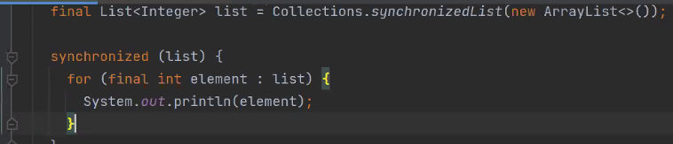

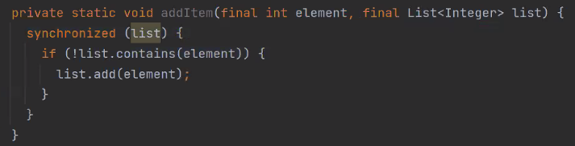

### Synchronized collections

Всеки един метод на тези колекции е синхронизиран също.

* **StringBuffer** is a thread-safe alternative of **StringBuilder**
* The **java.util.Collections** class provides methods to retrieve thread-safe collections
  + **Collections.synchronizedSet()**)
  + Synchronized list - **Collections.synchronizedList()**
  + Synchronized map - - **Collections.synchronizedMap()**
* **java.util.concurrentHashMap** provides a thread-safe hash map
* **CopyOnWriteArrayList** – връща последно актуално копие на итератора. Update-и през това време и да се правят, то при следващо вземане на копие на итератора, ще се е опреснило с промените. Използва се в случаи когато имаме повече четене на елементи, и малко на брой пъти добавяне на елементи.





## Проверка на нишки чрез **jps** и **jstack**

**jps**



**9084** е id-то на процесa на JVM

**jstack** като инструмент за разбиране къде точно се случва deadlock например

**jstack 9084**



# 3. Advanced concurrent programming

### I. Thread communication

#### Thread communication

* So far we saw how we can use implicit and explicit locks to provide synchronization between threads
* However locking might not be very flexible in coordinating threads
* A supplement mechanism whereby threads can notify (“wake up”) each other and wait to be notified is provided by the JVM
  + Provides **a wait-notify mechanism** between the threads in the JVM, thus creating **a publish-subscribe mechanism** at the thread level in the JVM

#### Wait and notify

* This is achieved by the **wait**, **notify** and **notifyAll** methods provides by the **java.lang.Object** class
* These methods work over a monitor lock that must be held from threads (i.e. used within a synchronized method or block)
* **notify** wake up only one thread waiting on the monitor lock while **notifyAll** wakes up all threads
  + Be careful when to use notify and notifyAll - in many cases it is more proper to use notifyAll

##### Exiting waits

* Waking up from the **wait** method can happen in the following situations:
  + When **notify/notifyAll** is called from another thread
  + If timeout expires (in case the overloaded **wait** methods are used)
  + The waiting thread is interrupted by calling the **interrupt** method
  + On rare occasions the OS or the JVM may wake up the thread (also called **spurious wakeup**)

##### Spurious wake-ups

* To guard against spurious wake ups **wait** must always be called in a loop

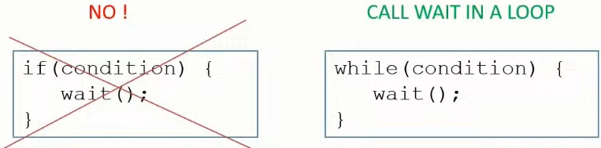

##### Wait/notify example

public class PublishSubscribeExample {

   private String message;

   public static void main(String[] args) {

       PublishSubscribeExample example = new PublishSubscribeExample();

       for (int i = 0; i < 100; i++) {

           new Thread(() -> {example.subscribe();}).start();

       }

       try {

           Thread.*sleep*(3000);

       } catch (InterruptedException e) {

           Thread.*currentThread*().interrupt(); *//interrupt flag is being cleared, so if we want the layers above to know if the thread was interrupted, we make like this*

}

       new Thread(() -> {example.publish("Hello threads!");}).start();

   }

   public synchronized void publish(String message){

       this.message = message;

       System.*out*.println("Notifying all threads ...");

**notifyAll();**

   }

   public synchronized void subscribe(){

       while (message == null){

           try {

**wait();**

           } catch (InterruptedException e){

               Thread.*currentThread*().interrupt();

           }

       }

       System.*out*.println("Message received: " + message);

   }

}

Notifying all threads ...

Message received: Hello threads!

Message received: Hello threads!

Message received: Hello threads!

#### Conditions

* JDK 5 introduced a more flexible (and preferable way) **to specify wait conditions** using the **java.util.concurrent.lock.Condition** interface
* Additional capabilities of the Condition interface include:
  + awaitUntil(Date date) method that waits until a specified date - и ако до това време не се случи, то се събужда нишката
  + **awaitUniterruptibly()** method that awaits until the thread is signalled

import java.util.concurrent.locks.Condition;

import java.util.concurrent.locks.ReentrantLock;

public class PublishSubscribeWithConditionExample {

   private String message;

   private ReentrantLock lock = new ReentrantLock();

   private Condition condition = lock.newCondition();

   public static void main(String[] args) {

       PublishSubscribeWithConditionExample example = new PublishSubscribeWithConditionExample();

       for (int i = 0; i < 100; i++) {

           new Thread(() -> {example.subscribe();}).start();

       }

       try {

           Thread.*sleep*(3000);

       } catch (InterruptedException e) {

           Thread.*currentThread*().interrupt(); *//interrupt flag is being cleared, so if we want the layers above to know if the thread was interrupted, we make like this*

}

       new Thread(() -> {example.publish("Hello threads!");}).start();

   }

   public synchronized void subscribe() {

       try {

           lock.lock();

           while (this.message == null){

               try {

                   condition.await();

               } catch (InterruptedException e){

                   Thread.*currentThread*().interrupt();

               }

           }

           System.*out*.println("Message received: " + this.message);

       } finally {

           lock.unlock();

       }

   }

   public synchronized void publish(String message) {

       try {

           lock.lock();

           this.message = message;

           System.*out*.println("Notifying all threads ...");

**condition.signalAll();**

       } finally {

           lock.unlock();

       }

   }

}

### II. Concurrent (general term) collections

* The standard JDK collections (such as LinkedList and ArrayList) are not thread-safe (except for legacy Vector and Hashtable, които **не се препоръчва да се използват** в нови Java приложения)
* The JDK provides several types of thread-safe collections:
  + **Synchronized collections** (such as ones that can be created with the **Collections.syncronizedXXX** methods) - the following methods from Collections class can be used to create synchronized collections:
* synchronizedCollection
* synchronizedSet
* synchronizedSortedSet
* synchronizedList
* synchronizedMap
* synchronizedSortedMap
* synchronizedNavigableMap

* **BlockingQueue** - thread-safe lock-based collections provided by the **java.util.concurrent** package such as the implementations of the **BlockingQueue** interface:
* ArrayBlockingQueue
* LinkedBlockingQueue
* LinkedBlockingQueue
* DelayQueue
* PriorityBlockingQueue
* SyncronousQueue

* Lock-free thread-safe collections (such as ConcurrentHashMap or Copy-on-write) - **не използва locks и synchronized**(синхронизация), а използва **Compare and Swap** техника на база процесорни инструкции, които ни дават възможност да запазваме нещо в паметта само ако дадено друго нещо/стойност вече е запазена в тази памет. **По-бързи тъй като lock/unlock коства ресурси/време**.  - before JDK 5 ConcurrentHashMap was NOT lock-free.

#### 1. Synchronized collections

private static void syncronizedCollectionExample() {

   List<String> items  = new ArrayList<>();

   List<String> synchronizedItems = **Collections.*synchronizedList***(items);

}

In the face of concurrent access, it is imperative that the user manually synchronize on the returned collection when iterating over it. The reason is that iteration is accomplished via multiple calls into the collection, which must be composed into a single atomic operation. The following is the idiom to iterate over a wrapper-synchronized collection.

Collection<Type> c = **Collections.synchronizedCollection**(myCollection);

synchronized(c) {

    for (Type e : c)

        foo(e);

}

If an explicit iterator is used, the iterator method must be called from within the synchronized block. Failure to follow this advice may result in nondeterministic behavior. The idiom for iterating over a Collection view of a synchronized Map is similar. It is imperative that the user synchronize on the synchronized Map when iterating over any of its Collection views rather than synchronizing on the Collection view itself, as shown in the following example.

Map<KeyType, ValType> m = Collections.synchronizedMap(new HashMap<KeyType, ValType>());

    ...

Set<KeyType> s = m.keySet();

    ...

// Synchronizing on m, not s!

synchronized(m) {

    while (KeyType k : s)

        foo(k);

}

#### 2. BlockingQueue

* BlockingQueue implementations provide the possibility for threads to wait on operations for adding or removing of elements.
* If the blocking queue is full, threads block until space becomes available for adding an element
* If the blocking queue is empty, threads block until an element is inserted in the queue so it can be removed
* BlockingQueues are used to hold tasks submitted to an Executor thread pool. For example, Fixed thread pool uses by default a LinkingBlockingQueue.

import java.util.concurrent.ArrayBlockingQueue;

public class BlockingQueue {

   ArrayBlockingQueue<String> blockingQueue = new ArrayBlockingQueue<String>(50);

   public void add() {

       try {

           blockingQueue.add("first");

           blockingQueue.add("second");

           blockingQueue.add("third");

           System.*out*.println("Adding items completed");

       }

       catch (Exception e) {

           Thread.*currentThread*().interrupt();

       }

   }

   public void remove() {

       try {

           System.*out*.println(blockingQueue.take());

           System.*out*.println(blockingQueue.take());

           System.*out*.println(blockingQueue.take());

           System.*out*.println("Removing items completed");

       } catch (InterruptedException e) {

           Thread.*currentThread*().interrupt();

       }

   }

   public static void blockingCollectionExample(){

       BlockingQueue example = new BlockingQueue();

       new Thread(() -> {example.remove();}).start();

       try {

           Thread.*sleep*(2000);

       } catch (InterruptedException e) {

           Thread.*currentThread*().interrupt();

       }

       new Thread(() -> {example.add();}).start();

   }

   public static void main(String[] args) {

*blockingCollectionExample*();

   }

}

Adding items completed

first

second

third

Removing items completed

#### 3. Lock-free collections

* Lock-free collections provided by the JDK come into two flavors:
  + Copy-on-write collections - като добавяме нов елемент, всеки път се прави ново копие, където го записваме този нов елемент. И това изглежда да е скъпа операция.
  + Concurrent collections based on atomic (compare-and-swap) operations

##### Copy-on-write collections

* Copy-on-write collections create a new collection every time an element is added or removed
* In that regard they are immutable and can be safely accessed from multiple threads
* Copy-on-write collections require extra performance due to the copying of the collection and should be avoided in scenarios where performance is critical
* Copy-on-write collections provided by the JDK include:
  + CopyOnWriteArrayList
  + CopyOnWriteArraySet

private static void copyOnWriteExample() {

   CopyOnWriteArrayList<String> copyOnWriteArrayList = new CopyOnWriteArrayList<>();

   copyOnWriteArrayList.add("first");

   copyOnWriteArrayList.add("second");

   copyOnWriteArrayList.add("third");

}

##### Concurrent (specific term) collections

* Concurrent collections do not use locks, but atomic compare-and-swap (CAS) operations
* The JDK provides support for compare-and-swap instructions provided by modern CPUs
* Avoiding locks (thus context switching) makes concurrent collections more performant than synchronized, blocking and copy-on-write in many scenarios
* Concurrent collections provided by the JDK include:
* ConcurrentHashMap
* ConcurrentLinkedQueue
* ConcurrentLinkedDeque
* ConcurrentSkipListMap
* ConcurrentSkipListSet

###### ConcurrentHashMap

* ConcurrentHashMap provides additional thread-safe atomic operations over a traditional HashMap such as:
* getOrDefault(key, value)
* putIfAbsent(key, value)
* remove(key, value)
* replace(key, oldValue, newValue)
* replaceAll(function)
* computeIfAbsent(key, function)
* computeIfPresent(key, function)
* compute(key, function)
* merge(key, value, function)

**//Ако използваме обикновен HashMap, не винаги ще ни връща 100 в долния пример със 100 нишки!!!**

public class Main {

   public static void main(String[] args) throws InterruptedException {

**ConcurrentHashMap<Integer, Integer> map = new ConcurrentHashMap<>();**

       map.put(1, 0);

       for (int i = 0; i < 100; i++) {

           new Thread(() -> {

**map.compute**(1, (key, value) -> {

                   return value + 1;

               });

           }).start();

       }

       Thread.*sleep*(1000);

       System.*out*.println(map.getOrDefault(1, -1));

   }

}

### III. Synchronizers

* Synchronizers provide more specific mechanisms for synchronization between a number of threads
* The JDK provides several synchronizers that can be used by applications:
* CountDownLatch
* CyclicBarier
* Semaphore
* Exchanger
* Phaser

Java concurrent animated - визуално описани

<https://github.com/vgrazi/java-concurrent-animated>

/java-concurrent-animated$ **mvn package -DskipTests**

/java-concurrent-animated/target$ **java -jar javaConcurrentAnimated.jar**

#### CountDownLatch

* Used when a predefined number of releases should happen before a thread is awakened
* Един път казваме да изчака, и намаляме с countDown()

public class CountDownLatch {

   public static void main(String[] args) {

       java.util.concurrent.CountDownLatch latch = new java.util.concurrent.**CountDownLatch(5)**;

       new Thread(() -> {

           try {

**latch.await();**

               System.*out*.println("Workers have finished !");

           } catch (InterruptedException e) {

               Thread.*currentThread*().interrupt();

           }

       }).start();

       for (int i = 0; i < 5; i++) {

           new Thread(() -> {

               System.*out*.println("Starting worker: " + Thread.*currentThread*().getName());

**latch.countDown()**;

           }).start();

       }

   }

}

Starting worker: Thread-1

Starting worker: Thread-2

Starting worker: Thread-4

Starting worker: Thread-3

Starting worker: Thread-5

Workers have finished !

Ако **CountDownLatch(3)**, тогава резултатът е:

Starting worker: Thread-1

Starting worker: Thread-5

Starting worker: Thread-4

Workers have finished !

Starting worker: Thread-3

Starting worker: Thread-2

#### CyclicBarrier

* Allows a number of threads to await for a predefined number of waits after which they are released
* Извикваме n на брой пъти преди да се освободи изпълението на нишките

public class CyclicBarrier {

   public static void main(String[] args) {

       java.util.concurrent.CyclicBarrier barrier = new java.util.concurrent.**CyclicBarrier**(**3**, () -> {

           System.*out*.println("Workers have finished!");

       });

       for (int i = 0; i < 5; i++) {

           new Thread(() -> {

               System.*out*.println("Starting worker: " + Thread.*currentThread*().getName());

               try {

                   barrier.await();

               } catch (InterruptedException e) {

                   Thread.*currentThread*().interrupt();

               } catch (BrokenBarrierException e) {

                   System.*out*.println("Ending worker: " + Thread.*currentThread*().getName());

               }

           }).start();

       } *//barrier can be reset with barrier.reset()*

}

}

Starting worker: Thread-2

Starting worker: Thread-0

Starting worker: Thread-1

Workers have finished!

Starting worker: Thread-3

Starting worker: Thread-4

#### Semaphore

* Each thread is blocked until a permit is available, semaphore is initialized with a number of permits
* Когато искаме в даден или във всеки момент от време да се изпълняват едновременно определен брой нишки

public class Semaphore {

   public static void main(String[] args) throws InterruptedException {

       java.util.concurrent.Semaphore semaphore = new java.util.concurrent.Semaphore(3);

       for (int i = 0; i < 5; i++) {

           new Thread(() -> {

               try {

                   System.*out*.println("Starting worker: " + Thread.*currentThread*().getName());

*//Acquires a permit from this semaphore, blocking until one is available, or the thread is interrupted.*

*//Acquires a permit, if one is available and returns immediately, reducing the number of available permits by one.*

semaphore.acquire();

                   System.*out*.println("Ending worker: " + Thread.*currentThread*().getName());

               } catch (InterruptedException e) {

                   Thread.*currentThread*().interrupt();

               }

           }).start();

       }

       Thread.*sleep*(2000);

       semaphore.release(); //Първите 3 нишки заемат трите части на семафората

       semaphore.release(); //четвърта и пета нишка се блокират докато не се освободи слот от семафората за тях

   }

}

Starting worker: Thread-2

Starting worker: Thread-0

Ending worker: Thread-2

Starting worker: Thread-3

Ending worker: Thread-3

Starting worker: Thread-1

Starting worker: Thread-4

Ending worker: Thread-0

Ending worker: Thread-1

Ending worker: Thread-4

#### Exchanger

* Provides the possibility to two threads to exchange (swap) objects

public class Exchanger {

   public static void main(String[] args) {

       java.util.concurrent.Exchanger exchanger = new java.util.concurrent.Exchanger();

       for (int i = 0; i < 2; i++) {

           new Thread(() -> {

               try{

                   Random random = new Random();

                   Integer value = random.nextInt();

                   Integer exchanged = (Integer) **exchanger.exchange**(value);

                   System.*out*.println("Exchanged value " + value + " for " + exchanged);

               } catch (InterruptedException e){

                   Thread.*currentThread*().interrupt();

               }

           }).start();

       }

   }

}

Веднъж се разменят стойностите, като първата нишка блокира, докато не е готова и втората-  така че да обменят стойности.

Exchanged value 1878992229 for 2140338631

Exchanged value 2140338631 for 1878992229

#### Phaser

* Similar to CountDownLatch and CyclicBarrier, but provides the ability **to change dynamically the number of awaiting threads** before they can proceed

public class Phaser {

   public static void main(String[] args) {

       java.util.concurrent.Phaser phaser = new java.util.concurrent.**Phaser(1)**;

**phaser.bulkRegister(2)**;*//още два пъти да се извика метода, преди да продължи приложението*

       for (int i = 0; i < 3; i++) {

           new Thread(() -> {

               System.*out*.println(Thread.*currentThread*().getName() + " arriving at phaser");

               phaser.arriveAndAwaitAdvance();

               System.*out*.println(Thread.*currentThread*().getName() + " leaving the phaser");

           }).start();

       }

   }

}

Thread-0 arriving at phaser

Thread-2 arriving at phaser

Thread-1 arriving at phaser

Thread-0 leaving the phaser

Thread-2 leaving the phaser

Thread-1 leaving the phaser

Ако **phaser.bulkRegister(3), то чакаме за общо четири нишки да влязат, а в нашия случай четвърта никога не идва….**

Thread-1 arriving at phaser

Thread-0 arriving at phaser

Thread-2 arriving at phaser

### IV. Atomic operations

#### Compare-and-Swap (CAS)

* Compare-and-Swap is an atomic instruction that compares the location in memory with a given value, and only if they are equals then sets a new value
* CAS is used to implement atomic operations that achieve **optimistic locking** and are thread-safe

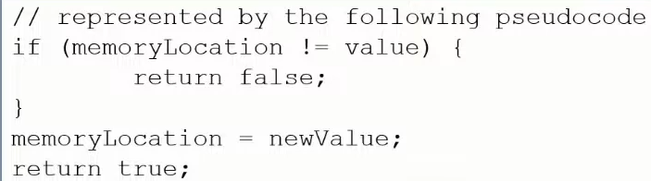

* The JDK provides support for calling CAS instructions through native code as provided by the **jdk.internal.misc.Unsafe** class.
  + Това е клас, който се ползва вътрешно от самата JVM на много места при операции свързани със синхронизация на нишки; Преди се е използвал този клас за приложения, които искат да заделят отделна памет извън HEAP паметта на JVM (unmanaged memory not allocated for the JVM); Не случайно се казва Unsafe - защото ако не се използва внимателно, може да доведе до сериозни проблеми
  + Apart from performing CAS operations the Unsafe class also provides the possibility to access off-heap memory. But since it is an internal class, it is encapsulated as of JDK 9  so cannot be used directly

* An alternative of Unsafe as of JDK 9 that provides support for CAS is provided by the **java.lang.invoke.VarHandle** class

import jdk.internal.misc.Unsafe;

import java.lang.invoke.VarHandle;

public class Main {

   public static void main(String[] args) {

**Unsafe.compareAndSetInt**();

**VarHandle.compareAndSet**();

   }

}

#### Atomic variables

* Maintaining a single variable that is updatable from many threads is a common scalability issue
* Atomic variables are already present in the JDK - they serve as a means to implement updatable variables in a multithreaded environment
* Atomic variables are part of the **java.util.concurrent.atomic** package
* They make use of the CAS support provided by the JDK to provide performant thread-safe operations over shared variables
* The other utilities that we already discussed that make use of CAS are concurrent collections (specific term) like **ConcurrentHashMap**

Atomic variables are provided by the following classes:

* AtomicBoolean
* AtomicInteger
* AtomicIntegerArray
* AtomicLong
* AtomicLongArray
* AtomicReference
* AtomicReferenceArray
* DoubleAccumulator
* DoubleAdder
* LongAccumulator
* LongAdder

##### Пример за AtomicInteger

   public static void main(String[] args) {

AtomicInteger value = new AtomicInteger();

       Thread thread = new Thread(() -> {

           value.**getAndIncrement**();

       });

       thread.start();

       value.getAndAdd(10);

       try {

           thread.join();

       } catch (InterruptedException e) {

           throw new RuntimeException(e);

       }

       System.*out*.println(value.get()); //11

   }

**java.util.concurrent.atomic.AtomicInteger:**

private static final jdk.internal.misc.Unsafe ***U***= jdk.internal.misc**.Unsafe.*getUnsafe*()**;

public final int getAndIncrement() {

   return ***U***.getAndAddInt(this, *VALUE*, 1);

}

**jdk.internal.misc.Unsafe:**

@HotSpotIntrinsicCandidate

public final int getAndAddInt(Object o, long offset, int delta) {

   int v;

   do {

       v = getIntVolatile(o, offset);

   } while (!**weakCompareAndSetInt**(o, offset, v, v + delta));

   return v;

}

@HotSpotIntrinsicCandidate

public final boolean **weakCompareAndSetInt**(Object o,

long offset, //offset в  паметта

                                         int expected, //ако тази стойност вече е налична в паметта

                                         int x) { //новата стойност x ако expected е налично

   return **compareAndSetInt**(o, offset, expected, x);

}

*/\*\**

*\* Atomically updates Java variable to {@code x} if it is currently*

*\* holding {@code expected}.*

*\**

*\* <p>This operation has memory semantics of a {@code volatile} read*

*\* and write.  Corresponds to C11 atomic_compare_exchange_strong.*

*\**

*\* @return {@code true} if successful*

*\*/*

@HotSpotIntrinsicCandidate

public final native boolean **compareAndSetInt**(Object o, long offset,

                                            int expected,

                                            int x);

native ще рече, че се извиква отдолу в JVM, вероятно на C++, Compare-and-Swap процесорна инструкция.

##### Пример за DoubleAccumulator

import java.util.concurrent.atomic.DoubleAccumulator;

public class Main {

   public static void main(String[] args) {

DoubleAccumulator accumulator = new DoubleAccumulator((x, y) -> x + y, 0);

       Thread thread = new Thread(() -> {

           accumulator.accumulate(0.9);

       });

       thread.start();

       accumulator.accumulate(10.1);

       try {

           thread.join();

       } catch (InterruptedException e) {

           throw new RuntimeException(e);

       }

       System.*out*.println(accumulator.get()); //11

   }

}

##### Пример за AtomicReference

Използва се за обекти от всякакъв тип, включително и за Стринг.

public class Main {

   public static void main(String[] args) {

AtomicReference<String> reference = new AtomicReference<String>("first");

       Thread thread = new Thread(() -> {

           reference.getAndAccumulate(" some text", (x, y) -> x + y);

       });

       thread.start();

       reference.getAndAccumulate(" otherText", (x, y) -> x + y);

       try {

           thread.join();

       } catch (InterruptedException e) {

           throw new RuntimeException(e);

       }

       System.*out*.println(reference.get());

   }

Не се гарантира поредността, но се гарантира thread safety

first otherText some text

#### StringBuffer

Thread-safe operations.

Но не е реализирано със CAS, а със **copy-on-write - т.е. за повече обем данни може да е бавна операцията**

### V. Concurrency utilities

#### Fork/join framework

* **ForkJoinPool** is an implementation of the **ExecutorService** interface introduced in JDK 7
* The fork/join framework is distinct because it uses a ***work-stealing* algorithm**. Worker threads that run out of things to do can steal tasks from other threads that are still busy.
* Provides the possibility to execute tasks that can be organized in a **divide-and-conquer** manner - разбиване на подзадачи например като сортиране с **mergeSort** алгоритъм (see Algorithms with Java notes) при многонишкова среда

if (my portion of the work is small enough)

  do the work directly

else

  split my work into two pieces

  invoke the two pieces and wait for the results

* Tasks submitted to the **ForkJoinPool** are represented by a **ForkJoinTask** instance
* Typical implementations of parallel tasks do not extend directly **ForkJoinTask**
* **RecursiveTask** instances can be used to execute parallel tasks that return a result
* **RecursiveAction** instances can be used to execute parallel tasks that do NOT return a result
* A **global** **ForkJoinPool** **instance** is used for any ForkJoinTasks that are not submitted to a particular ForkJoinPool
* To get a reference to the global ForkJoinPool instance, the static **ForkJoinPool.commonPool()** method can be used
* This is the case with **parallel streams**: they make use of the common ForkJoinPool for task execution

import java.util.concurrent.RecursiveAction;

public class NumberFormatAction extends **RecursiveAction** {

   int start;

   int end;

   public NumberFormatAction(int start, int end) {

       this.start = start;

       this.end = end;

   }

   @Override

   protected void compute() {

       if (end - start <= 2) {

           System.*out*.println(start + " " + end);

       } else {

           int mid = start + (end - start) / 2;

           NumberFormatAction left = new NumberFormatAction(start, mid);

           NumberFormatAction right = new NumberFormatAction(mid + 1, end);

**java.util.concurrent.ForkJoinTask.*invokeAll***(left, right);

       }

   }

}

public static void main(String[] args) {

   NumberFormatAction action = new NumberFormatAction(1, 50);

**ForkJoinPool.*commonPool*().invoke**(action);

}

Thread.*sleep*(1000);

System.***out***.println(Thread.*currentThread*()); - връща името на текущата нишка

System.***out***.println(ForkJoinPool.*commonPool*());

**public static void** main(String[] args) {  
 List<Integer> numbers = Arrays.*asList*(1, 2, 3, 4, 5, 6, 7, 8);  
 System.***out***.println(Runtime.*getRuntime*().availableProcessors()); - връща 1 ядро по-малко, защото едно ядро е заето с нишката на main метода  
 System.***out***.println(**ForkJoinPool**.*commonPool*()); - - връща състоянието на pool-a

#### Parallel streams / parallel programming

* Parallel streams can be created as regular streams with the **parallelStream** method

List list = new ArrayList();

list.parallelStream();

* Parallel streams should be used **only for time-intensive tasks rather than IO**
* In many cases regular streams outperform parallel ones so they need to be used with caution - затова винаги е добре когато мислим да използваме паралелни потоци, то да им сравним бързодействието с нормални потоци

threads and fibers – нишки и влакна – ниско ниво код близко до hardware

**public class** Main **implements** Runnable {  
 **public static void** main(String[] args) {  
 **new** Main().run();  
 }  
  
 @Override  
 **public void** run() {  
 **int** n = 10;  
  
 **while** (n-- > 0){  
 Thread thread = **new** Thread(**this**::doSomething); **//вземаме нишка от операционната система / изключително скъпа операция** thread.start();  
 }  
  
 }  
  
 **private void** doSomething() {  
 **long** z = 0;  
  
 **while** (**true**){  
 z++;  
 }  
 }  
}

**Imperative style – обикновени цикли, if-else клаузи – как ще се случи**

**Functional/Declarative style – какво ще се случи (без значение как), не се интересуваме от самото изпълнение, а от логиката - .stream – този стил е много близък до многонишковото програмиране и е higher level of abstraction**



List<Integer> numbers = Arrays.*asList*(1, 2, 3, 4, 5, 6, 7, 8);  
numbers.stream().parallel(); равно на numbers.parallelStream();- произволен ред ги печата

numbers.stream().sequential(); - в последoвателен ред ги печата.

In JAVA (Java 8) we do not have Reactive streaming.



**Прави ги парарелно, но ги печата подредени.**



Примери с **.reduce() метода: - като агрегатор**

//Вземи сбора на всички числа

**int**[] numbers = **new int**[]{1, 2, 3, 4, 5};  
**int** sum = Arrays.*stream*(numbers).reduce(0, (val, num) -> val += num);

//вземи най-дългата дума

String[] words = **new** String[]{**"hello"**, **"pesho"**, **"abc"**, **"worlddd"**};  
String longestWord = Arrays.*stream*(words).reduce(**""**, (val, w) -> {  
 **if** (w.length() > val.length()) {  
 val = w;  
 }  
 **return** val;  
});

List<Integer> numbers = Arrays.*asList*(1, 2, 3, 4, 5, 6, 7, 8);  
numbers.parallelStream().reduce(0, (total,e) -> *add*(total, e)); //0 e identity value

**private static** Integer add(Integer total, Integer e) {  
 **return** total+= e;  
}

//reduce does not take initial value, it takes identity value – it is the value which will not change the operation if you apply it on

X + identity value 0

Y * identity value 1

Да внимаваме – ако превключим от sequential към parallel, identity value трябва да е коректно зададено. Не е ок да напишем 36 години, при паралелното дава друг резултат.

The question is – How many threads should I create? How much food should I eat?

Ако създам прекалено много нишки, даже по-бавно би работило.

IO intensvive – прави паузи често, тогава може да имаме повече нишки



Configuring number of threads JVM wide:

**Djava.util.concurrent.ForkJoinPool.common.parallelism=100** 100 нишки

#### Completable Future

* Provides a facility to create a chain of dependant non-blocking tasks
* **No divide-and-conquer - it could be any relation of operations - i.e. a smarter way of organization when using CompletableFuture**
* An asynchronous task can be triggered as the result of a completion of another task

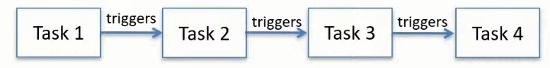

* A CompletableFuture may be completed/canceled by a thread prematurely (преждевременно)

* Provides a very flexible API that allows additionally:
  + To combine the result of multiple tasks in a CompletableFuture
  + To provide synchronous/asynchronous callbacks upon completion of a task
  + To provide a CompletableFuture that executes when first task in a group completes
  + To provide a CompletableFuture that executes when all tasks in a group complete

1. Най-простият пример

import java.util.concurrent.CompletableFuture;

public class Main {

   public static void main(String[] args) {

       CompletableFuture<Integer> task1 = new CompletableFuture<>();

*// forcing completing of future by specifying result*

boolean complete = task1.**complete**(10);

   }

}

2.

import java.util.concurrent.CompletableFuture;

import java.util.concurrent.ExecutionException;

public class Main {

   public static void main(String[] args) throws ExecutionException, InterruptedException

CompletableFuture<Integer> task1 = CompletableFuture.***supplyAsync***(() -> {

*//some code logic here*

return 10;

       });

*//executed on completion of the future*

CompletableFuture<Integer> integerCompletableFuture = task1.thenApply((x) -> x * x);

       System.*out*.println(integerCompletableFuture.get()); *//100*

*//executed in case of exception or completion of the future*

task1.**handle**((x, y) -> {

           return ............

       });

       System.*err*.println(task1.get());

*//can be completed prematurely with a result*

task1.complete(20);

   }

}

3. Верига от задачи

CompletableFuture<Object> prev = null;

Supplier<Object> supplier = () -> {};

for (int i = 0; i < count; i++) {

   CompletableFuture<Object> task;

   if (prev != null) {

       task = prev.thenCompose(x -> {

           return CompletableFuture.*supplyAsync*(supplier);

       });

   } else {

       task = CompletableFuture.*supplyAsync*(supplier);

   }

   prev = task;

}

**prev.get(); //изпълнява целия chain**

#### A few more things

* There is a **Timer** utility/class that can be used for scheduling tasks, but a **scheduled executor thread pool is more preferable as a more robust alternative**
* A **ThreadLocalRandom** utility is provided since JDK 7 that can be used to generate random numbers for the current thread
* A **Flow** interface introduced in JDK 9 provides a **reactive streams specification for the JDK** that can be used to provide a publish-subscribe mechanism - frameworks like in Spring (implemented by WebFlux reactor) and in Quarkus(implemented by Mutiny)
  + Парадигмата за реактивно програмиране идва от Microsoft като постепенно се имплементира в различни програмни езици. Идеята на реактивното програмиране е да се изпълняват само неблокиращи операции и се касае за IO операции(в това число http протокол, web socket, комуникация с базата данни и  т.н.) в не малка част от случаите! Идеята за реактивното програмиране решава въпроса за скалируемост - да може например повече да се бомбардирва със http заявки даден http endpoint

### VI. Testing concurrent applications

* Testing concurrent applications for correctness is inherently difficult
* In many cases non-deterministic unit tests are written that try to simulate running a particular piece of code in a multithreaded manner
* Testing frameworks provide certain utilities that can be used to facilitate testing of concurrent applications

* A classical way of running multiple threads against code-under-test in a unit test is to use **CountDownLatch:**

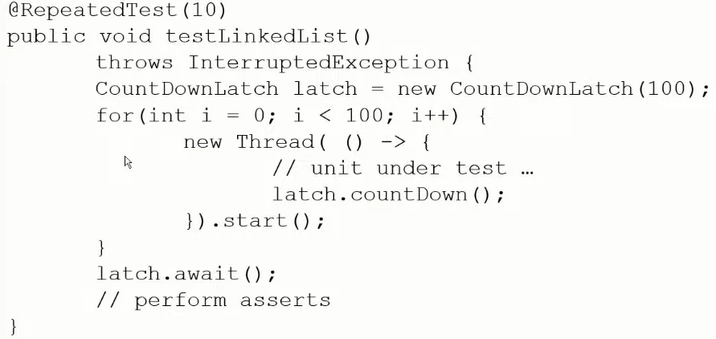

* Frameworks like **ThreadWeaver** provide the possibility to interleave execution threads - interleaving happens using breakpoints (line by line) so that the unit-under-test is tested using different thread ordering

* For performance testing a framework like **JMH**(the ***Java Microbenchmark Harness***) can be used to perform proper application warmup before the test is executed - самото JDK се тества с JMH

### VII. Latest concurrency enhancements

* At the time of 2023/2024, JDK 21 is the latest LTS (long-term support) release of JDK 21
* A few but MAJOR additions for writing concurrent applications are introduced:
  + Virtual threads (aka fibers) provided by **Project Loom**
  + Scoped values
  + Structured concurrency

#### Virtual threads

* Virtual threads are “lightweight” threads scheduled by the JVM
* In comparison with standard platform threads, they are not bound directly to OS threads
* They are still executed by an OS thread
* They are an instance of the **java.lang.Thread** class - същата инстанция както и стандартните нишки
* Virtual threads are very suitable for high-throughput concurrent application
* Typical example are Java server applications where many threads are blocked and waiting
* Not suitable for long running operations

import java.util.concurrent.ExecutionException;

import java.util.concurrent.ExecutorService;

import java.util.concurrent.Executors;

import java.util.concurrent.Future;

public class Main {

   public static void main(String[] args) {

   }

   private static void createSimpleVirtualThread() throws InterruptedException {

       Thread thread = **Thread.*ofVirtual*().start**(() -> {...});

       thread.join();

   }

   private static void createVirtualThreadPool() throws InterruptedException, ExecutionException {

       ExecutorService virtualThreadPool = **Executors.*newVirtualThreadPerTaskExecutor*()**;

       Future<?> task = **virtualThreadPool.submit**(() -> {...});

       task.get();

   }

}

# 4. Asynchronous programming

### What is Asynchronous Programming?

Let's delve into an analogy of asynchronous programming: Imagine waking up in the morning and starting to boil some eggs for breakfast. Instead of waiting idly for them to cook, you begin another task, such as baking bacon and toast. In this scenario, you're akin to a thread executing I/O operations - you initiate them and let them run independently. Both tasks are non-blocking for you; while the food cooks, you're free to sit at the table, enjoy some YouTube videos, or even take a shower. Once any task is completed (for instance, the bacon is ready), you handle it by placing it on your plate. Similarly, when the eggs are done, you remove them from the water and prepare them to be eaten.

Consider another real-world example of asynchronous operations: a waiter at a restaurant taking orders. Upon receiving an order from a customer, he relays it to the kitchen for preparation. Rather than waiting beside the kitchen counter for the dish to be ready – an approach similar to a Java application operating on a single thread - the waiter moves on to attend to another customer's order. As soon as a meal is prepared, he retrieves it from the kitchen and serves it to the respective customer.

This process mirrors how an application thread behaves during an API call, initiating a time-consuming operation on an external system or executing a complex database query that takes several seconds or more.

Real-life scenarios also require exception handling, akin to software development. For instance, if the waiter takes an order for pasta bolognese but finds out that the kitchen has run out of beef, it poses a resource synchronisation issue typical in asynchronous operations.

Modern web applications, particularly those hosted in cloud environments, need to accommodate thousands of simultaneous users. This scalability is achieved not only through service replication, such as pod replication in EKS, but also by making efficient use of threads within each pod at the application level. Asynchronous operations facilitate

non-blocking I/O, leading to more efficient use of resources.

**Async vs parallel operations:** Asynchronous programming focuses on non-blocking tasks, while parallel programming involves executing multiple computations simultaneously, leveraging multi-core processors. Both approaches improve performance but are used for different purposes.

### Async Programming in Other Languages

**C#** in the **.NET** framework utilises the **Task<T>** class and **async** and **await** keywords,making asynchronous programming more straightforward and cleaner. An **async** method returns a **Task** or **Task<T>**, which represents ongoing work. C# similar to Java utilises a thread pool for executing asynchronous tasks. When an async method awaits an asynchronous operation, the current thread is returned to the thread pool until the awaited operation completes.

C/C++

public async Task<string> GetDataAsync() {

var data = await GetDataFromDatabaseAsync();

return data;

}

**JavaScript** handles asynchronous operations through **Promises** and **async/await** syntax,fitting its event-driven nature. A **Promise** represents an operation that hasn't been completed yet but is expected in the future. JavaScript, particularly in the **Node.js** environment, operates on a single-threaded event loop for handling asynchronous operations.

JavaScript

async function fetchData() {

let response = await fetch('https://api.example.com/data');

let data = await response.json();

console.log(data);

}

In JAVA it is CompletableFuture

In JS it is Promises

### Java's CompletableFuture Class

Java's **CompletableFuture** class was introduced in **Java 8. CompletableFuture** is part of Java's **java.util.concurrent** package and provides a way to write asynchronous code by representing a future result that will eventually appear. It lets us perform operations like calculation, transformation, and action on the result without blocking the main thread. This approach helps in writing non-blocking code where the computation can be completed by a different thread at a later time.

**CompletableFuture** and the broader **Java Concurrency API** make use of thread pools (**like the ForkJoinPool**) for executing asynchronous operations. This allows Java applications to handle multiple asynchronous tasks efficiently by leveraging multiple threads.

CompletableFuture.supplyAsync(() -> {

return "Result of the asynchronous computation";

})

.thenAccept(System.out::println);

**public static** CompletableFuture<Integer> create() {  
 **return** CompletableFuture.*supplyAsync*(() -> 2);  
}

In Java, when a **CompletableFuture** operation is waiting on a dependent future or an asynchronous computation, it doesn't block the waiting thread. Instead, the completion of the operation triggers the execution of dependent stages in the **CompletableFuture** chain, potentially on a different thread from the thread pool.

### Example Scenario with CompletableFuture

Let's consider a scenario where we need to perform a series of dependent and independent asynchronous operations:

1. **Fetch User Details**: Given a userID, we first retrieve the user's details asynchronously.

2. **Fetch Credit Score**: Once we have the user's details, we fetch their credit score.

3. **Calculate Account Balance**: Independently, we also calculate the user's account balance from a different source.

4. **Make a Decision**: Finally, we combine the credit score and account balance to make a financial decision.

**5. Handle Potential Errors**

#### Step 1: Fetching User Details Asynchronously

We start by simulating an asynchronous operation to fetch user details using **supplyAsync**. This returns a **CompletableFuture** that will complete with the user details:

CompletableFuture<String> getUserDetailsAsync(String userId) {

return CompletableFuture.**supplyAsync**(() -> "UserDetails for " + userId);

}

#### Step 2: Transforming and Fetching Credit Score

Next, we use **thenApply** to transform the result (e.g., formatting user details) and **thenCompose** to fetch the credit score, demonstrating the chaining of asynchronous operations:

CompletableFuture<String> userDetailsFuture = getUserDetailsAsync("userId123")

.**thenApply**(userDetails -> "Transformed " + userDetails);

CompletableFuture<Integer> creditScoreFuture = userDetailsFuture

.**thenCompose**(userDetails -> getCreditScoreAsync(userDetails));

**thenApply** is for synchronous transformations, while **thenCompose** allows for chaining another asynchronous operation that returns a **CompletableFuture**.

#### Step 3: Calculating Account Balance in Parallel

We calculate the account balance using another asynchronous operation, showcasing how independent futures can run in parallel:

CompletableFuture<Double> accountBalanceFuture = calculateAccountBalanceAsync("userId123");

#### Step 4: Combining Results and Making a Decision

With **thenCombine** we merge the results of two independent **CompletableFuture** – credit score and account balance - to make a decision:

CompletableFuture<Void> decisionFuture = creditScoreFuture

.**thenCombine**(accountBalanceFuture, (creditScore, accountBalance) ->

makeDecisionBasedOnCreditAndBalance(creditScore, accountBalance))

.**thenAccept**(decision -> System.out.println("Decision: " + decision));

#### Step 5. Error Handling

Error handling is crucial in asynchronous programming. We use exceptionally to handle any exceptions that may occur during the asynchronous computations, providing a way to recover or log errors:

.exceptionally(ex -> {

System.err.println("An error occurred: " + ex.getMessage());

return null;

});

### CompletableFuture from Indian UK guy

#### Some Info

CompletableFuture<Integer> future = *create*();  
CompletableFuture<Void> future2 = future.thenAccept(data -> System.***out***.println(data));  
  
*create*()  
 .thenAccept(data -> System.***out***.println(data))

.thenApply(d -> d * 10)  
 .thenRun(() -> System.***out***.println(**"This never dies"**));



.**thenAccept**(data -> System.***out***.println(data))

**Consumer**<String> **printer** = str -> System.***out***.println(str);

Arrays.*stream*(sc.nextLine().split(**"\\s+"**)).forEach( е-> **printer.accept**(е));

**.thenApply**(d -> d * 10)

**Function**<Integer, Integer> squared = x -> x * x; - първият е входните данни, втория параметър е типа на изхода  
System.***out***.println(squared.**apply**(25)); //връща 625

**.thenRun**(() -> System.***out***.println(**"This never dies"**));

**Supplier**<Integer> genRandomInt = () -> **new** Random().nextInt(51);  
**int** rnd = genRandomInt.**get();**

#### Adding data to the pipeline

**public static void** main(String[] args) **throws** InterruptedException {  
 CompletableFuture<Integer> future = **new** CompletableFuture<Integer>();  
 future  
 .thenApply(d -> d * 2)  
 .thenApply(d -> d + 1)  
 .thenAccept(data -> System.***out***.println(data));  
 System.***out***.println(**"We built the pipeline"**);  
 System.***out***.println(**"Prepared to print"**);  
  
 *sleep*(1000);  
  
 future.**complete**(2);  
 *sleep*(1000);

}

#### Working with exceptions



**public static** CompletableFuture<Integer> create() {  
 **return** CompletableFuture.*supplyAsync*(() -> 2);  
}

**public static void** main(String[] args) {  
 *create*()  
 .thenApply(data -> data * 2)  
 **.exceptionally**(thr -> *handleException*(thr))  
 .thenAccept(data -> System.***out***.println(data));

}

**private static** Integer handleException(Throwable thr) {  
 System.***out***.println(**"ERROR: "** + thr);  
 **throw new** RuntimeException(**"It is beoynd all hope"**);  
}

future.**completeExceptionally**(new RuntimeException()); - с две думи нищо не сме свършили

##### Състояния на CompletableFuture:

**Pending (final)**

**Resolved state (final)**

**Rejected (final)**

Future.**orTimeout**();

##### Combine and compose

//JavaScript

then(e => func(e)) 🡺

In JavaScript func may return data or return a promise

If date is returned, it is wrapped into a promise

If promise is returned, then that is returned from the then

In JavaScript the return type could be any type, but in JAVA the return type should always be T (what we started with)

**public static** CompletableFuture<Integer> create(**int** number) {  
 **return** CompletableFuture.*supplyAsync*(() -> number);  
}

**public static void** main(String[] args) **throws** InterruptedException {  
 *create*(2).**thenCombine**(*create*(3), (result1, result2) -> result1 + result2)  
 .thenAccept(data -> System.***out***.println(data));

}











**public static** CompletableFuture<Integer> create(**int** number) {  
 **return** CompletableFuture.*supplyAsync*(() -> number);  
}

**public static** CompletableFuture<Integer> inc(**int** number){  
 **return** CompletableFuture.*supplyAsync*(() -> number + 1);  
}

*create*(2)  
*// .thenApply(data -> inc(data))* .thenCompose(data -> *inc*(data))  
 .thenAccept(result -> System.***out***.println(result));

### Using CompletableFutures Effectively

#### Most Important Methods

###### 1. supplyAsync

The **supplyAsync** method is part of the **CompletableFuture** class introduced in Java 8, residing in the **java.util.concurrent package**. It's designed to run a piece of code asynchronously and return a **CompletableFuture** that will be completed with the **value** obtained from that code. Essentially, it allows you to execute a **Supplier<T>** asynchronously, where **T** is the type of **value** returned by the Supplier.

**Syntax and Usage:**

static <U> CompletableFuture<U> supplyAsync(Supplier<U> supplier)

* **U:** The type of value obtained from the **Supplier<U>**
* supplier: A **Supplier<U>** that provides the **value** to be used in the completion of the

returned **CompletableFuture<U>**

Simple example:

CompletableFuture<String> future = CompletableFuture.supplyAsync(() -> {

// Simulate a long-running operation

try {

TimeUnit.SECONDS.sleep(2);

} catch (InterruptedException e) {

Thread.currentThread().interrupt();

}

return "Result of the asynchronous operation";

});

When you invoke **supplyAsync**, it executes the given **Supplier** asynchronously (usually in a different thread). The method immediately returns a **CompletableFuture** object. This **CompletableFuture** will be completed in the future when the **Supplier** finishes its execution, with the result being the value provided by the **Supplier**.

It allows the main thread to continue its operations without waiting for the task to complete. This is particularly useful in web applications or any I/O-bound applications where you don't want to block the current thread.

By default, tasks submitted via **supplyAsync** without specifying an executor are executed in the common fork-join pool (**ForkJoinPool.commonPool()**). However, you can also specify a custom **Executor** if you need more control over the execution environment:

Executor **executor** = Executors.newCachedThreadPool();

CompletableFuture<String> future = CompletableFuture.supplyAsync(() -> {

// Task here

return "Result";

}, **executor**);

###### 2. runAsync

**CompletableFuture.runAsync** is akin to **CompletableFuture.supplyAsync** but for scenarios where you don't need to return a value from the asynchronous operation. Both methods are intended for executing tasks asynchronously, but they differ in their return types and the type of tasks they're suited for.

**runAsync** is used to execute a **Runnable** task asynchronously, which does not return a result. Since **Runnable** does not produce a return value, **runAsync** returns a **CompletableFuture<Void>.**

static CompletableFuture<Void> runAsync(Runnable runnable)

static CompletableFuture<Void> runAsync(Runnable runnable, Executor executor)

* **Asynchronous Execution**: Executes the given **Runnable** task in a separate thread, allowing the calling thread to proceed without waiting for the task to complete.
* **No Return Value**: Suitable for asynchronous tasks that perform actions without needing to return a result, such as logging, sending notifications, or other side effects.
* **Custom Executor Support**: Allows specifying a custom **Executor** for more control over task execution, such as using a dedicated thread pool.

Here's an example that demonstrates using **runAsync** to execute a simple asynchronous task:

CompletableFuture<Void> future = CompletableFuture.runAsync(() -> {

// Simulate a task that takes time but doesn't return a result

try {

TimeUnit.SECONDS.sleep(1);

System.out.println("Task completed");

} catch (InterruptedException e) {

Thread.currentThread().interrupt();

}

});

// Do something else while the task executes

future**.join();** // Wait for the task to complete if necessary

###### 3. get()

The **get()** method blocks the current thread until the **CompletableFuture** completes, either normally or exceptionally. Once the future completes, **get()** returns the result of the computation if it completed normally, or throws an exception if the computation completed exceptionally.

**1. Blocking Behaviour**: Like **join()** ,**get()** is a blocking call. It makes the caller thread wait until the **CompletableFuture**'s task is completed.

2. **Checked Exceptions**: **get()** can throw checked exceptions, including:

a. **InterruptedException**: If the current thread was interrupted while waiting.

b. **ExecutionException**: If the computation threw an exception. This exception wraps the actual exception thrown by the computation, which can be obtained by calling **getCause()** on the **ExecutionException**.

3. **Timeout**: The overloaded version of **get(long timeout, TimeUnit unit)** allows specifying a maximum wait time. If the timeout is reached before the future completes, it throws a **TimeoutException**, providing a mechanism to avoid indefinite blocking.

4. **Use Case**: Use **get()** when you need to handle checked exceptions explicitly, or when you need to retrieve the result of the computation within a certain timeframe.

Example:

CompletableFuture<String> future = CompletableFuture.supplyAsync(() -> {

// Simulate a long-running operation

try {

TimeUnit.SECONDS.sleep(2); // 2-second delay

} catch (InterruptedException e) {

Thread.currentThread().interrupt();

}

return "Result of the asynchronous operation";

});

try {

// Attempt to retrieve the result, waiting up to 3 seconds

String result = future**.get**(3, TimeUnit.SECONDS);

System.out.println(result);

} catch (InterruptedException e) {

Thread.currentThread().interrupt();

System.out.println("The current thread was interrupted while waiting.");

} catch (ExecutionException e) {

System.out.println("The computation threw an exception: " + e.getCause());

} catch (TimeoutException e) {

System.out.println("Timeout reached before the future completed.");

}

###### 4. join()

The **join** method on a **CompletableFuture** is a blocking call that causes the current thread to wait until the **CompletableFuture** is completed. During this waiting period, the current thread is inactive, essentially "joining" the completion of the task represented by the **CompletableFuture**.

* **Blocking Behaviour**: **join()** blocks until the **CompletableFuture** upon which it is called completes, either normally or exceptionally. It makes the asynchronous operation synchronous for the calling thread, as the thread will not proceed until the future is completed.
* **Exception Handling**: Unlike **get()**, which throws checked exceptions (such as **InterruptedException** and **ExecutionException**), **join()** is designed to throw an unchecked exception (**CompletionException**) if the **CompletableFuture** completes exceptionally. This can simplify error handling in certain contexts where checked exceptions are undesirable.
* **Usage**: It's typically used when you need to synchronize asynchronous computation at some point, for example, when the result of the asynchronous computation is required for subsequent operations, or at the end of a program to ensure that all asynchronous tasks have completed.

Example scenario:

If you have a main application thread that kicks off an asynchronous task using **CompletableFuture.runAsync()** or **CompletableFuture.supplyAsync()**, and later in the program you need the result of that task or need to ensure that the task has completed before proceeding, you might call **join()**:

CompletableFuture<Void> future = CompletableFuture.runAsync(() -> {

// Long-running task

try {

TimeUnit.SECONDS.sleep(1); // Simulates a delay

} catch (InterruptedException e) {

Thread.currentThread().interrupt();

}

System.out.println("Async task finished");

});

System.out.println("Waiting for the async task to complete...");

future**.join();** // Blocks here until the above task completes

System.out.println("Main thread can now proceed");

###### 5. thenApply(Function<? super T, ? extends U> fn)

- **Purpose**: Applies a synchronous transformation function to the result of the **CompletableFuture** when it completes.

* **Behaviour**: Executes on the same thread that completed the previous stage, or in the thread that calls **get()** or **join()** if the future has already completed.
* **Return Type**: **CompletableFuture<U>** where U is the type returned by the function.

###### 6. thenApplyAsync(Function<? super T, ? extends U> fn)

- **Purpose**: Similar to **thenApply**, but the transformation function is executed

asynchronously, typically using the default executor.

- **Behaviour**: Can execute the function in a different thread, providing better

responsiveness and throughput for tasks that are CPU-intensive or involve blocking.

- **Return Type**: **CompletableFuture<U>**

CompletableFuture<Integer> future = CompletableFuture**.supplyAsync**(() -> 42);

CompletableFuture<String> applied = future.**thenApply**(result -> "Result: " + result);

applied.**thenAccept**(System.out::println); // Prints: Result: 42

CompletableFuture<String> appliedAsync = future.**thenApplyAsync**(result -> "Async Result: " + result);

appliedAsync**.thenAccept**(System.out::println); // Prints: Async Result: 42

###### 7. thenCombine(CompletionStage<? extends V> other, BiFunction<? super T, ? super V, ? extends U> fn)

**- Purpose**: Combines the result of this **CompletableFuture** with another asynchronously computed value. The combination is done when both futures complete.

- **Behaviour**: The **BiFunction** provided is executed synchronously, using the thread that completes the second future.

**- Return Type: CompletableFuture<U>**

###### 8. thenCombineAsync(CompletionStage<? extends V> other, BiFunction<? super T, ? super V, ? extends U> fn)

**- Purpose**: Similar to **thenCombine**, but the **BiFunction** is executed asynchronously.

- **Behaviour**: Useful when the combination function is computationally expensive or

involves blocking.

**- Return Type: CompletableFuture<U>**

CompletableFuture<Integer> future1 = CompletableFuture.supplyAsync(() -> 40);

CompletableFuture<Integer> future2 = CompletableFuture.supplyAsync(() -> 2);

CompletableFuture<Integer> combined = future1.thenCombine(future2, Integer::sum);

combined.thenAccept(result -> System.out.println("Sum: " + result)); // Prints: Sum: 42

CompletableFuture<Integer> combinedAsync = future1.thenCombineAsync(future2, Integer::sum);

combinedAsync.thenAccept(result -> System.out.println("Async Sum: " + result)); // Prints: Async Sum: 42

###### 9. thenAccept and thenAcceptAsync

**- Purpose**: Consumes the result of the **CompletableFuture** without returning a result. **thenAccept** is synchronous, while **thenAcceptAsync** is asynchronous.

**- Use Case**: Useful for executing side-effects, such as logging or updating a user interface, with the result of the **CompletableFuture**.

CompletableFuture<Void> accepted = CompletableFuture.supplyAsync(() -> "Hello")

.thenAccept(result -> System.out.println(result + ", World!")); //Prints: Hello, World!

CompletableFuture<Void> acceptedAsync = CompletableFuture.supplyAsync(() -> "Async Hello")

.thenAcceptAsync(result -> System.out.println(result + ", World!")); //Prints: Async Hello, World!

###### 10. thenRun and thenRunAsync

* **Purpose**: Executes a **Runnable** action when the **CompletableFuture** completes, without using the result of the future. **thenRun** is synchronous, while **thenRunAsync** is asynchronous.
* **Use Case**: Useful for triggering actions that do not depend on the future's result, such as signalling completion or cleaning up resources.

CompletableFuture.**supplyAsync**(() -> "Task completed")

**.thenRun**(() -> System.out.println("Running next step...")); // Executed after the supplyAsync task

CompletableFuture.supplyAsync(() -> "Async task completed")

**.thenRunAsync**(() -> System.out.println("Running async next step...")); // Executed asynchronously after the supplyAsync task

###### 11. exceptionally(Function<Throwable, ? extends T> fn)

* **Purpose**: Handles exceptions arising from the **CompletableFuture** computation, allowing for a fallback value to be provided or a new exception to be thrown.
* **Use Case**: Essential for robust error handling in asynchronous programming, allowing for recovery or logging of failures.

CompletableFuture<String> exceptionFuture = CompletableFuture.supplyAsync(() ->

{

if (true) throw new RuntimeException("Exception!");

return "No Exception";

})

.**exceptionally**(ex -> "Exception Handled: " + ex.getMessage());

exceptionFuture.**thenAccept**(System.out::println); // Prints: Exception Handled: java.lang.RuntimeException: Exception!

###### 12. handle and handleAsync

* **Purpose**: Applies a function to the result or exception of the **CompletableFuture**. The synchronous variant is **handle**, and the asynchronous variant is **handleAsync.**
* **Use Case**: Useful when you need to process the result of a computation regardless of its success or failure, such as optionally transforming the result or providing a default in case of an exception.

CompletableFuture<String> handleFuture = CompletableFuture.supplyAsync(() -> {

if (true) throw new RuntimeException("Handle Exception!");

return "Handled";

})

**.handle**((result, ex) -> ex != null ? "Recovered: " + ex.getMessage() : result);

handleFuture.**thenAccep**t(System.out::println); // Prints: Recovered: java.lang.RuntimeException: Handle Exception!

CompletableFuture<String> handleAsyncFuture = CompletableFuture.supplyAsync(() -> {

if (true) throw new RuntimeException("Async Handle Exception!");

return "Async Handled";

})

**.handleAsync**((result, ex) -> ex != null ? "Async Recovered: " + ex.getMessage() : result);

handleAsyncFuture**.thenAccept**(System.out::println); // Prints: Async Recovered: java.lang.RuntimeException: Async Handle Exception!

#### Summary

* **Synchronous vs. Asynchronous**: For each operation(**thenApply**, **thenAccept**, **thenRun**, **thenCombine**) there's an asynchronous variant (**thenApplyAsync**, **thenAcceptAsync**, **thenRunAsync**, **thenCombineAsync**) that can execute its task in a separate thread, making it suitable for longer-running operations.
* **Chaining Computations**: These methods enable chaining multiple stages of computation, transforming results, and combining the outcomes of independent computations in a fluent and readable manner.
* **Error Handling**: Methods like **exceptionally** and **handle** provide mechanisms for dealing with errors that may occur during the asynchronous computations, ensuring resilience and robustness in asynchronous logic.

#### Counter-intuitive Behaviours and How to Address Them

The **CompletableFuture API** in Java is a powerful mechanism for managing asynchronous operations. However, its flexibility can sometimes lead to counterintuitive behaviours, subtle bugs, and performance issues. Understanding these aspects is crucial for developers to effectively use and debug **CompletableFuture**. Let's dive into each point.

##### Misuse of CompletableFuture Leading to Subtle Bugs and Performance Issues

* **Blocking Calls Inside CompletableFuture**: Using **get()** or **join()** within a **CompletableFuture**'s chain can block the asynchronous execution, negating the benefits of non-blocking code.

**Solution**: Replace blocking calls with non-blocking constructs like **thenCompose** for chaining futures or **thenAccept** for handling results.

* **Ignoring Returned Futures**: Not handling the **CompletableFuture** returned by methods like **thenApplyAsync** can lead to unobserved exceptions and behavior that does not execute as expected.

**Solution**: Always chain subsequent operations or attach error handling (e.g.**exceptionally** or **handle**) to every CompletableFuture.

##### Debugging Challenges in Asynchronous Code

* **Stack Traces Lack Context**: Exceptions in asynchronous code can have stack traces that don't easily lead back to the point where the async operation was initiated.

**Strategies**:

* + Use **handle** or **exceptionally** to catch exceptions within the future chain and add logging or breakpoints.
  + Consider wrapping asynchronous operations in higher-level methods that catch and log exceptions, providing more context.

##### Strategies to Identify and Fix Common Issues

* **Consistent Error Handling**: Attach an **exceptionally** or **handle** stage to each **CompletableFuture** to manage exceptions explicitly.
* **Avoid Common Pitfalls**: For example - executing long-running or blocking operations in **supplyAsync** without specifying a custom executor. This can lead to saturation of the **common fork-join pool**.

**Solution**: Use a custom executor for CPU-bound tasks to prevent interference with the global common fork-join pool.

* **Debugging Asynchronous Chains**: Break down complex chains of **CompletableFuture** operations into smaller parts. Test each part separately to isolate issues.

##### Tools and Techniques for Debugging CompletableFuture Chains

* **Logging**: Insert logging statements within **completion** stages (e.g., after **thenApply**, **thenAccept**) to trace execution flow and data transformation.
* **Visual Debugging Tools**: Some IDEs and tools offer visual representations of **CompletableFuture** chains, which can help in understanding the flow and identifying where the execution might be hanging or failing.
* **Custom Executors for Monitoring**: Use custom executors wrapped with logging or monitoring to track task execution and thread usage. This is particularly useful for identifying tasks that run longer than expected.
* **Async Profiling**: Tools like async-profiler can help identify hotspots and thread activity specific to asynchronous operations.

# 5. Reactive programming

## I. What is Reactive Programming

### Reactive Programming

* Is a model of coding where **communication happens** through a **non-blocking stream of data**
* Makes code "reactive", **reacting** to **change** and **not** **being blocked**, such as performing operations that   
  read/wait for responses from a database or file
* Can react to **events** as data **becomes available**
* Using it we can use **effective resources utilization** (CPU cores) for computing
* It's principles are based on the **Reactive Manifesto -** [**https://reactivemanifesto.org/**](https://reactivemanifesto.org/)

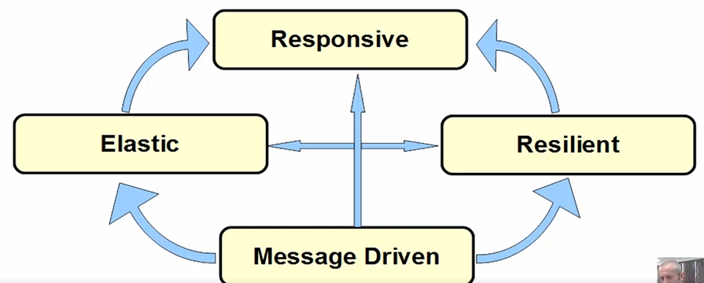

* It is build around **publisher-subscriber pattern** (observer pattern)
* In non-blocking code, the **Back pressure** becomes important to **control the rate of events** so that a   
  fast producer does **not overwhelm** its destination

Една щайга ябълка в устата – ми не. Вземам една ябълка, като я изям подавам сигнал, че искам следваща ябълка. **Backpressure** е количеството информация, която нашия **consumer** желае да получи.

### Traditional MVC is Blocking vs Non-blocking

Първа нишка при традиционния вариант се отблокира навреме/веднага.

Но втора и трета нишка стоят блокирани при традиционния blocking вариант за доста време.



Изпращаме заявка към базата данни, след като нишката изпрати заявката, то спира да служи тук, и прави процесорно нещо друго. След като данните са взети от базата, то тази съща нишка или друга нишка отново се заема със заявката – този път да върне отговора от базата данни.



### Reactive Streams and Reactor

* **Reactive Streams**: is a **specification** that defines how an API that implements and follows the Reactive Programming paradigm should work - <http://www.reactive-streams.org/>
* **Reactor**: is a Java implementation of the **Reactive Streams specification** (Reactor is just the Java implementation)
* **Reactor** projectallows building **high-performance (low latency high throughput) non-blocking asynchronous** applications on JVM
* **Reactor** has powerful API for declaring **data transformations** and **functional composition**
* Make use of the concept of **Mechanical Sympathy** built on top of Disruptor / RingBuffer
* **Spring WebFlux** is the "reaction"/implementation of Spring for this paradigm to use on web applications

### Projects

<https://reactivex.io/>

Rx = Observables + Flow transformations + Schedulers

Go: RxGo , Kotlin: RxKotlin, **Java: RxJava**, JavaScript: RxJS, Python: RxPY, C#: Rx.NET, Scala: RxScala, Clojure: RxClojure, C++: RxCpp, Ruby: Rx.rb, Python: RxPY, Groovy: RxGroovy, JRuby: RxJRuby

Spring WebFlux

Kafka

Netty

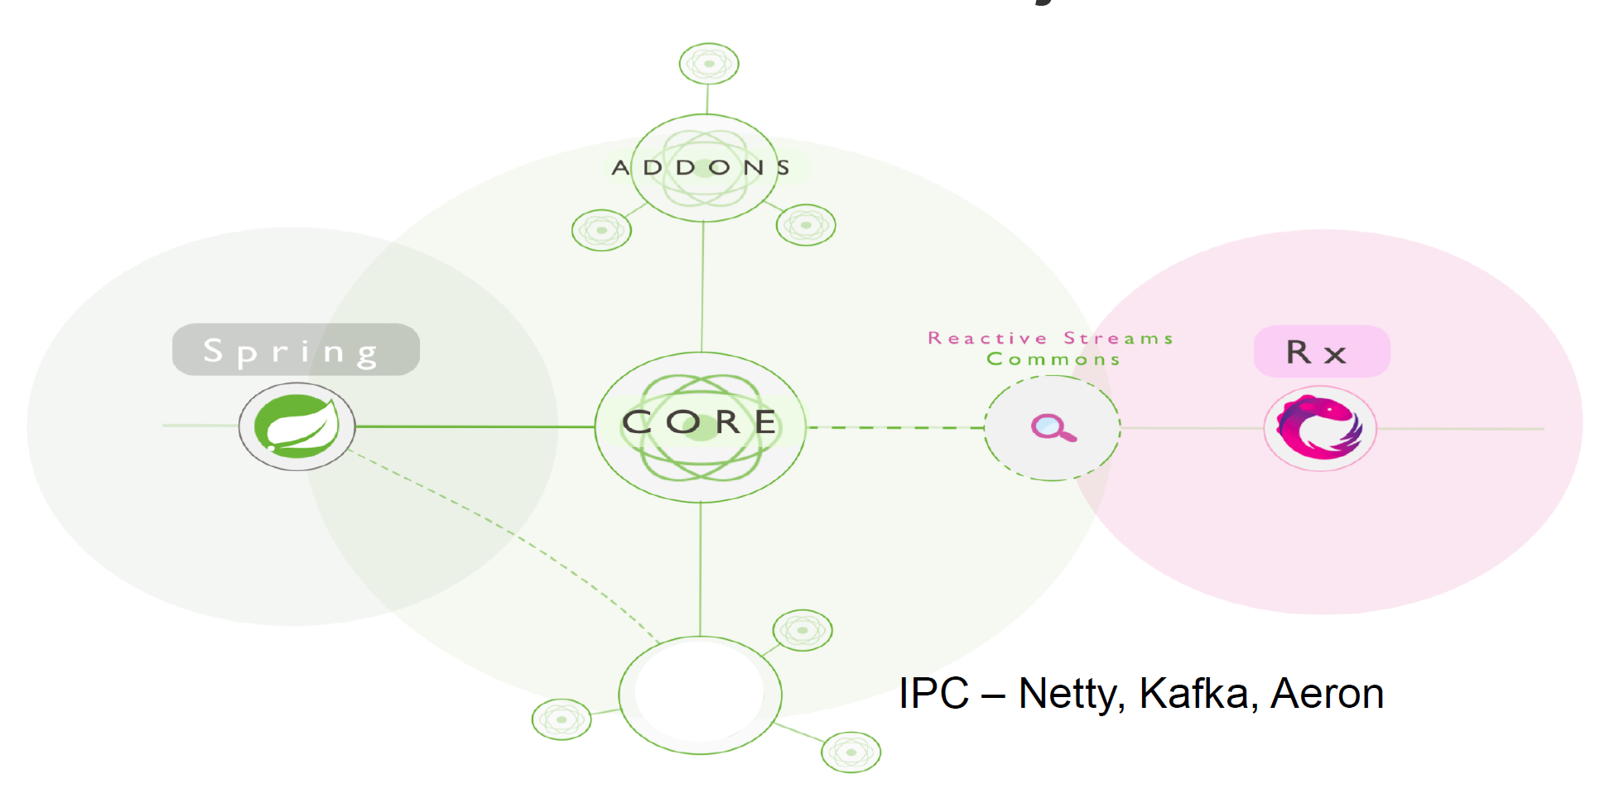

### Hot and Cold Event Streams

**PULL based (Cold Event Streams) Cold streams** - (e.g. RxJava Observable / Flowable or Reactor Flow / Mono) are streams that run their sequence when and if they are subscribed to. They present the sequence from the start to each subscriber.

**PUSH based (Hot Event Streams)** - emit values independent of individual subscriptions. They have their own timeline and events occur whether someone is listening or not. When subscription is made observer receives current events as they happen.

#### Hot Stream Example

EmitterProcessor<String> emitter =EmitterProcessor.*create*();

FluxSink<String> sink = emitter.sink();

emitter.publishOn(Schedulers.*single*())

.map(String::toUpperCase)

.filter(s -> s.startsWith("HELLO"))

.delayElements(Duration.*of*(1000, *MILLIS*))

.subscribe(System.*out*::println);

sink.next("Hello World!"); *// emit -non blocking*

sink.next("Goodbye World!");

sink.next("Hello Trayan!");

Thread.*sleep*(3000);

### Reactive Streams VS Java 8 Streams

* The core difference is that **Reactive is a hot push model**, whereas the **Java 8 Streams** are a **cold pull model**
  + In reactive events are pushed to the subscribers as they come in
* **Java 8 Streams -** pulling all the data and returning a result
* With **Reactive** we could have an **infinite stream** coming in from an external resource, with **multiple subscribers** attached

### Reactive Stream APIs

* As per **Java 9 and reactive specification,** below are APIs we need to use for reactive implementation
  + **Publisher** - Emits a sequence of events to subscribers according to the demand received from its subscribers
  + **Subscriber(Consumer)** - Receives&Processes events emitted by a Publisher
  + **Subscription** - Defines a one-to-one relationship between a Publisher and a Subscriber
  + **Processors** - Represents a processing stage consisting of both a Publisher and a Subscriber (Consumer) and obeys the contracts of both = **a pipe from a Publisher and a Subscriber**

### Spring 5 Reactive Building Blocks

* WebFlux
* Spring Data reactive library
* Reactive IO
* Nonblocking Servlet container
* Spring security reactive API
* [Source - https://docs.spring.io/](https://docs.spring.io/)



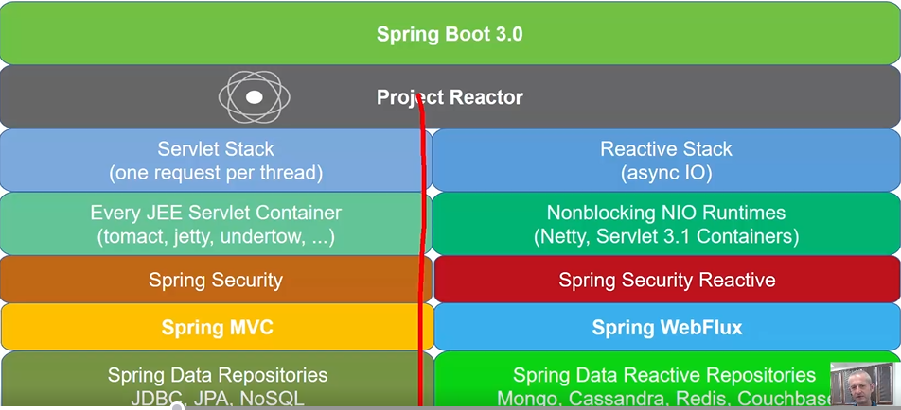

## II. Spring WebFlux

### Spring WebFlux

* Spring WebFlux е **алтернатива** на стандартния Spring MVC (макар че могат да се използват и заедно)
* **Web framework** that brings support for the **reactive** programming model
* Implemented **using** the **Project Reactor,** and its publisher implementations — **Flux** and **Mono**, the library chosen by Spring
* WebFlux is **not a replacement for Spring MVC** they can actually complement each other, working together on the same solution

### Spring WebFlux Dependencies

* Adding Spring WebFlux Dependency in pom.xml
* The Reactive Web dependency includes Spring WebFlux dependency

<**dependency**>  
 <**groupId**>org.springframework.boot</**groupId**>  
 <**artifactId**>spring-boot-starter-webflux</**artifactId**>  
</**dependency**>

### Mono and Flux

**Mono** – може да emit-ва 0 или 1 парче данни

**Flux** – може да emit-ва наведнъж повече от едно парче данни

* In WebFlux, the data returned from any operation is packed into a **reactive stream**
* There are **two types** that embody this approach and are the building blocks in WebFlux:
* **Mono** - is a stream which returns zero items or a single item (0..1)
* **Flux -** is a stream which returns zero or more items (0..n)

### Working with Mono and Flux

* **Mono/Flux.just()**
  + The easiest way to emit an element is using the **just** method

Mono.**just**(1).subscribe(System.out::println);  
Flux.**just**(1,2,3).subscribe(System.out::println);

* Mono/Flux can have more than one **subscribers**

Flux<Integer> **flux** = Flux.just(1,2,3);  
flux.**subscribe**(s->System.out.println(**"Subscr One-"**+ s));  
flux.subscribe(s->System.out.println(**"Subscr Two-"**+ s));

* Example of **two** **subscribers** with delay

Flux<Integer> flux = Flux.just(1, 2, 3);  
flux  
 .map(n -> ++n)  
 .delayElements(Duration.ofMillis(500))  
 .subscribe(System.***out***::println); //2, 3, 4  
  
flux  
 .delayElements(Duration.ofMillis(1000))  
 .subscribe(s -> System.***out***.println(**"Subscriber One-"** + s)); //1, 2, 3

* The **subscribe** method could accept other parameters as well to handle the **error** and **completion** calls

Flux.just(1, 2, 3)  
 .subscribe(  
 i -> System.***out***.println(**"Received :: "** + i),  
 err -> System.***out***.println(**"Error :: "** + err),  
 () -> System.***out***.println(**"Successfully completed"**) //completion – моментът когато няма повече инфо в нашия flux  
 );

## III. Programming Models

### Programming Models

* We can implement it in two ways:
  + **Annotated Controllers** 
    - using Spring MVC annotations with minimum modifications
    - The old applications can also be converted to reactive nature and can use its features and benefits
  + **Functional Endpoints** 
    - functional lambda style of programming

### Annotated Controllers VS Func Endpoints



### Annotated Controllers

* **Similar** to how we use controllers in **classic Spring MVC**
* To mark a class as a controller, we use the **@RestController** annotation on a class level.
* Having Spring WebFlux and the Reactor Core dependencies, in the class path, will let Spring know that the **@RestController** is in fact a reactive component and add support for **Mono** and **Flux**

### Annotated Controllers Example

* Annotated Controller Example

@RestController  
@RequestMapping(**"/students"**)  
**public class** StudentsControllers {  
 *//Inject studentsService in constructor*

@GetMapping(**"/all"**)  
 **public** Flux<Students> findAll(){  
 **return** studentsService.findAll();  
 }

### Functional Endpoints

* Spring WebFlux includes **WebFlux.fn**, a lightweight functional programming model in which functions are used to **route** and **handle** **requests** and contracts are designed for immutability
* An HTTP request is handled with a **HandlerFunction** that takes ServerRequest and returns a delayed ServerResponse - **Mono<ServerResponse>**
* Incoming requests are routed to a handler function with a **RouterFunction** - takes ServerRequest and returns a delayed HandlerFunction - **Mono<HandlerFunction>**

### Functional Endpoints Example – Handler

* Example of Student Handler

**public class** StudentHandler {  
 *//...* **public** Mono<ServerResponse> getStudent(ServerRequest request) {  
 **int** studentId = Integer.valueOf(request.pathVariable(**"id"**));  
 **return** repository.getStudent(studentId)  
 .flatMap(**student -> ok().contentType(APPLICATION_JSON).bodyValue(student))**  
 .switchIfEmpty(ServerResponse.notFound().build());  
 } *//... }*

### Functional Endpoints Example – Router

* Example of Router Function

*//... Inject PersonHandler handler in constructor*

RouterFunction<ServerResponse> router = router()  
 .GET(**"/student/{id}"**, accept(APPLICATION_JSON), handler::getStudent)  
 .GET(**"/student "**, accept(APPLICATION_JSON), handler::listStudents)  
 .POST(**"/student "**, handler::createStudent)  
 .build();

### Spring WebFlux Configuration – за по-стари Spring версии

* The **@Configuration** and **@EnableWebFlux** annotations mark a class as a configuration class and Spring's bean management will register it
* To use or extend the existing WebFlux configuration API, you can implement **WebFluxConfigurer**

@Configuration  
@EnableWebFlux  
**public class** Configuration **implements** WebFluxConfigurer {...}

## IV. Demos

### Demo – the 4 interfaces of reactive streams

**import** java.util.LinkedList;  
**import** java.util.List;  
**import** java.util.concurrent.Flow.Subscription;  
**import** java.util.concurrent.Flow.Subscriber;  
  
*//I.e. this is the consumer***public class** SimpleSubscriber<T> **implements** Subscriber<T> {  
 **private** List<T> **consumedElements** = **new** LinkedList<>();  
 **private** Subscription **subscription**;  
  
 @Override  
 **public void** onSubscribe(Subscription subscription) {  
 **this**.**subscription** = subscription;  
 subscription.request(1);  
 }  
  
 @Override  
 **public void** onNext(T item) {  
 **consumedElements**.add(item);  
  
 *//Applying backpressure - искам вече следващото* **subscription**.request(1);  
 }  
  
 @Override  
 **public void** onError(Throwable throwable) {  
 throwable.printStackTrace();  
 }  
  
 @Override  
 **public void** onComplete() {  
 System.***out***.println(**"I'm complete!!!"**);  
 **consumedElements**.forEach(System.***out***::println);  
 System.***out***.println(**"--------------"**);  
 }  
  
 **public int** getConsumedElementsCount(){  
 **return consumedElements**.size();  
 }  
  
 **public** List<T> getConsumedElements() {  
 **return consumedElements**;  
 }  
}

------------------------------------------

**import** java.util.concurrent.Flow.Processor;  
**import** java.util.concurrent.Flow.Subscriber;  
**import** java.util.concurrent.Flow.Subscription;  
**import** java.util.concurrent.SubmissionPublisher;  
**import** java.util.function.Function;  
  
**public class** TransformationProcessor<T, R> **implements** Processor<T, R> {  
 **private final** Function<T, R> **transformation**;  
 **private final** SubmissionPublisher<R> **submissionPublisher**;  
 **private** Subscription **subscription**;  
  
 *//нещо като pipe - ще получаваме от нашия publisher едни елементи, и ще ги превръщаме в други елементи* **public** TransformationProcessor(Function<T, R> transformation) {  
 **this**.**transformation** = transformation;  
 **this**.**submissionPublisher** = **new** SubmissionPublisher<R>();  
 }  
  
 *//publisher* @Override  
 **public void** subscribe(Subscriber<? **super** R> subscriber) {  
 **submissionPublisher**.subscribe(subscriber);  
 }  
  
 *//publisher* @Override  
 **public void** onSubscribe(Subscription subscription) {  
 **this**.**subscription** = subscription;  
 subscription.request(1); *//the backpressure* }  
  
 *//Subscriber/producer* @Override  
 **public void** onNext(T item) {  
 R transformed = **transformation**.apply(item);  
 **submissionPublisher**.submit(transformed); *//събмитваме надолу по веригата* **this**.**subscription**.request(1); *//the backpressure* }  
  
 *//Subscriber/producer* @Override  
 **public void** onError(Throwable throwable) {  
 throwable.printStackTrace();  
 }  
  
 *//Subscriber/producer* @Override  
 **public void** onComplete() {  
 System.***out***.println(**"Transformation is complete, closing down."**);  
 }  
}

-------------------------------------------

**import** java.util.List;  
**import** java.util.concurrent.SubmissionPublisher;  
**import** java.util.concurrent.TimeUnit;  
**import** java.util.function.Function;  
  
**import static** org.awaitility.Awaitility.*await*;  
**import static** org.junit.jupiter.api.Assertions.*;  
  
**class** ReactiveTests {  
  
 @Test  
 **void** testAllItemsConsumed() {  
 *//The producer!!!* SubmissionPublisher<String> publisher = **new** SubmissionPublisher<>();  
  
 SimpleSubscriber<String> mySubscriber = **new** SimpleSubscriber<>();  
  
 *//set new consumer for producer publisher* publisher.subscribe(mySubscriber);  
  
 *assertEquals*(1, publisher.getNumberOfSubscribers()); *//Returns the number of current subscribers.* List<String> names = List.*of*(**"Anna"**, **"John"**, **"Pesho"**);  
 names.forEach(item -> publisher.submit(item)); *//sbmit = publishes the given items to each current subscriber* publisher.close();  
  
 *//Make it synchronous with the awaitility library  
 await*()  
 .atMost(1, TimeUnit.***SECONDS***)  
 .until(  
 () -> mySubscriber.getConsumedElementsCount() == names.size()  
 );  
  
 *assertEquals*(3, mySubscriber.getConsumedElementsCount());  
 }  
  
 @Test  
 **public void** testTransformation() {  
 *//arrange = given part* Function<String, String> transfFunc = String::toUpperCase;  
 TransformationProcessor<String, String> transformationPipe = **new** TransformationProcessor<>(transfFunc);  
  
 SubmissionPublisher<String> startPublisher = **new** SubmissionPublisher<>();  
 SimpleSubscriber<String> finishSubscriber = **new** SimpleSubscriber<>();  
  
 List<String> items = List.*of*(**"SenKo"**, **"Pesho"**, **"lilly"**); *//от едната страна на pipe-а* List<String> expectedItems = List.*of*(**"SENKO"**, **"PESHO"**, **"LILLY"**); *//какво излизза от другата страна на pipe-а  
  
  
 //act = when* startPublisher.subscribe(transformationPipe); *//началната точка на pipe-a* transformationPipe.subscribe(finishSubscriber); *//крайната точка на Pipe-a* items.forEach(item -> startPublisher.submit(item));  
 startPublisher.close();  
  
 *//Make it synchronous with the awaitility library  
 await*()  
 .atMost(1, TimeUnit.***SECONDS***)  
 .until(  
 () -> expectedItems.equals(finishSubscriber.getConsumedElements())  
 );  
  
 *//assert  
 assertEquals*(expectedItems, finishSubscriber.getConsumedElements());  
 }  
}

### Demo – Mono and Flux

Spring Reactive Web

dependencies {  
 implementation **'org.springframework.boot:spring-boot-starter-webflux'** testImplementation **'org.springframework.boot:spring-boot-starter-test'** testImplementation **'io.projectreactor:reactor-test'**}

**import** reactor.core.publisher.Flux;  
**import** reactor.core.publisher.Mono;  
  
**import** java.util.List;  
**import** java.util.Optional;  
**import** java.util.Random;  
  
**public class** FluxMonoExplained {  
 **private** User **user1** = **new** User().setFirstName(**"A"**).setLastName(**"B"**);  
 **private** User **user2** = **new** User().setFirstName(**"A1"**).setLastName(**"B1"**);  
  
 **public** User getUser() {  
 **if** (isAuthenticated()) {  
 **return user1**;  
 } **else** {  
 **return null**;  
 }  
 }  
  
 **public** Mono<User> getUserReactive() {  
 **if** (isAuthenticated()) {  
 **return** Mono.*just*(**user1**);  
 } **else** {  
 **return** Mono.*empty*();  
 }  
 }  
  
 **public** Optional<User> getUserOpt() {  
 **if** (isAuthenticated()) {  
 **return** Optional.*of*(**user1**);  
 } **else** {  
 **return** Optional.*empty*();  
 }  
 }  
  
 **public** List<User> getAllUsers() {  
 **return** List.*of*(**user1**, **user2**);  
 }  
  
 **public** Flux<User> getAllUsersReactive() {  
 **return** Flux.*just*(**user1**, **user2**);  
 }  
  
  
 **private boolean** isAuthenticated() {  
 **return new** Random().nextBoolean();  
 }  
  
}  
  
**class** User {  
 **private** String **firstName**, **lastName**;  
  
 **public** String getFirstName() {  
 **return firstName**;  
 }  
  
 **public** User setFirstName(String firstName) {  
 **this**.**firstName** = firstName;  
 **return this**;  
 }  
  
 **public** String getLastName() {  
 **return lastName**;  
 }  
  
 **public** User setLastName(String lastName) {  
 **this**.**lastName** = lastName;  
 **return this**;  
 }  
}

------------------------

**import** org.junit.jupiter.api.Test;  
**import** reactor.core.publisher.Flux;  
**import** reactor.core.publisher.Mono;  
  
**import** java.util.function.Consumer;  
**import** java.util.stream.Collectors;  
  
**class** WebfluxGeneralTest {  
 @Test  
 **public void** fluxToStream() {  
 Flux<String> springProjectsFlux = Flux.*just*(getSpringProjects());  
  
 springProjectsFlux  
 .toStream()  
 .map(String::toUpperCase)  
 .forEach(System.***out***::println);  
 }  
  
 @Test  
 **public void** subscribeToFlux() {  
 Flux<String> springProjectsFlux = Flux.*just*(getSpringProjects());  
  
 springProjectsFlux.subscribe(  
 System.***out***::println  
 );  
 }  
  
 @Test  
 **public void** doOnEach() {  
 Flux<String> springProjectsFlux = Flux.*just*(getSpringProjects());  
  
 springProjectsFlux.doOnEach(  
 signalConsumer -> {  
 **if** (signalConsumer.isOnNext()) {  
 System.***out***.println(signalConsumer.get());  
 }  
 }  
 )  
 .subscribe();  
 }  
  
 @Test  
 **public void** mapAndFilter() {  
 Flux<String> springProjectsFlux = Flux.*just*(getSpringProjects());  
  
 springProjectsFlux  
 .map(String::toUpperCase)  
 .filter(s -> s.contains(**"REST"**))  
 .subscribe(System.***out***::println);  
 }  
  
 @Test  
 **public void** collect() {  
 Flux<String> springProjectsFlux = Flux.*just*(getSpringProjects());  
  
 springProjectsFlux  
 .map(String::length)  
 .collect(Collectors.*summarizingInt*(Integer::intValue))*//статистика от дължината на всички заглавия* .subscribe(System.***out***::println);  
  
*// IntSummaryStatistics{count=7, sum=85, min=10, average=12.142857, max=16}* }  
  
 @Test  
 **public void** subscribe() {  
 Flux<String> springProjectsFlux = Flux.*just*(getSpringProjects());  
  
 Consumer<String> onNextConsumer = System.***out***::println;  
 Consumer<Throwable> onErrorConsumer = Throwable::printStackTrace;  
 Runnable onDone = () -> System.***out***.println(**"We are done!"**);  
  
 springProjectsFlux.subscribe(  
 onNextConsumer,  
 onErrorConsumer,  
 onDone  
 );  
 }  
  
 @Test  
 **public void** testOnError() {  
 Flux<Integer> numbers = Flux.*just*(**"1"**, **"two"**, **"3"**)  
 .map(Integer::*parseInt*);  
  
 Consumer<Integer> onNextConsumer = System.***out***::println;  
 Consumer<Throwable> onErrorConsumer = Throwable::printStackTrace;  
 Runnable onDone = () -> System.***out***.println(**"We are done!"**);  
  
 numbers.subscribe(  
 onNextConsumer,  
 onErrorConsumer, *//throws error this time* onDone  
 );  
 }  
  
 @Test  
 **public void** mono(){  
 Mono.*just*(**"TEST"**).map(String::toUpperCase).subscribe(System.***out***::println);  
 }  
  
 **private** String[] getSpringProjects() {  
 **return new** String[]{  
 **"Spring REST"**,  
 **"Spring DATA REST"**,  
 **"Spring Batch"**, *//Java Batching* **"Spring MVC"**,  
 **"Spring Webflux"**,  
 **"Spring JMS"**, *//Java Messaging Service* **"Spring Kafka"**};  
 }  
}

-------------

**import** org.junit.jupiter.api.Test;  
**import** reactor.core.publisher.Flux;  
**import** reactor.core.scheduler.Schedulers;  
  
**public class** AsyncFlux {  
  
 *//синхронно* @Test  
 **public void** syncFlux() {  
 MyInteger sum = **new** MyInteger(0);  
  
 Flux.*just*(1, 2, 3, 4)  
 .reduce(MyInteger::*sum*)  
 .subscribe(sum::set);  
  
 System.***out***.println(sum);  
  
*// Output  
// Summing 1 and 2  
// Summing 3 and 3  
// Summing 6 and 4  
// MyInteger{initialValue=10}* }  
  
  
 *//асинхронно* @Test  
 **public void аsyncFlux**() {  
 MyInteger sum = **new** MyInteger(0);  
  
 Flux.*just*(1, 2, 3, 4)  
 .subscribeOn(Schedulers.*boundedElastic*())  
 .reduce(MyInteger::*sum*)  
 .subscribe(sum::set);  
  
 System.***out***.println(sum);  
  
 *//Output  
// MyInteger{initialValue=0}  
// Summing 1 and 2  
// Summing 3 and 3  
// Summing 6 and 4* }  
  
}  
  
  
**class** MyInteger {  
 **private** Integer **initialValue**;  
  
 **public** MyInteger(Integer initialValue) {  
 **this**.**initialValue** = initialValue;  
 }  
  
 **public static int** sum(**int** a, **int** b) {  
 System.***out***.println(**"Summing "** + a + **" and "** + b);  
 **return** a + b;  
 }  
  
 **public void** set(Integer aNumber) {  
 **this**.**initialValue** = aNumber;  
 }  
  
 @Override  
 **public** String toString() {  
 **return "MyInteger{"** +  
 **"initialValue="** + **initialValue** +  
 **'}'**;  
 }  
}

### Demo service-client

**You can see also README.md file in the repo – for more clarification.**

#### webflux service

build.gradle

dependencies **{** implementation 'org.springframework.boot:spring-boot-starter-webflux'

**}**

application.properties

server.port=9001

See in my repo in GitHub

2024-09-10 19:14:28.778 INFO 27668 --- [ main] o.s.b.web.embedded.netty.NettyWebServer : Netty started on port 9001

**public class** ExchangeRate {  
 **private** String **fromCurrency**;  
 **private** String **toCurrency**;  
 **private** Instant **time**;  
 **private** BigDecimal **rate**;  
  
 **public** ExchangeRate(String fromCurrency, String toCurrency, Instant time, BigDecimal rate) {  
 **this**.**fromCurrency** = fromCurrency;  
 **this**.**toCurrency** = toCurrency;  
 **this**.**time** = time;  
 **this**.**rate** = rate;  
 }

}

------------------------------

@Service  
**public class** ExchangeRateService {  
  
 **private** List<ExchangeRate> **exchangeRates** = **new** ArrayList<>();  
  
 **public** ExchangeRateService() {  
 **exchangeRates**.add(**new** ExchangeRate(**"EUR"**, **"BGN"**, Instant.*now*(), BigDecimal.*valueOf*(1.96)));  
 **exchangeRates**.add(**new** ExchangeRate(**"USD"**, **"BGN"**, Instant.*now*(), BigDecimal.*valueOf*(1.74)));  
 **exchangeRates**.add(**new** ExchangeRate(**"GBN"**, **"BGN"**, Instant.*now*(), BigDecimal.*valueOf*(2.16)));  
 **exchangeRates**.add(**new** ExchangeRate(**"RSD"**, **"BGN"**, Instant.*now*(), BigDecimal.*valueOf*(0.017)));  
 }  
  
 **public** Flux<ExchangeRate> getExchangeRateStream(**int** durationInterval) {  
 Flux<ExchangeRate> ret = Flux.*generate*(() -> 0,  
 (index, sink) -> {  
 ExchangeRate updateRate = randomize(**exchangeRates**.get(index));  
 sink.next(updateRate);  
 System.***out***.println(**"Generated a new exchange rate..."**);  
  
 **return** (++index) % **exchangeRates**.size();  
 });  
  
 **if** (durationInterval > 0) {  
 **return** ret.delayElements(Duration.*ofSeconds*(durationInterval));  
 } **else** {  
 **return** ret;  
 }  
 }

-----------------

@Component  
**public class** ExchangeRateHandler {  
 **private final** ExchangeRateService **exchangeRateService**;  
  
 **public** ExchangeRateHandler(ExchangeRateService exchangeRateService) {  
 **this**.**exchangeRateService** = exchangeRateService;  
 }  
  
 **public** Mono<ServerResponse> getExchangeRates(ServerRequest request) {  
 **int** size = Integer.*parseInt*(request.queryParam(**"size"**).orElse(**"10"**));  
  
 *//Вземане на моно от отложен server response* **return** *ok*()  
 .contentType(MediaType.***APPLICATION_JSON***)  
 .body(**this**.**exchangeRateService**.getExchangeRateStream(0).take(size),  
 ExchangeRate.**class**);  
 }  
  
 **public** Mono<ServerResponse> streamExchangeRates(ServerRequest request) {  
 **int** size = Integer.*parseInt*(request.queryParam(**"size"**).orElse(**"10"**));  
  
 *//Вземане на моно от отложен server response* **return** *ok*()  
 .contentType(MediaType.***APPLICATION_STREAM_JSON***)  
 .body(**this**.**exchangeRateService**.getExchangeRateStream(1).take(size),  
 ExchangeRate.**class**);  
 }  
}

----------------------

*.*@Configuration  
**public class** ExchangeRateRouter {  
  
 @Bean  
 **public** RouterFunction<ServerResponse> route(ExchangeRateHandler exchangeRateHandler) {  
 **return** RouterFunctions  
 .*route*(*GET*(**"/rates"**).and(*accept*(MediaType.***APPLICATION_JSON***)), exchangeRateHandler::getExchangeRates)  
 .andRoute(*GET*(**"/rates"**).and(*accept*(MediaType.***APPLICATION_STREAM_JSON***)), sr -> exchangeRateHandler.streamExchangeRates(sr));  
 }  
}

#### webflux client with Reactive MongoDb driver

dependencies **{** implementation 'org.springframework.boot:spring-boot-starter-data-mongodb-reactive'  
 implementation 'org.springframework.boot:spring-boot-starter-webflux'  
 annotationProcessor 'org.springframework.boot:spring-boot-configuration-processor'



---------------------

docker-compose.yaml

**version**: 3.1  
**services**:  
 **mongo**:  
 **image**: mongo  
 **restart**: always  
 **ports**:  
 - 27017:27017

в терминала командата docker-compose up

------------------

Документация

<https://docs.spring.io/spring-framework/reference/web/webflux.html>

----------------------

Mongo graphic user interface GUI

**Robo 3T is now Studio 3T Free**



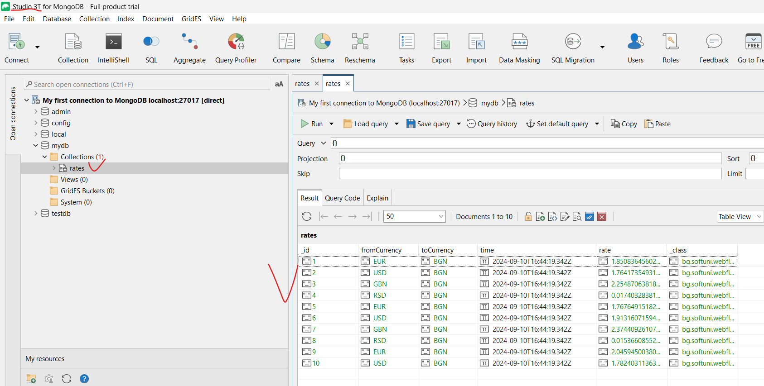

---------------------------

**import** org.springframework.boot.context.properties.ConfigurationProperties;  
**import** org.springframework.boot.context.properties.EnableConfigurationProperties;  
**import** org.springframework.context.annotation.Configuration;  
  
@Configuration  
@EnableConfigurationProperties  
@ConfigurationProperties(**"softuni.webflux.client"**)  
**public class** ClientConfig {  
 **private** String **schema**;  
 **private** String **host**;  
 **private** String **port**;

}

-----------------

application.yml

**softuni:  
 webflux:  
 client:**  
 schema: http  
 host: localhost  
 port: 9001  
  
spring:  
 data:  
 mongodb:  
*# uri: mongodb://localhost:27017/mydb* database: mydb  
 host: localhost  
 port: 27017  
  
*# if application.properties  
# uri=mongodb://localhost:27017/mydb*

---------------------------

**import** org.springframework.data.annotation.Id;  
**import** org.springframework.data.mongodb.core.mapping.Document;  
  
**import** java.math.BigDecimal;  
**import** java.time.Instant;  
  
@Document *//като @Entity анотацията за релационните база данни, но за MongoDB***public class** ExchangeRate {  
 @Id  
 **private** String **id**;  
  
 **private** String **fromCurrency**;  
 **private** String **toCurrency**;  
 **private** Instant **time**;  
 **private** BigDecimal **rate**;

}

---------------------

import bg.softuni.webfluxclient.config.ReactiveClientConfig;  
import bg.softuni.webfluxclient.model.ExchangeRate;  
import org.springframework.http.MediaType;  
import org.springframework.stereotype.Component;  
import org.springframework.web.**reactive**.function.client**.WebClient**;  
import reactor.core.publisher.Flux;  
  
@Component  
public class ExchangeRateReactiveClient {  
 private final String SERVICE_URL;  
 private final String API_PATH = "/rates";  
  
 public ExchangeRateReactiveClient(ReactiveClientConfig reactiveClientConfig) {  
 SERVICE_URL = reactiveClientConfig.getSchema() + "://" + reactiveClientConfig.getHost() + ":" + reactiveClientConfig.getPort();  
 }  
  
 public Flux<ExchangeRate> getRateStream(){  
 return WebClient.*builder*()  
 .baseUrl(SERVICE_URL)  
 .build()  
 .get()  
 .uri(API_PATH)  
 .accept(MediaType.*APPLICATION_STREAM_JSON*)  
 .retrieve()  
 .bodyToFlux(ExchangeRate.class);  
 }  
}

----------------

@Repository  
**public interface** ExchangeRateRepository **extends ReactiveMongoRepository**<ExchangeRate, String> {  
  
}

-----------------------------

import bg.softuni.webfluxclient.model.ExchangeRate;  
import bg.softuni.webfluxclient.reactiveclient.ExchangeRateReactiveClient;  
import bg.softuni.webfluxclient.repository.ExchangeRateRepository;  
import org.springframework.context.ApplicationListener;  
import org.springframework.context.event.ContextRefreshedEvent;  
import org.springframework.stereotype.Service;  
import reactor.core.publisher.Mono;  
  
import java.util.concurrent.atomic.AtomicInteger;  
  
@Service  
public class ExchangeRateInit implements ApplicationListener<ContextRefreshedEvent> {  
  
 private final ExchangeRateReactiveClient reactiveClient;  
 private final ExchangeRateRepository repository;  
  
 public ExchangeRateInit(ExchangeRateReactiveClient reactiveClient, ExchangeRateRepository repository) {  
 this.reactiveClient = reactiveClient;  
 this.repository = repository;  
 }  
  
 @Override  
 public void onApplicationEvent(ContextRefreshedEvent event) {  
 AtomicInteger idNum = new AtomicInteger(1);  
 reactiveClient.getRateStream()  
 .subscribe(exchangeRate -> {  
 Mono<ExchangeRate> exchangeRateMono = repository.save(exchangeRate.setId(String.*valueOf*(idNum.getAndIncrement())));  
 exchangeRateMono.subscribe(er -> System.*out*.println("Saved " + er));  
 });  
 }  
}

#### RestController and Service approach of webflux client

import bg.softuni.webfluxclient.model.ExchangeRate;  
import bg.softuni.webfluxclient.service.RatesService;  
import org.springframework.web.bind.annotation.DeleteMapping;  
import org.springframework.web.bind.annotation.GetMapping;  
import org.springframework.web.bind.annotation.PatchMapping;  
import org.springframework.web.bind.annotation.PathVariable;  
import org.springframework.web.bind.annotation.PostMapping;  
import org.springframework.web.bind.annotation.RequestBody;  
import org.springframework.web.bind.annotation.RequestMapping;  
import org.springframework.web.bind.annotation.RestController;  
import reactor.core.publisher.Flux;  
import reactor.core.publisher.Mono;  
  
*//with controller*@RestController  
@RequestMapping("/ratescontroller")  
public class RatesController {  
  
 private final RatesService ratesService;  
  
 public RatesController(RatesService ratesService) {  
 this.ratesService = ratesService;  
 }  
  
 *//when more than 1 element, we return flux* @GetMapping  
 public Flux<ExchangeRate> getRates() {  
 return ratesService.listRatesFromService();  
 }  
  
 *//returning 1 element* @GetMapping("/{id}")  
 public Mono<ExchangeRate> getRateById(@PathVariable String id) {  
 return ratesService.getRateByIdFromService(id);  
 }  
  
 *//returning 1 element - the created one* @PostMapping  
 public Mono<ExchangeRate> createRate(@RequestBody ExchangeRate exchangeRate) {  
 return ratesService.createRateFromService(exchangeRate);  
 }  
  
 *//returning 1 element - the updated one* @PatchMapping("{id}")  
 public Mono<ExchangeRate> updateRate(@PathVariable String id, @RequestBody ExchangeRate exchangeRate) {  
 return ratesService.updateRateFromService(id, exchangeRate);  
 }  
  
 *//when no element to return, we use void* @DeleteMapping("{id}")  
 public Mono<Void> updateRate(@PathVariable String id) {  
 return ratesService.deleteRateFromService(id);  
 }  
}

----------------------

import bg.softuni.webfluxclient.model.ExchangeRate;  
import bg.softuni.webfluxclient.repository.ExchangeRateRepository;  
import org.springframework.stereotype.Service;  
import reactor.core.publisher.Flux;  
import reactor.core.publisher.Mono;  
  
@Service  
public class RatesService {  
 private final ExchangeRateRepository rateReactiveRepository;  
  
 public RatesService(ExchangeRateRepository rateReactiveRepository) {  
 this.rateReactiveRepository = rateReactiveRepository;  
 }  
  
 public Flux<ExchangeRate> listRatesFromService() {  
 return rateReactiveRepository.findAll();  
 }  
  
 public Mono<ExchangeRate> getRateByIdFromService(String id) {  
 return rateReactiveRepository.findById(id);  
 }  
  
 public Mono<ExchangeRate> createRateFromService(ExchangeRate exchangeRate) {  
 return rateReactiveRepository.save(exchangeRate);  
 }  
  
 public Mono<ExchangeRate> updateRateFromService(String id, ExchangeRate exchangeRate) {  
 return rateReactiveRepository.findById(id)  
 .map(r -> {  
 r.setRate(exchangeRate.getRate());  
 r.setFromCurrency(exchangeRate.getFromCurrency());  
 r.setToCurrency(exchangeRate.getToCurrency());  
 r.setTime(exchangeRate.getTime());  
  
 return r;  
 })  
 .flatMap(rateReactiveRepository::save);  
 }  
  
 public Mono<Void> deleteRateFromService(String id) {  
 return rateReactiveRepository.deleteById(id);  
 }  
}

#### Router and Handler approach of webflux client

import bg.softuni.webfluxclient.handler.RatesHandler;  
import org.springframework.context.annotation.Bean;  
import org.springframework.context.annotation.Configuration;  
import org.springframework.web.reactive.function.server.RouterFunction;  
import org.springframework.web.reactive.function.server.ServerResponse;  
  
import static org.springframework.http.MediaType.*APPLICATION_JSON*;  
import static org.springframework.http.MediaType.*APPLICATION_STREAM_JSON*;  
import static org.springframework.web.reactive.function.server.RequestPredicates.*accept*;  
import static org.springframework.web.reactive.function.server.RouterFunctions.*route*;  
  
*//with router*@Configuration  
public class RatesRouter {  
  
 @Bean  
 public RouterFunction<ServerResponse> router(RatesHandler ratesHandler) {  
 return *route*()  
.GET("ratesrouter", *accept*(*APPLICATION_STREAM_JSON*), request -> ratesHandler.listRatesFromHandler())  
*//.GET("ratesrouter/{id}", accept(APPLICATION_JSON), request -> ratesHandler.getRateByIdFromHandler(request))*.GET("ratesrouter/{id}", *accept*(*APPLICATION_JSON*), ratesHandler::getRateByIdFromHandler)  
.POST("ratesrouter", *accept*(*APPLICATION_JSON*), ratesHandler::createRateFromHandler)  
.PATCH("ratesrouter/{id}", *accept*(*APPLICATION_JSON*), request -> ratesHandler.updateRateFromHandler(request))  
.DELETE("ratesrouter/{id}", serverRequest -> ratesHandler.deleteRateFromHandler(serverRequest))  
 .build();  
 }  
}

---------------

import bg.softuni.webfluxclient.model.ExchangeRate;  
import bg.softuni.webfluxclient.repository.ExchangeRateRepository;  
import org.springframework.http.MediaType;  
import org.springframework.stereotype.Component;  
import org.springframework.web.reactive.function.server.ServerRequest;  
import org.springframework.web.reactive.function.server.ServerResponse;  
import reactor.core.publisher.Mono;  
  
import java.net.URI;  
  
import static org.springframework.http.MediaType.*APPLICATION_JSON*;  
import static org.springframework.web.reactive.function.server.ServerResponse.*ok*;  
  
@Component  
public class RatesHandler {  
 private final ExchangeRateRepository rateReactiveRepository;  
  
 public RatesHandler(ExchangeRateRepository rateReactiveRepository) {  
 this.rateReactiveRepository = rateReactiveRepository;  
 }  
  
 public Mono<ServerResponse> listRatesFromHandler() {  
 return *ok*().body(rateReactiveRepository.findAll(), ExchangeRate.class);  
 }  
  
 public Mono<ServerResponse> getRateByIdFromHandler(ServerRequest request) {  
 String rateId = request.pathVariable("id");  
 return rateReactiveRepository.findById(rateId)  
 .flatMap(rate -> *ok*().contentType(*APPLICATION_JSON*).bodyValue(rate))  
 .switchIfEmpty(ServerResponse.*notFound*().build());  
 }  
  
 public Mono<ServerResponse> createRateFromHandler(ServerRequest serverRequest) {  
 return serverRequest.bodyToMono(ExchangeRate.class)  
 .flatMap(user -> rateReactiveRepository.save(user))  
 .flatMap(savedRate -> ServerResponse  
 .*created*(URI.*create*("/ratesrouter/" + savedRate.getId()))  
 .contentType(MediaType.*APPLICATION_JSON*)  
 .bodyValue(savedRate))  
 .onErrorResume(e -> ServerResponse.*badRequest*().build());  
 }  
  
 public Mono<ServerResponse> updateRateFromHandler(ServerRequest request) {  
 String rateId = request.pathVariable("id");  
 Mono<ExchangeRate> rateToUpdate = request.bodyToMono(ExchangeRate.class);  
  
 return rateToUpdate  
 .flatMap(exchangeRate -> rateReactiveRepository.findById(rateId)  
 .flatMap(r -> {  
 r.setRate(exchangeRate.getRate());  
 r.setFromCurrency(exchangeRate.getFromCurrency());  
 r.setToCurrency(exchangeRate.getToCurrency());  
 r.setTime(exchangeRate.getTime());  
  
 return rateReactiveRepository.save(r);  
 }))  
 .flatMap(updatedRate -> ServerResponse.*ok*().bodyValue(updatedRate))  
 .switchIfEmpty(ServerResponse.*notFound*().build());  
 }  
  
 public Mono<ServerResponse> deleteRateFromHandler(ServerRequest request) {  
 String rateId = request.pathVariable("id");  
  
 return rateReactiveRepository.findById(rateId)  
 .flatMap(existingRate -> rateReactiveRepository.delete(existingRate)  
 .then(ServerResponse.*ok*().build()))  
 .switchIfEmpty(ServerResponse.*notFound*().build());  
 }  
}

# 6. Threads comparison

1. Computations -> Platform threads
2. Super Real Time - > Webflux 100%, VirtualThreads 90-95%, CompletableFuture, Future, etc
3. InputOutput -> VirtualThreads (**project Loom and JDK 21**)

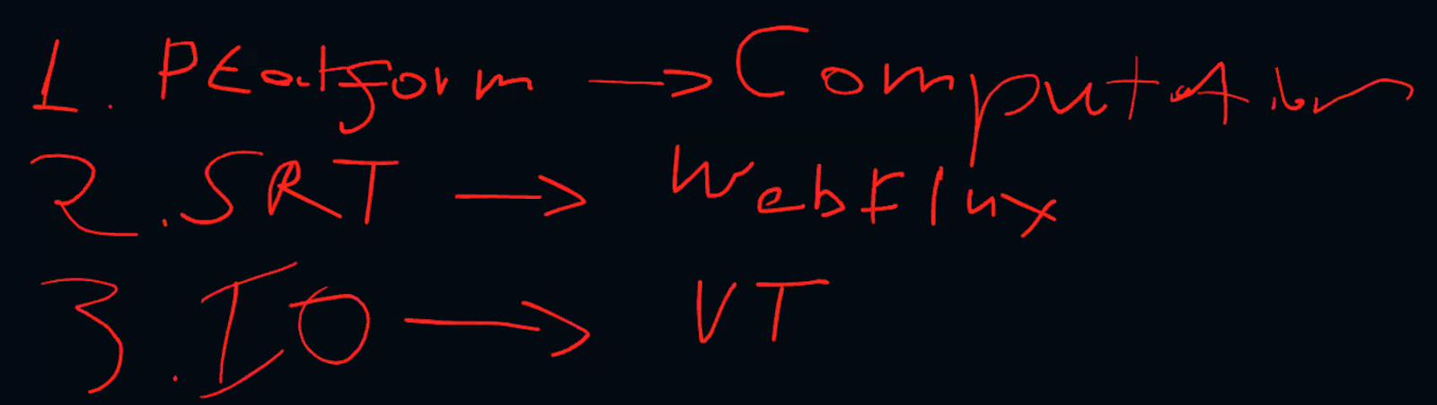

Spring Webflux is substituting Spring MVC. You’d better use only one of them in a microservice!

# 7. Messaging systems

## Intro

* Messaging provides a mechanism for loosely-coupled integration of systems
* The central unit of processing in a message is a message which typically contains a **body** and a **header**
* Use cases include:
  + Log aggregation between systems
  + Event propagation between systems - някакви събития се fire-ват
  + Offloading log-running tasks to worker nodes - the result of the task then to be sent to a third systems for example
* Messaging solutions implement different protocols for transferring of messages such as **AMQP** (binary protocol), XMPP, MQTT and many more like XML, JSON, etc.
* The variety of protocols implies vendor lock-in when using a particular messaging solution (also called a messaging broker) - ако е специфичен протокола лошо. Т.е. протокола е добре да е такъв, че да може да се използва от различни message broker systems

* Message brokers
  + ActiveMQ - using JMS (Java Messaging System) Java EE
  + RabbitMQ
  + Qpid
  + TIBCO
  + WebSphere MQ
  + Msmq

* Messaging solutions provide means for:
  + Securing message transfer, authenticating and authorizing messaging endpoints
  + Routing messages between endpoints
  + Subscribing to the broker

* An **enterprise service bus (ESB)** is one layer of abstraction above a messaging solution that further provides:
  + Adapters for different messaging protocols
  + Translation of messages between the different types of protocols

## I. RabbitMQ

### Info

* An open source message broker written in Erlang
  + Заема малко ранм памет и процесор
  + при Erlang няма context switching като при JVM
  + reliability - дете ако не се изпълни, то родителят му го пуска за изпълнение наново
* **Implements the AMQP protocol** (Advanced Message Queueing Protocol)
* Has a pluggable architecture and provides extension for other protocols such as HTTP, STOMP and MQTT

* AMQP is a binary protocol that aims to standardize middleware communication
* The AMQP protocol derives its origins form the financial industry - processing of large volumes of financial data between different systems is a classic use case of messaging
* The AMQP protocol defines:
  + **Exchanges** - the message broker endpoints that receive messages
  + **Queues** - the message broker endpoints that store messages from exchanges and are used by subscribers for retrieval of messages. The Queue can also be persistent - messages can be saved.
  + **Bindings** - rules that bind exchanges and queues
* The AMQP protocol is programmable - which means that the above entities can be created/ modified/ deleted by applications

* The AMQP protocol defines multiple connection channels inside a single TCP connection in order to remove the overhead of opening a large number of TCP connections to the message broker

* Each message can be published with a **routing key**
* Each binding between an exchange and a queue has a **binding key**
* Routing of messages is determined based on matching between the **routing key** and the **binding key**

### Messaging patterns with RabbitMQ

* Different types of messaging patterns are implemented by means of different types of exchanges
* RabbitMQ provides the following types of exchanges:
  + default - без име като търси съвпадение на **routing key** с **binding key**
  + direct - има име като търси съвпадение на **routing key** с **binding key**
  + fanout
  + topic
  + headers- на база мачинг по хедъри също

#### Default exchange

* А default exchange has **the empty string as a name** and routes messages to a queue if the routing key of the message matches the queue name (no binding needs to be declared between a default exchange and a queue)
* Default exchanges are suitable for point-to-point communication between endpoints

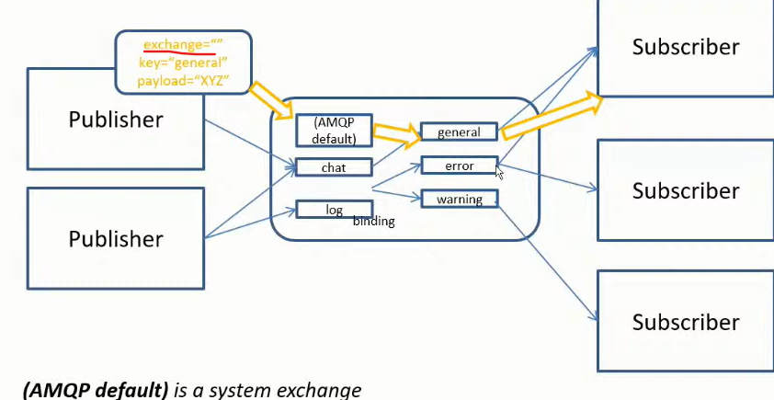

#### Direct exchange

* А direct exchange routes messages to a queue if the routing key of the message matches the binding key between the direct exchange and the queue
* Direct exchanges are suitable for point-to-point communication between endpoints
* Binding key should be defined here mandatory

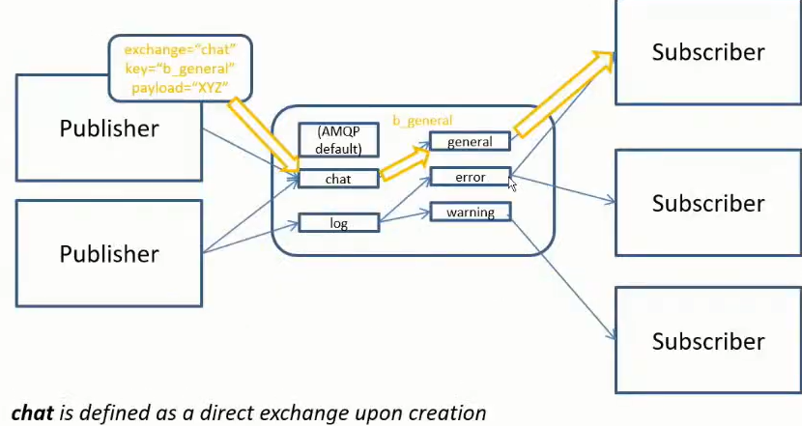

#### Fanout exchange

* А fanout exchange routes (broadcasts) messages to all queues that are bound to it (the binding key is not used)
* Fanout exchanges are suitable for publish-subscribe communication between endpoints

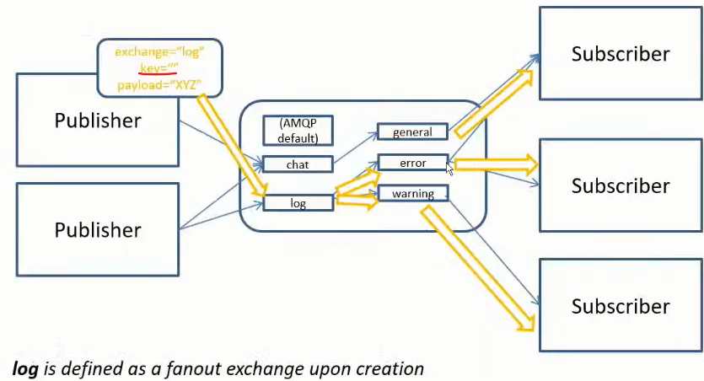

#### Topic exchange

* А topic exchange routes (multicasts) messages to all queues that have a binding key (can be a pattern) that matches the routing key of the message
* Topic exchanges are suitable for routing messages to different queues based on the type of message
* Диеса след *warning.* може да е всякаква дума

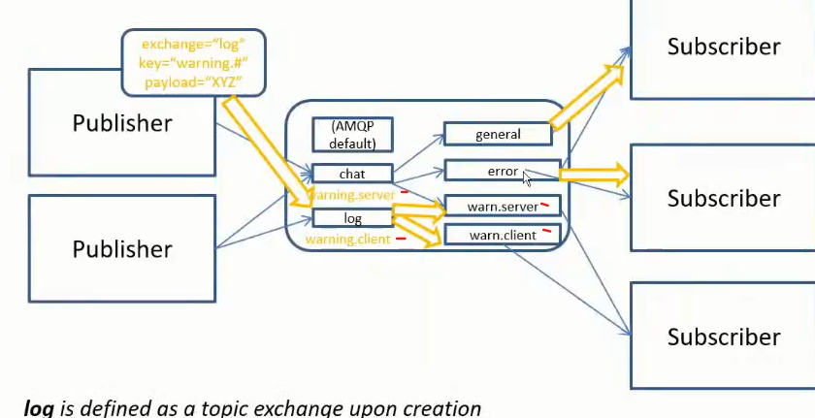

#### Headers exchange

* А headers exchange routes messages based on a custom message header
* Header exchanges are suitable for routing messages to different queues based on more than one attribute

### Installation of the RabbitMQ server

First install the Erlang - <https://www.erlang.org/downloads>

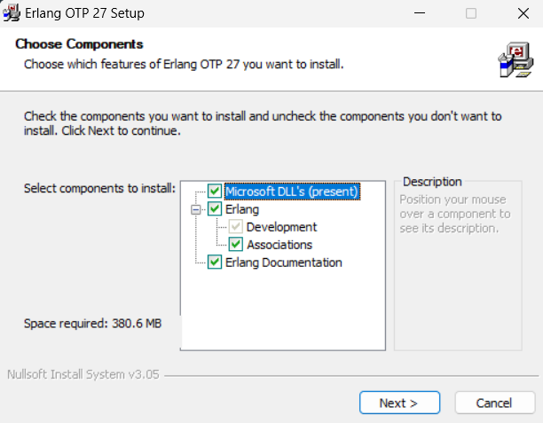

Then install the RabbitMQ server - <https://www.rabbitmq.com/docs/download>

rabbitmq-service.bat

rabbitmq-service.bat

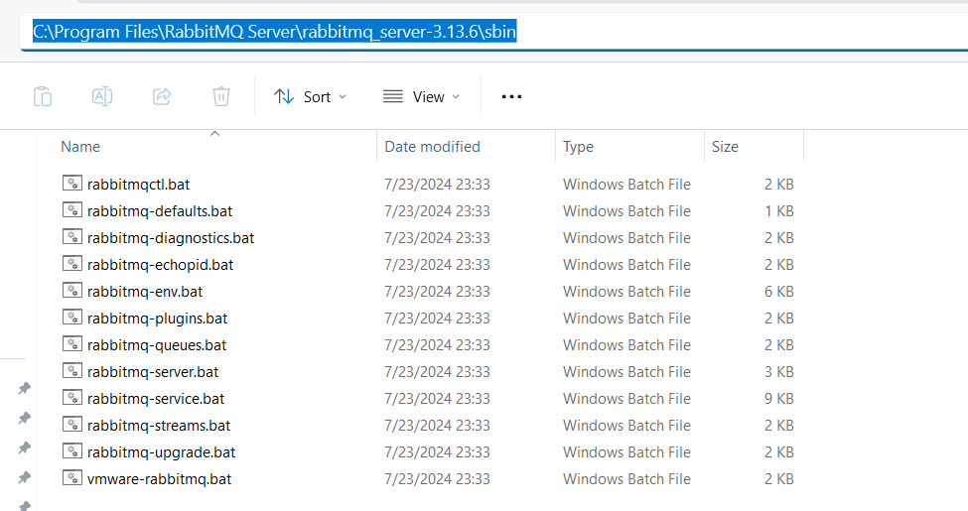

C:\Program Files\RabbitMQ Server\rabbitmq_server-3.13.6\sbin>**rabbitmq-plugins.bat enable** rabbitmq_management

Enabling plugins on node rabbit@SVILKATA:

rabbitmq_management

The following plugins have been configured:

  rabbitmq_management

  rabbitmq_management_agent

  rabbitmq_web_dispatch

Applying plugin configuration to rabbit@SVILKATA...

The following plugins have been enabled:

  rabbitmq_management

  rabbitmq_management_agent

  rabbitmq_web_dispatch

set 3 plugins.

Offline change; changes will take effect at broker restart.

**През CommandPrompt като администратор:**

C:\Program Files\RabbitMQ Server\rabbitmq_server-3.13.6\sbin>rabbitmq-plugins.bat list

Listing plugins with pattern ".*" ...

 Configured: E = explicitly enabled; e = implicitly enabled

 | Status: [failed to contact rabbit@SVILKATA - status not shown]

 |/

[  ] rabbitmq_amqp1_0              3.13.6

[  ] rabbitmq_auth_backend_cache   3.13.6

[  ] rabbitmq_auth_backend_http    3.13.6

[  ] rabbitmq_auth_backend_ldap    3.13.6

[  ] rabbitmq_auth_backend_oauth2  3.13.6

[  ] rabbitmq_auth_mechanism_ssl   3.13.6

[  ] rabbitmq_consistent_hash_exchange 3.13.6

[  ] rabbitmq_event_exchange       3.13.6

[  ] rabbitmq_federation           3.13.6

[  ] rabbitmq_federation_management 3.13.6

[  ] rabbitmq_jms_topic_exchange   3.13.6

**[*] rabbitmq_management           3.13.6**

**[*] rabbitmq_management_agent     3.13.6**

[  ] rabbitmq_mqtt                 3.13.6

[  ] rabbitmq_peer_discovery_aws   3.13.6

[  ] rabbitmq_peer_discovery_common 3.13.6

[  ] rabbitmq_peer_discovery_consul 3.13.6

[  ] rabbitmq_peer_discovery_etcd  3.13.6

[  ] rabbitmq_peer_discovery_k8s   3.13.6

[  ] rabbitmq_prometheus           3.13.6

[  ] rabbitmq_random_exchange      3.13.6

[  ] rabbitmq_recent_history_exchange  3.13.6

[  ] rabbitmq_sharding             3.13.6

[  ] rabbitmq_shovel               3.13.6

[  ] rabbitmq_shovel_management    3.13.6

[  ] rabbitmq_stomp                3.13.6

[  ] rabbitmq_stream               3.13.6

[  ] rabbitmq_stream_management    3.13.6

[  ] rabbitmq_top                  3.13.6

[  ] rabbitmq_tracing              3.13.6

[  ] rabbitmq_trust_store          3.13.6

**[*] rabbitmq_web_dispatch         3.13.6**

[  ] rabbitmq_web_mqtt             3.13.6

[  ] rabbitmq_web_mqtt_examples    3.13.6

[  ] rabbitmq_web_stomp            3.13.6

[  ] rabbitmq_web_stomp_examples   3.13.6

Type services.msc

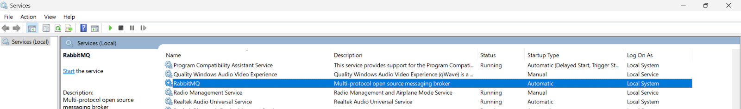

C:\Program Files\RabbitMQ Server\rabbitmq_server-3.13.6\sbin>**rabbitmq-server.bat**

2024-07-31 11:52:47.571000+03:00 [warning] <0.134.0> Using RABBITMQ_ADVANCED_CONFIG_FILE: c:/Users/svilk/AppData/Roaming/RabbitMQ/advanced.config

2024-07-31 11:52:52.145000+03:00 [notice] <0.45.0> Application syslog exited with reason: stopped

2024-07-31 11:52:52.145000+03:00 [notice] <0.213.0> Logging: switching to configured handler(s); following messages may not be visible in this log output

  ##  ##  RabbitMQ 3.13.6

  ##  ##

  ##########  Copyright (c) 2007-2024 Broadcom Inc and/or its subsidiaries

  ######  ##

  ##########  Licensed under the MPL 2.0. Website: https://rabbitmq.com

  Erlang:  27.0.1 [jit]

  TLS Library: OpenSSL - OpenSSL 3.1.0 14 Mar 2023

  Release series support status: see https://www.rabbitmq.com/release-information

  Doc guides:  https://www.rabbitmq.com/docs

  Support: https://www.rabbitmq.com/docs/contact

  Tutorials:   https://www.rabbitmq.com/tutorials

  Monitoring:  https://www.rabbitmq.com/docs/monitoring

  Upgrading:   https://www.rabbitmq.com/docs/upgrade

  Logs: <stdout>

     c:/Users/svilk/AppData/Roaming/RabbitMQ/log/rabbit@SVILKATA.log

  Config file(s): c:/Users/svilk/AppData/Roaming/RabbitMQ/advanced.config

  Starting broker... **completed with 3 plugins.**

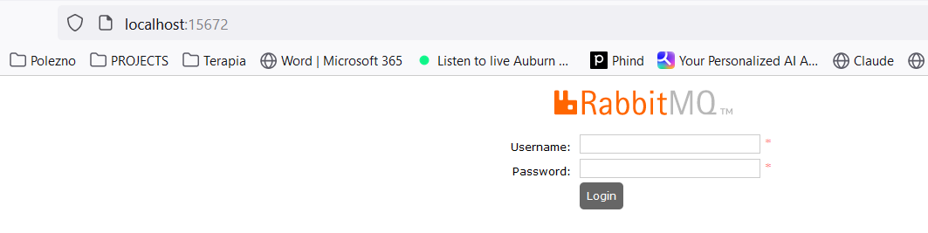

**username: guest**

**password: guest**

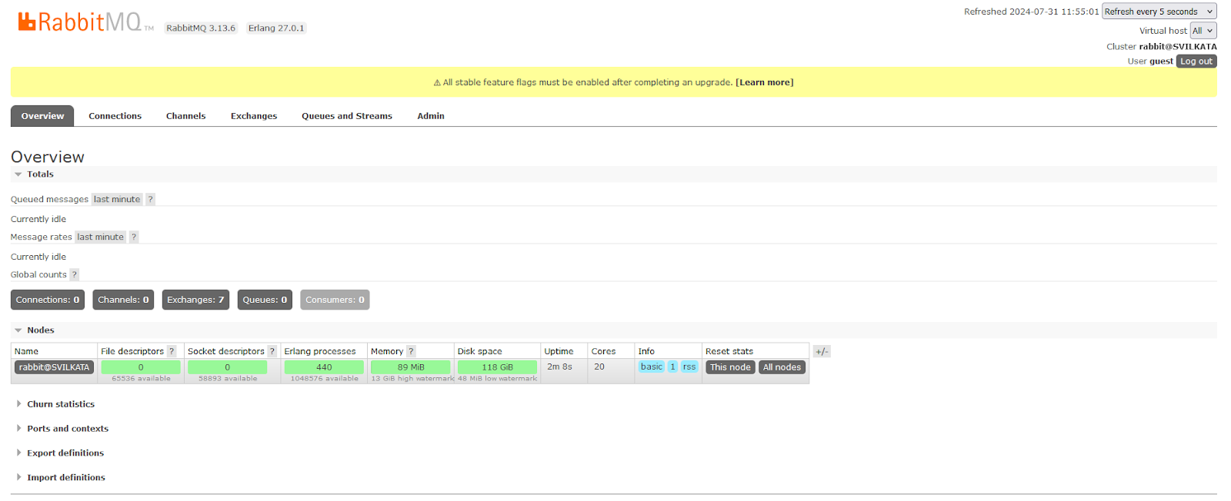

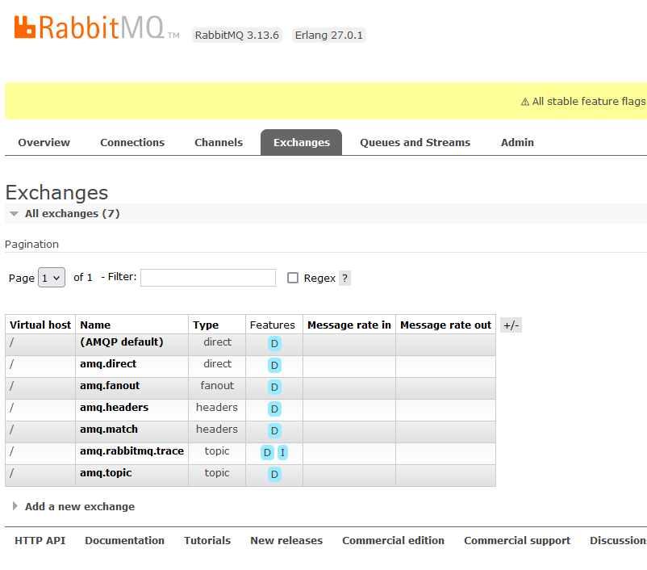

### Using the Java Client

<dependency>

 <groupId>com.rabbitmq</groupId>

 <artifactId>amqp-client</artifactId>

 <version>5.20.0</version>

</dependency>

import com.rabbitmq.client.Channel;

import com.rabbitmq.client.Connection;

import com.rabbitmq.client.ConnectionFactory;

import java.io.IOException;

import java.nio.charset.StandardCharsets;

import java.util.concurrent.TimeoutException;

public class Publisher {

   public static void main(String[] args) throws IOException, TimeoutException {

       Connection connection = null;

       Channel channel = null;

       try {

           ConnectionFactory connectionFactory = new ConnectionFactory();

           connectionFactory.setHost("localhost"); *//by default on port 15672*

connection = connectionFactory.newConnection();

           channel = connection.createChannel();

           channel.exchange**Declare**("name_exchange", "direct"); *//created only once on the RabbitMQ server*

channel.queue**Declare**("name_queue", false, false, false, null); *//created only once on the RabbitMQ server*

           channel.queueBind("name_queue", "name_exchange", "routing_key_test");

           channel.basicPublish("name_exchange", "routing_key_test", null,

                   "Hello RabbitMQ from Java client".getBytes(StandardCharsets.*UTF_8*));

       } finally {

           if (channel != null) {

               channel.close();

           }

           if (connection != null) {

               connection.close();

           }

       }

   }

}

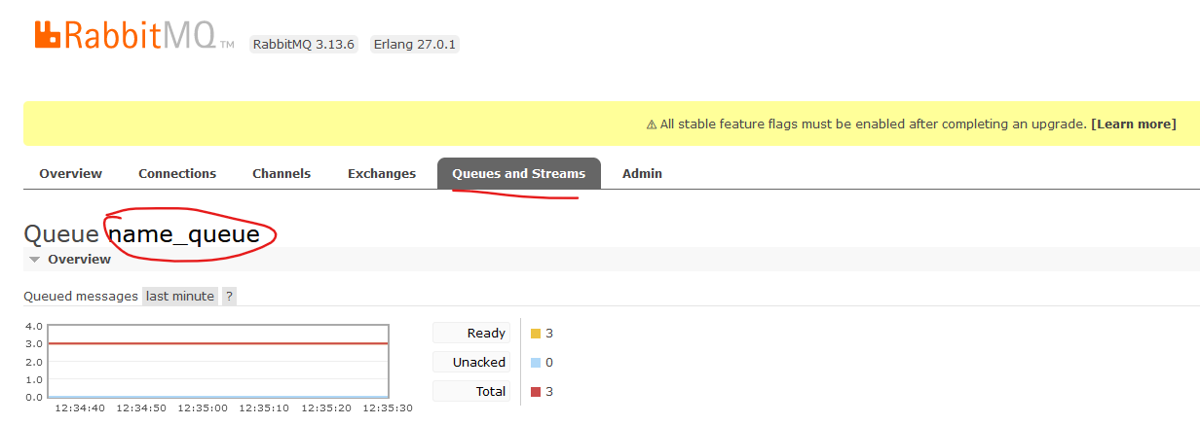

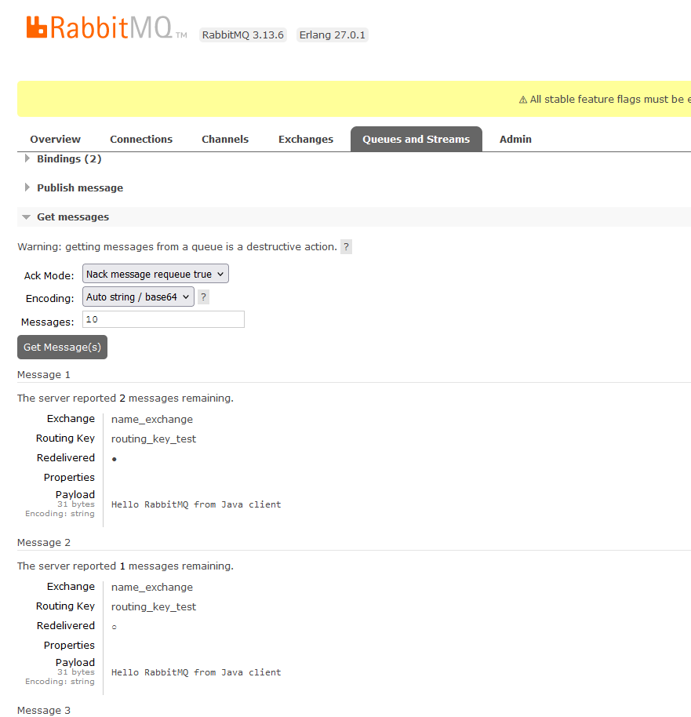

import com.rabbitmq.client.AMQP;

import com.rabbitmq.client.Channel;

import com.rabbitmq.client.Connection;

import com.rabbitmq.client.ConnectionFactory;

import com.rabbitmq.client.DefaultConsumer;

import com.rabbitmq.client.Envelope;

import java.io.IOException;

import java.util.concurrent.TimeoutException;

public class Subscriber {

   public static void main(String[] args) throws IOException, TimeoutException, InterruptedException {

       Connection connection = null;

       Channel channel = null;

       try {

           ConnectionFactory connectionFactory = new ConnectionFactory();

           connectionFactory.setHost("localhost"); *//by default on port 15672*

connection = connectionFactory.newConnection();

           channel = connection.createChannel();

           channel.exchangeDeclare("name_exchange", "direct"); *//created only once on the RabbitMQ server*

channel.queueDeclare("name_queue", false, false, false, null); *//created only once on the RabbitMQ server*

           channel.queueBind("name_queue", "name_exchange", "routing_key_test");

           while (true) {

               channel.basicConsume("name_queue", true, new DefaultConsumer(channel) {

                   @Override

                   public void handleDelivery(String consumerTag, Envelope envelope, AMQP.BasicProperties properties, byte[] body) throws IOException {

*// super.handleDelivery(consumerTag, envelope, properties, body);  no-op no work to do*

System.*out*.println(new String(body));

                   }

               });

               Thread.*sleep*(3000);

           }

       } finally {

           if (channel != null) {

               channel.close();

           }

           if (connection != null) {

               connection.close();

           }

       }

   }

}

### Administration

* Administration of the broker includes a number of activities such as:
  + Updating the broker
  + Backing up the broker database
  + installing/uninstalling and configuring plug-ins
  + Configuring the various components of the broker

* Apart from queues, exchanges and bindings we can also manage the following types of components:
  + vhosts (virtual hosts) - for logical separation of broker components
  + users
  + Parameters - defining upstream links to another brokers
  + Policies - for queue mirroring

* Administration of single instance or an entire cluster can be performed in several ways:
  + Using the management Web interface

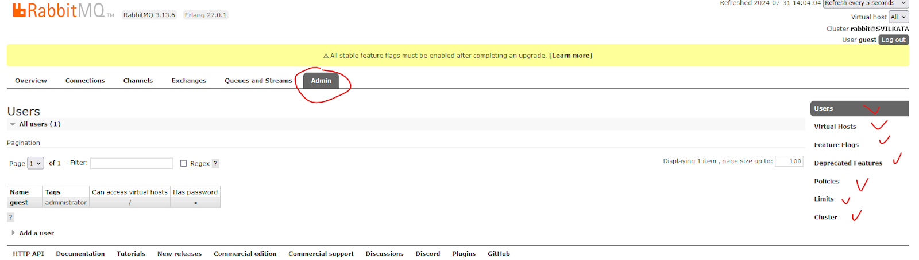

* Using the management HTTP API - rest API
* Using the **rabbitmq-admin.py / rabbitmqadmin.py** script - written on Python
* Using the **rabbitmqctl** utility

### Scalability and High Availability in RabbitMQ

#### Basic default configuration

* RabbitMQ provides clustering support that allows new RabbitMQ nodes to be added on the fly
* Clustering by default does not guarantee that message loss may or may not occur - ако дадена инстанция примерно падне

* Nodes in a RabbitMQ cluster can be:
  + DISK - data is persisted in the node database
  + RAM - data is buffered only in-memory - когато не е критично да се запазват данните след рестарт например
* **Nodes share only broker metadata - messages are not replicated among nodes!! - съобщението не се репликира в останалите node-ве**

**Example:**

А и B са DISK nodes, a C е Ram node.

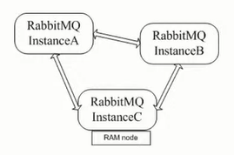

**Instance A node DISK**

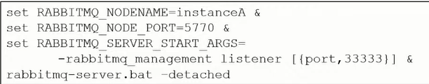

**Instance B node DISK**

Пускаме инстанция B, спираме я, присъединяваме я след това

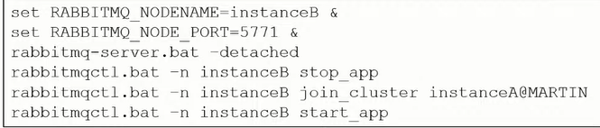

**Instance C node RAM**

Пускаме инстанция C, спираме я, присъединяваме я след това

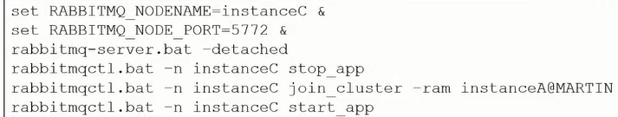

* If a node that hosts a queue buffers unprocessed messages goes down, then messages are lost
* Default clustering mechanism provides scalability in terms of queues rather than high availability

#### Mirrored queues

* **Mirrored queues** are an extension to the default clustering mechanism that can be used to establish **high availability** at the broker level
* Mirrored queues provide queue replication over different nodes that allows a message to survive node failure
* Queue mirroring is establishing by means of a mirroring policy that specifies:
  + Number of nodes to use for queue replication
  + Particular nodes designated by name for queue replication
  + All nodes for queue replication

* The node where the queue is created is the master node - all other nodes are slaves
* A new master node can be promoted in case the original one goes down
* A slave node is promoted to/as the new master in case it is fully synchronized with the old master

**Example:**

Let’s define the test queue in the cluster and mirror it over all other nodes:

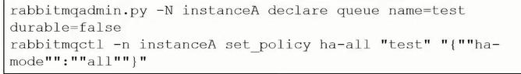

#### **Federation and Shovel plugins**

* The RabbitMQ clustering mechanism uses Erlang message passing along with a message cookie in order to establish communication between the nodes…….. which is **not reliable** over the Wide Area Networks!!
* In order to establish high availability among nodes in different geographic locations you can use the **federation, federation_management** and **shovel** plug-ins
* The shovel plug-in works at a lower level than the federation plug-in

##### **Federation**

* Ако искаме да репликираме опашката на отдалечена инстанция D:

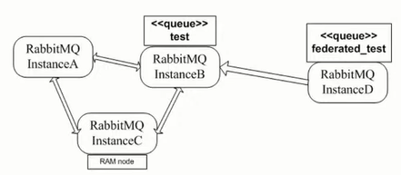

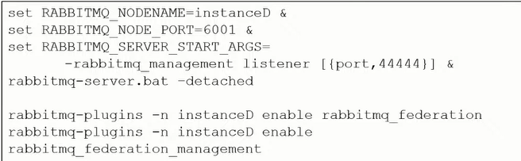

* Declare the **federated_test** queue



Declare the upstream to the initial cluster and set a federation link to the **test** queue:

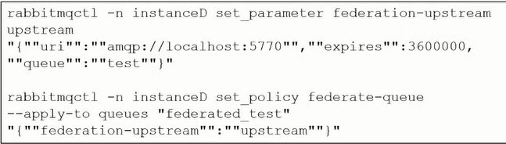

##### Shovel

The shovel plug-in provides two variants:

* **static** - all links between the source/destination nodes/clusters are defined statically in the RabbitMQ configuration file
* **dynamic** - all links between the source/destination nodes/clusters are defined dynamically via the RabbitMQ parameters

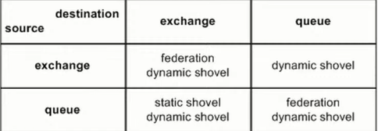

### Integrations

#### Info

* RabbitMQ provides integrations with other protocols such as STOMP, MQTT and LDAP by means of RabbitMQ plug-ins
* Using the Java Client - already discussed above
* The Spring framework provides integration with AMQP protocol and RabbitMQ in particular
* The **Spring AMQP framework** provides:
  + **RabbitAdmin** class for automatically declaring queues, exchanges and bindings
  + **Listener container** for asynchronous processing of inbound messages
  + **RabbitTemplate** class for sending and receiving messages

* Utilities of the Spring AMQP framework can be used directly in Java or preconfigured in the Spring configuration
* The **Spring Integration framework** to **Spring Boot** provides adapters for the AMQP protocol

* Integration with Quarkus framework

#### Spring AMQP framework

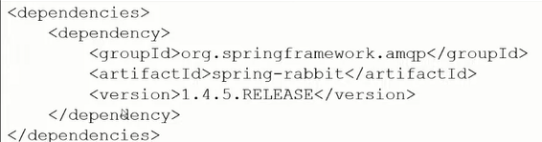

The **RabbitAdmin** class:

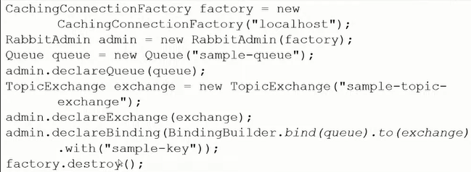

**Listener container**

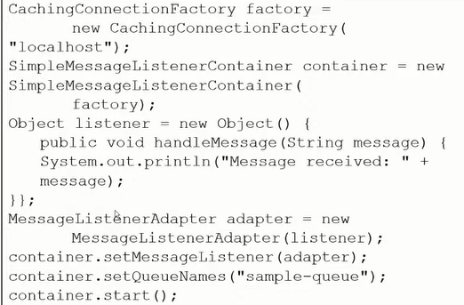

The **RabbitTemplate** class:

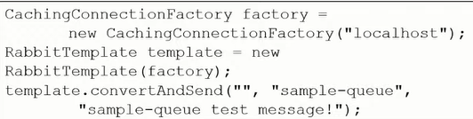

* All of the above Spring AMQP framework examples  can be configured using the Spring configuration - so that to be cleaner and to decouple RabbitMQ configuration from the business logic/Java code

For example within a **configuration.xml** file:

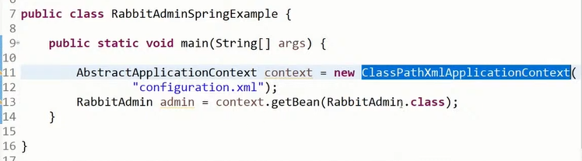

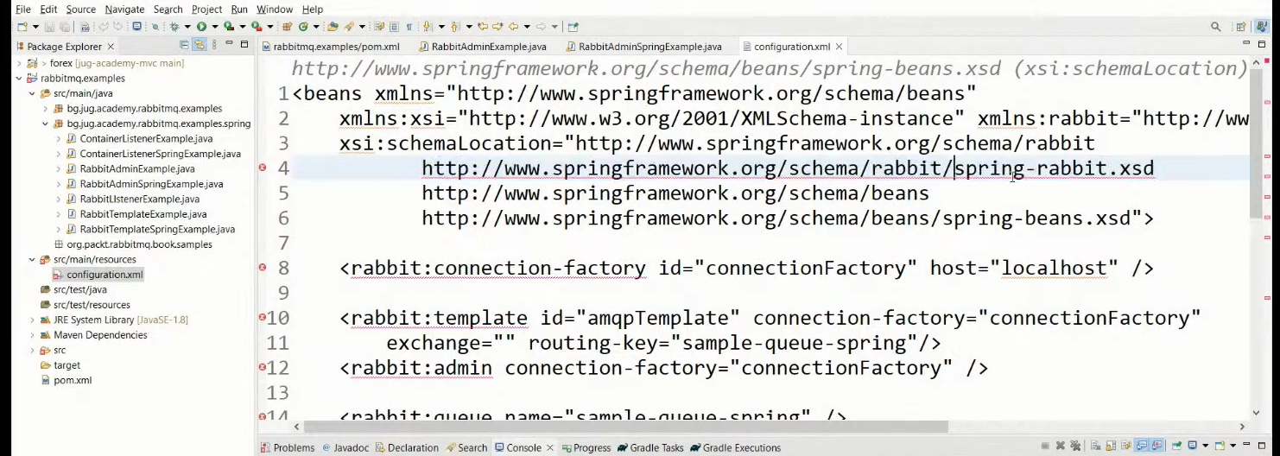

#### Spring Boot Starter AMQP - Spring Integration framework

In gradle

implementation ‘org.springframework.boot:**spring-boot-starter-amqp**’

Предоставя ни бийнове за  **RabbitAdmin** class, **Listener container** and **RabbitTemplate** class.

Посредством дефиниране на бийнове - можем да си декларираме **exchange, queue** или **queueBinding**

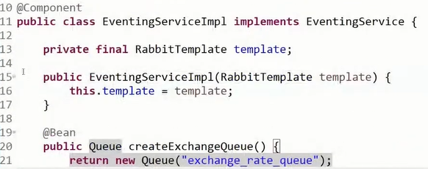

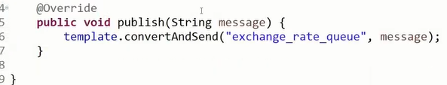

#### Quarkus framework

<dependency>

 <groupId>io.quarkus</groupId>

 <artifactId>quarkus-smallrye-reactive-messaging-rabbitmq</artifactId>

</dependency>

In application.properties file

mp.messaging.outgoing.bi.use-ssl=true

mp.messaging.outgoing.bi.connector=smallrye-rabbitmq

mp.messaging.outgoing.bi.exchange.type=direct

mp.messaging.outgoing.bi.port=5672

import io.smallrye.reactive.messaging.rabbitmq.**OutgoingRabbitMQMetadata**;

@Inject

@Channel("asd")  //from Microprofile

Emitter<String> emitter;  //from Microprofile

public void emmitMessage(RabbitMqPayload payload) {

   String messagePayload = JsonUtils.*toJsonString*(List.*of*(payload));

*LOGGER*.debugf("Emitting Bi message to RabbitMQ %s", messagePayload);

**OutgoingRabbitMQMetadata** metadata = new OutgoingRabbitMQMetadata.Builder()

**.withRoutingKey**(payload.routingKey())

           .build();

   Message<String> message = Message.of(messagePayload, Metadata.of(metadata));

   biEmitter.send(message); //from Microprofile

*LOGGER*.infof("Bi message emitted to route %s", payload.routingKey());

}

### Security

* RabbitMQ uses SASL Simple Authentication Security Layer for authentication (SASL PLAIN used by default)
* RabbitMQ uses access control lists (permissions) for authorization
* SSL/TLS support can be enabled for the AMQP communication channels
* SSL/TLS support can be enabled for node communication between nodes in a cluster
* SSL/TLS support can be enabled for the federation and shovel plug-ins

## II. Apache Kafka

Book

Kafka – The Definitive Guide – Real-Time Data and Stream Processing at Scale

### Main Concepts

* Kafka is run as a cluster on one or more servers (brokers) that can span multiple datacenters
* The Kafka **cluster** stores **streams of records** in one or more **brokers** in categories called **topics**
* Each record consists of a **key, value and timestamp**
* **Horizontally scalable** – trying to put more nodes

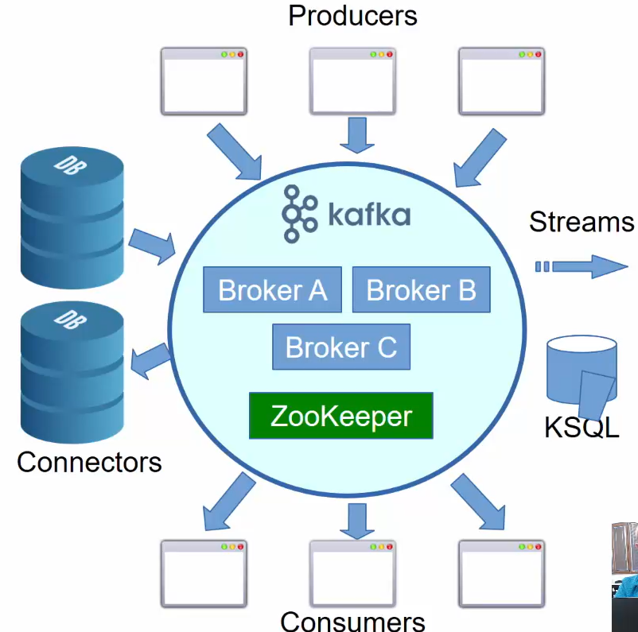

KSQL – стария подход без стриймове

* The **Producer API** – publish a stream of records to one or more Kafka topics
* The **Consumer API** – subscribe to one or more topics and process the stream of records produced
* The **Streams API** – a stream processor, consuming an input stream form one or more topics and producing an output stream to one or more output topics, effectively transforming the input streams to output streams
* The **Connector API** – allows building and running reusable producers or consumers that connect Kafka topics to existing applications or data systems – e.g. connector to a DB might capture every change in a table

### Use cases

* For activity tracking – например LinkedIn да знае кой профил гледате/се гледа най-много
* Messaging
* Metrics and logging
* Commit log
* Stream processing – data pipeline – за един ден колко човека са кликнали на моята страница

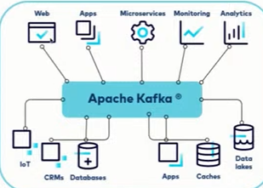

### Brokers and Clusters

A single Kafka server/instance is called a ***broker***. The broker receives messages from producers, assigns offsets to them, and writes the messages to storage on disk. It also services consumers, responding to fetch requests for partitions and responding with the messages that have been published. Depending on the specific hardware and its performance characteristics, a single broker can easily handle thousands and millions of messages per second.

В един Kafka инстанция/брокер може да има 1 или повече топици, а във всеки топик има определен брой partitions.

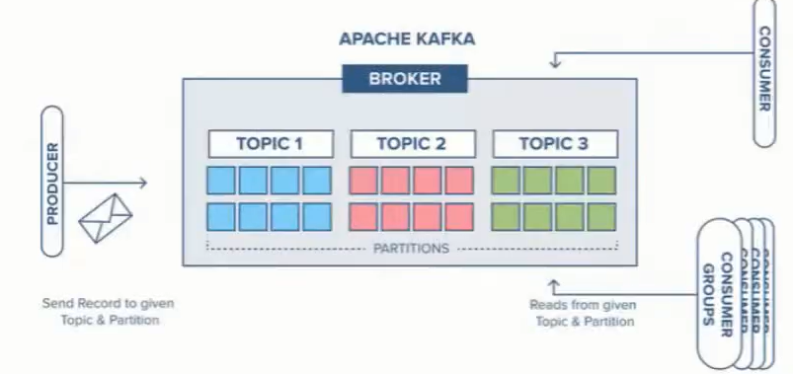

**Cluster** – комбинация от няколко брокера (поне 3), т.е. няколко брокера които работят заедно и се координират заедно.

С други думи да има Fault tolerance, и когато един broker instance падне/или целият cluster падне, то да има опция да се репликират данните.

Като си правим cluster, то самите broker instances да бъдат географски на различни места – че ако падне нета на единия instance, дa не паднат всичките брокер инстанции и дефакто целия клъстер.

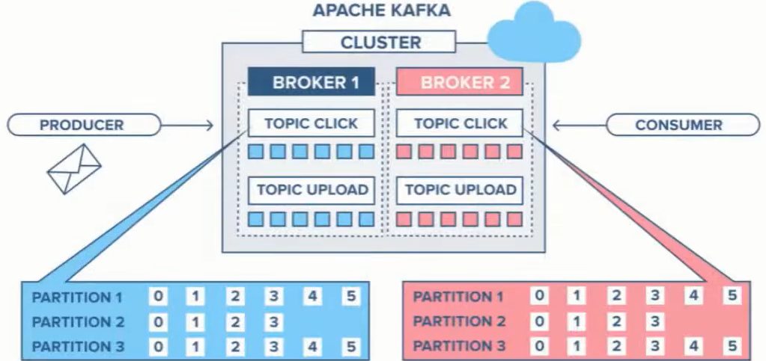

* Kafka is maintained as clusters where each **node** within a cluster **is called a Broker**. Multiple brokers allow us to evenly distribute data across multiple servers and partitions. This load should be monitored continuously and brokers and topics should be reassigned when necessary.
* Each Kafka cluster will designate on of the brokers as the **Controller** which is responsible for managing and maintaining the overall **health of a cluster**, in addition to the basic broker responsibilities. Controllers are responsible for:
  + creating/deleting topics and partitions
  + taking action to rebalance partitions
  + assign partition leaders
  + handle situations when nodes fail or get added
* Controllers subscribe to receive notifications from **ZooKeeper** which tracks the state of all nodes, partitions and replicas

### Topics and Partitions

* **Topic** = stream of records. A topic is a category or feed name to which records are published. Topics in Kafka are always multi-subscriber; that is, a topic can have zero, one or many **consumers** that subscribe to the data.
* For each topic, the Kafka cluster maintains a **partition log** – each **partition** is an ordered, immutable sequence of records that is continually appended to – a structured **commit log.**
* The records in each partition are each assigned a sequential id number called the **offset** that uniquely identifies each record within the partition.
* Each partition is append-only. Records in the partition can be deleted automatically (whole segments are deleted) based on initial configuration about capacity.
* Ако in-memory буфера се напълни, то чак тогава данните се записват в база данни – подлежи на настройка
* With key – Messages are appended in the same partition if they have the same key
* Without key – messages are appended to the next partition in a round-robin fashion
* The order is guaranteed only in a partition and only if we have/use **key**

**Kafka topic – основната единица**

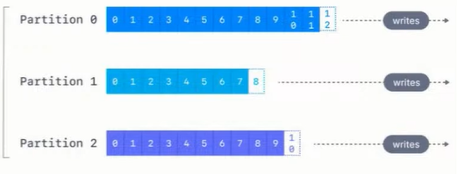

Колкото partitions има в даден топик, то толкова паралелни consumers може да имаме.

Ако имаме повече от 1 partition в даден топик, то нямаме гаранция за подредба. Освен разбира се ако не използваме **key!**

Partition представлява множество съобщения/елементи едно след друго, с определен индекс, който наричаме **offset!**

### Producers

#### Producer commit

Producers publish data to the topics of their choice. The producer is responsible for **choosing which record to assign to which partition** within the topic. This can be done in a round-robin fashion simply to balance load or it can be done according to some semantic partition function (e.g. based on **key’s hash value**).

From the producer side, "commit" refers to the acknowledgement received from the Kafka brokers that a message has been successfully written to the topic partitions.

Key points about **producer commits**:

It provides durability guarantees based on the acks configuration.

With acks=0, no acknowledgement is expected from the brokers.

With acks=all, the producer waits for all in-sync replicas to confirm receipt before considering the message committed.

**Batching**

**spring.kafka.producer.batch-size=100**

Sets the maximum number of records to be sent om one request. Sends the batch as soon as it is filled.

**spring.kafka.producer.properties[linger.ms]**

Gives the batch that much ms to be filled and sent automatically (see above). After the duration, if the batch is still not filled, sends it as it is.

**spring.kafka.producer.buffer-memory**

If a batch cannot be sent due to broker being down or whatever other recoverable issue, fills new batches in the buffer.

After the buffer is filled, the **send()** method blocks for **spring.kafka.producer.properties[max.block.ms]**. This buffer **must be large enough** to contain at least one full batch or such batches will be lost.

**spring.kafka.producer.compression-type=lz4** avro gzip snappy

The batch will be compressed before sending. This directly increases throughput and latency (not much latency)

Следните неща ни интересуват като изпращаме съобщения:

* **acks=0**

Does not wait for a response to consider the sent successful



* **acks=1**

Wait for the leader to commit the message/s but do not wait for the replicas to commit!!

Изчакай поне Leader да ти върне, че е записано съобщението, но не чакаме да се случи репликацията. Проблем би бил ако leader-а умре/падне, и тогава съобщението се губи



* **acks=all**

Wait for the leader and all replicas(или еди колко си на брой реплики) to commit, so that to consider the message/s sent.

Note: all == -1

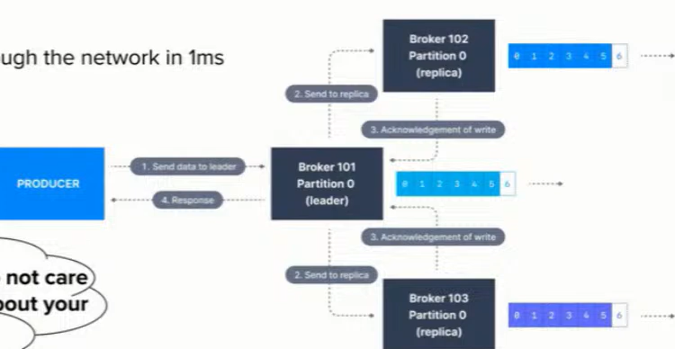

x2 slower – докато се получат повтържденията за репликите, и се забавя

Assuming that a message/s is sent through the network in 1ms. This leads to 2.5ms latency.

1000 / 2ms = 2micro s per message

#### Kafka Producer send() Method

• Asynchronously sends a record to a topic

new ProducerRecord(TOPIC , reading.getId (), reading)

• Allows sending many records without blocking for a broker response

• send() method returns a Future

• Two forms:

• send() method without a callback

• send() method with a callback - the callback gets invoked when the broker has acknowledged the send

[ ACK = -1 (all ISR), 0 or 1 (leader)]

• Callbacks for records sent to same partition are executed in the sent order

• Callback receives RecordMetadata which contains a record’s partition, offset, and timestamp, and possible Exception if there was an error sending.

#### Kafka send() Method Exceptions

•InterruptException - If thread is interrupted while blocking

•SerializationException - If key or value can not be serialized using configured serializers

•TimeoutException – when fetching metadata or allocating memory exceeds max.block.ms, or getting **acks** from Broker exceed timeout.ms, etc.

•KafkaException - when Kafka error occurs, but not in public API

•AuthenticationException - if authentication fails

•AuthorizationException - the producer is not allowed to write

•IllegalStateException -if a transactional.id has been configured and no transaction has been started, or when send() invoked on closed producer

#### Kafka Producer partitionsFor() Method

•partitionsFor(topic) - returns meta-data for partitions:

public List<PartitionInfo> partitionsFor(String topic)

•Used by producers that implement their own partitioning – for custom partitioning

•PartitionInfo consists of topic, partition, leader node (Node), replica nodes (Node[]) and inSyncReplicanodes.

•Node consists of id, host, port, and rack

#### Kafka Producer Interceptors

•Activate interceptors by adding them to interceptor.classes property of the producer

props.put(

ProducerConfig.*INTERCEPTOR_CLASSES_CONFIG*,

CountingProducerInterceptor.class.getName());

•Producer interceptor methods:

public ProducerRecord<K, V> **onSend**(ProducerRecord<K, V> record)

public void **onAcknowledgement**(RecordMetadatametadata, Exception exception)

#### Kafka Producer flush() and close() Methods

Runtime.*getRuntime*().addShutdownHook(new Thread(() -> {

executor.shutdown();

try {

executor.awaitTermination(200, TimeUnit.*MILLISECONDS*);

*log*.info("Flushing and closing producer");

producer.**flush();**

producer**.close**(10_000, TimeUnit.*MILLISECONDS*);

} catch (InterruptedExceptione) {

*log*.warn("shutting down", e);

}}

);

#### Kafka Producer metrics() Method

•metrics() - used to get a map of metrics:

public Map<MetricName,? extends Metric> metrics()

•Returns a full set of producer metrics.

•MetricName consists of name, group, description, and tags(Map).

•Metric consists of a MetricName and a Measurablevalue(double) or Object (gauge).

### Topic replication and read balancing

* **min.insync.replicas** – how many brokers (including the leader) should have the data before it is considered stored and ready to serve. Recommended is **replication.factor -1** (можем да настроим да я има тази информация на само 1 брокер, на още 2 брокера, и т.н. – зависи от use case-a и от наличните брокери)

Each partition is replicated separately, has its own **broker leader** and ISR.

Обикновено единия брокер се води Leader на partition-a.

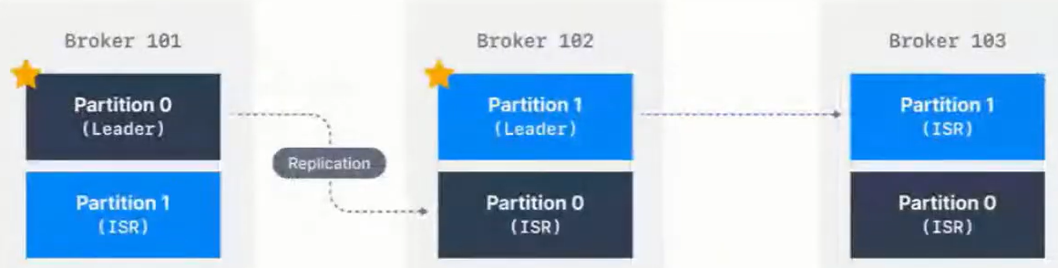

Когато изпращаме данни, ние изпращаме данни към съответния Leader на съответния partition.

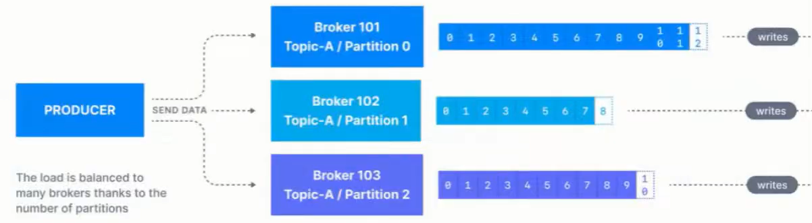

За **topic А в нашето Кафка приложение** примерно имаме 3 брокера/Кафка инстанции - имаме Leader и Followers – т.е. за topic A имаме **Leader брокер АА**, който преразпределя и казва дали ако информацията е **reading**, то да не я прави той, а да предостави възможност broker BB или broker CC да извърши тази операция – съответно през **replica2** на partition1 на брокер BB; или през **replica3** на partition2 на брокер CC.

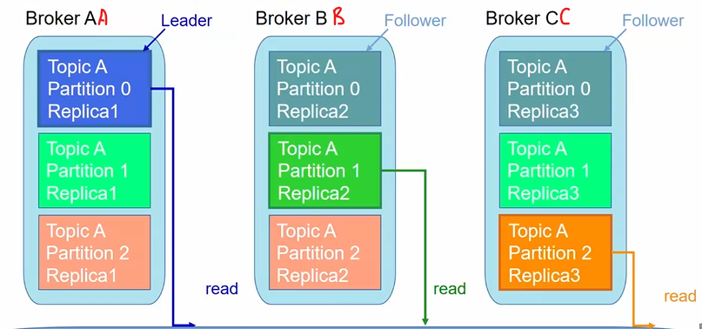

### What is a Kafka message

И key и value са **binary**! За Кафка всичко е byte-ове.

Възможност за компресия. Запазват се sequential – на следващия сегмент на диска.

Headers – например информация през кои сървиси е минало

Информация на кой partition e, и на кой офсет индекс е даденото съобщение.

Timestamp by default се слага от producer-a, а не вътрешно от Кафка брокера!

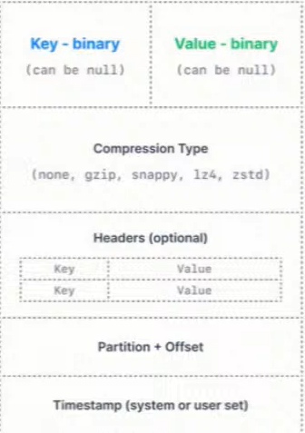

* Messages are stored inside topics within a log structured format, where the data gets written sequentially.
* A message can have a maximum size of 1MB by default, and while this is configurable, Kafka was not designed to process large size records. It is recommended to split large payloads into smaller messages, using identical key values so they all get saved in the same partition as well as assigning part numbers to each split message in order to reconstruct it on the consumer.
* Messages (aka Records) are always written in record batches. Record batches and records have their own headers. The detailed format of each is described in: <http://kafka.apache.org/documentation/#recordbatch>

### Consumers

**Kafka скалира не на базата на топици, а на базата на partitions**!!!

* Consumers label themselves with a **consumer group**, and each record published to a topic **is delivered to one consumer instance within a consumer group**. Can be separate processes/machines
* Same consumer group – records will effectively be load balanced
* Different consumer groups – **broadcast** to all the consumers

#### Consumer group

* **Consumer group = “logical subscriber”** -> many consumer instances for scalability and fault tolerance = publish-subscribe semantics where the **subscriber is a cluster of consumers** instead of a single process.
* The way consumption is implemented in Kafka is by **dividing up the partitions in the log over the consumer instances** so that each instance is the exclusive consumer of a ‘share’ of partitions at any point of time
* Group membership is handled by the Kafka protocol **dynamically**. If new instances join the group, they will take some partitions from other group members; if an instance dies, its partitions will be distributed.
* Kafka only provides a **total order over records within a partition**, not between different partitions in a topic. Per-partition ordering combined with the ability to partition data **by key** is sufficient for most applications.
* **If you require a total order over records** ----> use a **topic that has only one partition** = only one consumer process per consumer

Пример: Имаме 5 партишъни. И разпределяме партишъните на различни consumers.

В текущият пример можем да сложим общо макс 5 consumers!!! Или с други думи правилото е че можем да скалираме consumers до броя на partitions!

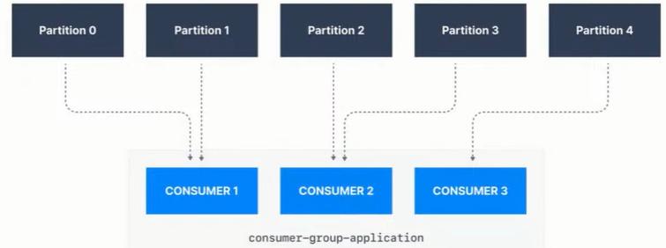

#### Many consumers groups

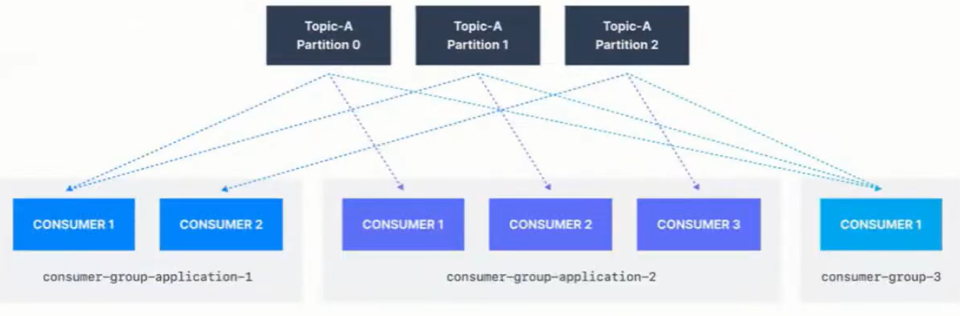

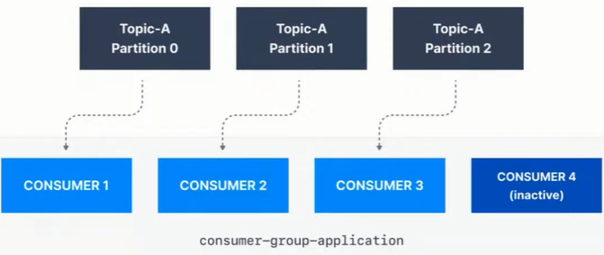

#### Consumer commit

* Consumer Commit is the process of telling Kafka to remember that you have processed **(consumed)** the messages of a partition to a specific offset
* When first started, the consumer looks up where it left off via the kafka commit facility
* A call to **seek()** is made to initialize an internal counter which determines the messages that will be poll()-ed for the lifetime of the **consumer**

**Poll** означава вземи съобщението от брокера, и го процесни при теб (при Spring framework-a например)

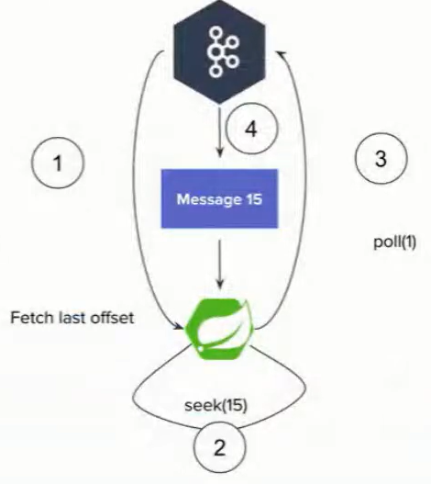

In Kafka consumers**, "commit" refers to the process of marking a message or offset as having been processed successfully**. This is typically done by the consumer application itself, not by the Kafka brokers 2.

Key points about committing in Kafka consumers:

It allows the consumer to keep track of which messages it has already processed.

It enables resuming from the last committed offset if the consumer crashes or restarts.

It helps prevent duplicate processing of messages.

#### Consumer

**Batching again**

**spring.kafka.consumer.max-poll-records=500**

Sets the maximum number of records that will be returned by a poll()

**spring.kafka.listener.ack-mode=batch**

Auto commit is mostly evil. Don’t use it by default unless actually verifiably ok for your data

Като процеснеш batch-а, то commit-ни ръчно тогава offset-а. Ако се закача наново, то да не го процесна същото съобщение.

**spring.kafka.consumer.enable-auto-commit=false**

**max.poll.interval.ms=5min**

You must be able to process a full batch in that time or a rebalance will be triggered. На колко време да вземаме съобщенията обратно.

### Delivery guarantees

Това съобщение защо сме го процеснали 2 пъти.

Или това съобщение защо изобщо не сме го процеснали.

At **least once** means not that a single message might be duplicated but a whole batch it is scary with big batches 😊

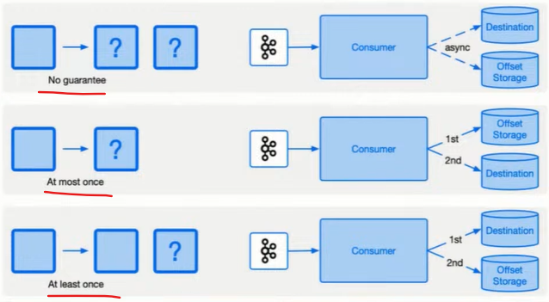

Idempotent producer – получаване на дуплицирани съобщения

Поради network проблем може Кафка брокера да е приел съобщението и да не отговори, и ние да изпратим съобщението наново.

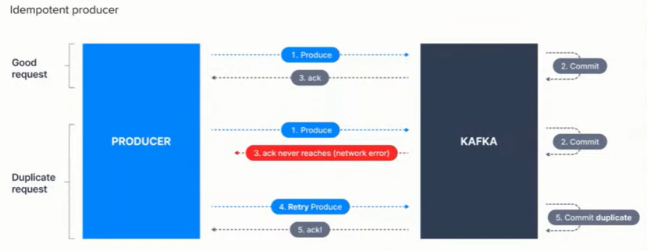

Idempotent producer

**spring.kafka.producer.properties[max.in.flight.requests.per.connection]=5**

**spring.kafka.producer.properties[enable.idempotence]=true**

It works for the lifespan of the producer. Required but not enough for proper idempotency across restarts.

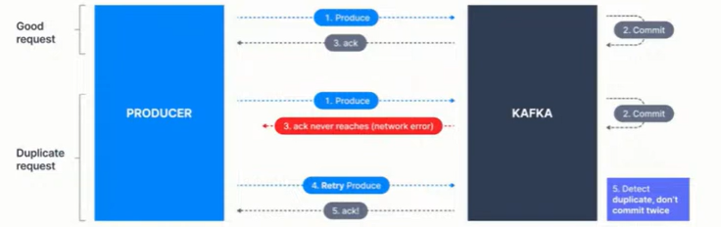

Ако е Network проблем, това решава дуплицирането.

Consumer – producer problem

Ако чета в Кафка, и пиша в Кафка – имам проблем. Защото трябва да имаме/използваме нещо, което се казва трансакции (трансакции в Кафка).

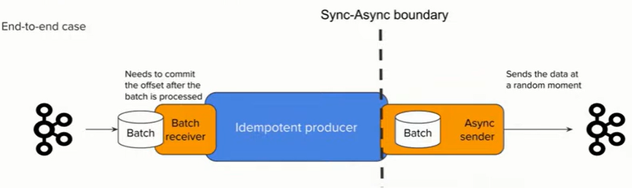

**kafkaTemplate.send(msg)**

This is fully async. You don’t know when the data is actually going to be sent. The method returns a future that can be waited but to do it for each message breaks the batching and is extremely slow.

### Kafka Transactions

Ако ползваме база данни да записваме Kafka съобщения, то няма как едновременно да използваме Kafka transactions и db transactions! Няма да е атомарна цялата операция с 2 вида транзакции!

Properties props = new Properties();

props.put("bootstrap.servers", "localhost:9092");

props.put("transactional.id", "my-transactional-id");

Producer<String, String> producer = new KafkaProducer<>(props, new StringSerializer(), new StringSerializer());

producer.initTransactions();

try {

producer.beginTransaction();

for (inti= 0; i< 100; i++)

producer.send(new ProducerRecord<>("my-topic", Integer.*toString*(i),Integer.*toString*(i)));

producer.commitTransaction();

} catch (ProducerFencedException | OutOfOrderSequenceException| AuthorizationException e) {

*// We can't recover from these exceptions, so our only option is to close the producer and exit.*

producer.close();

} catch (KafkaExceptione) {

*// For all other exceptions, just abort the transaction and try again.*

producer.abortTransaction();

}

producer.close();

### Demo with kafka-clients

Docker-compose file for Zookeeper, Kafka and RedPanda

and also logback.xml configuration. – see BGJUG public repo.

**build.gradle – Groovy style**

dependencies **{** implementation group: 'org.apache.kafka', name: **'kafka-clients'**, version: '3.6.1'  
 *//SLF4J Api* implementation 'org.slf4j:slf4j-api:1.7.32' *//Use the latest version available  
  
 //Logback (SLF$J implementation)* implementation 'ch.qos.logback:logback-classic:1.2.6' *//Use the latest version available*  
**}**

import org.apache.kafka.clients.producer.**KafkaProducer**;  
import org.apache.kafka.clients.producer.Producer;  
import org.apache.kafka.clients.producer.ProducerRecord;  
  
import java.util.Properties;  
  
public class ProducerExample {  
 public static void main(String[] args) {  
 Properties properties = new Properties();  
 properties.put("bootstrap.servers", "localhost:29092");  
 properties.put("key.serializer", "org.apache.kafka.common.serialization.StringSerializer");  
 properties.put("value.serializer", "org.apache.kafka.common.serialization.StringSerializer");  
  
 Producer<String, String> producer = new KafkaProducer<>(properties);  
  
 producer.send(new ProducerRecord<>("bgjug","KAFKA","Welcome to RabbitMQ"), (metadata, exception) -> {  
 if (exception == null) {  
 System.*out*.println("Message sent successfully - Topic: " +  
 metadata.topic() + ", Partition: " + metadata.partition() +  
 ", Offset: " + metadata.offset());  
 } else {  
 System.*err*.println("Error sending message: " + exception.getMessage());  
 }  
 });  
  
 producer.close();  
 }  
}

След като пуснем Producer-a, получаваме следния лог:

13:19:15.064 [main] INFO o.a.k.c.producer.ProducerConfig - ProducerConfig values:

**acks = -1**

auto.include.jmx.reporter = true

batch.size = 16384

bootstrap.servers = [localhost:29092]

buffer.memory = 33554432

client.dns.lookup = use_all_dns_ips

client.id = producer-1

compression.type = none

**connections.max.idle.ms = 540000**

delivery.timeout.ms = 120000

enable.idempotence = true

interceptor.classes = []

**key.serializer = class org.apache.kafka.common.serialization.StringSerializer**

linger.ms = 0

max.block.ms = 60000

max.in.flight.requests.per.connection = 5

max.request.size = 1048576

metadata.max.age.ms = 300000

metadata.max.idle.ms = 300000

metric.reporters = []

metrics.num.samples = 2

metrics.recording.level = INFO

metrics.sample.window.ms = 30000

partitioner.adaptive.partitioning.enable = true

partitioner.availability.timeout.ms = 0

partitioner.class = null

partitioner.ignore.keys = false

receive.buffer.bytes = 32768

reconnect.backoff.max.ms = 1000

reconnect.backoff.ms = 50

request.timeout.ms = 30000

retries = 2147483647

retry.backoff.ms = 100

sasl.client.callback.handler.class = null

sasl.jaas.config = null

sasl.kerberos.kinit.cmd = /usr/bin/kinit

sasl.kerberos.min.time.before.relogin = 60000

sasl.kerberos.service.name = null

sasl.kerberos.ticket.renew.jitter = 0.05

sasl.kerberos.ticket.renew.window.factor = 0.8

sasl.login.callback.handler.class = null

sasl.login.class = null

sasl.login.connect.timeout.ms = null

sasl.login.read.timeout.ms = null

sasl.login.refresh.buffer.seconds = 300

sasl.login.refresh.min.period.seconds = 60

sasl.login.refresh.window.factor = 0.8

sasl.login.refresh.window.jitter = 0.05

sasl.login.retry.backoff.max.ms = 10000

sasl.login.retry.backoff.ms = 100

sasl.mechanism = GSSAPI

sasl.oauthbearer.clock.skew.seconds = 30

sasl.oauthbearer.expected.audience = null

sasl.oauthbearer.expected.issuer = null

sasl.oauthbearer.jwks.endpoint.refresh.ms = 3600000

sasl.oauthbearer.jwks.endpoint.retry.backoff.max.ms = 10000

sasl.oauthbearer.jwks.endpoint.retry.backoff.ms = 100

sasl.oauthbearer.jwks.endpoint.url = null

sasl.oauthbearer.scope.claim.name = scope

sasl.oauthbearer.sub.claim.name = sub

sasl.oauthbearer.token.endpoint.url = null

security.protocol = PLAINTEXT

security.providers = null

send.buffer.bytes = 131072

socket.connection.setup.timeout.max.ms = 30000

socket.connection.setup.timeout.ms = 10000

ssl.cipher.suites = null

ssl.enabled.protocols = [TLSv1.2, TLSv1.3]

ssl.endpoint.identification.algorithm = https

ssl.engine.factory.class = null

ssl.key.password = null

ssl.keymanager.algorithm = SunX509

ssl.keystore.certificate.chain = null

ssl.keystore.key = null

ssl.keystore.location = null

ssl.keystore.password = null

ssl.keystore.type = JKS

ssl.protocol = TLSv1.3

ssl.provider = null

ssl.secure.random.implementation = null

ssl.trustmanager.algorithm = PKIX

ssl.truststore.certificates = null

ssl.truststore.location = null

ssl.truststore.password = null

ssl.truststore.type = JKS

transaction.timeout.ms = 60000

transactional.id = null

value.serializer = class org.apache.kafka.common.serialization.StringSerializer

import **org.apache.kafka.clients.consumer**.Consumer;  
import org.apache.kafka.clients.consumer.ConsumerConfig;  
import org.apache.kafka.clients.consumer.ConsumerRecords;  
import org.apache.kafka.clients.consumer.KafkaConsumer;  
import org.apache.kafka.common.serialization.StringDeserializer;  
import org.slf4j.Logger;  
import org.slf4j.LoggerFactory;  
  
import java.time.Duration;  
import java.util.Collections;  
import java.util.Properties;  
  
public class ConsumerExample {  
  
 private static final Logger *logger* = LoggerFactory.*getLogger*(ConsumerExample.class);  
  
 public static void main(String[] args) {  
 Properties properties = new Properties();  
 properties.put(ConsumerConfig.*BOOTSTRAP_SERVERS_CONFIG*, "localhost:29092");  
*// properties.put(ConsumerConfig.GROUP_ID_CONFIG, "your.group.id");* properties.put(ConsumerConfig.*GROUP_ID_CONFIG*, "svilen");  
 properties.put(ConsumerConfig.*KEY_DESERIALIZER_CLASS_CONFIG*, StringDeserializer.class.getName());  
 properties.put(ConsumerConfig.*VALUE_DESERIALIZER_CLASS_CONFIG*, StringDeserializer.class.getName());  
 properties.put(ConsumerConfig.*AUTO_OFFSET_RESET_CONFIG*, "earliest");  
  
 Consumer<String, String> consumer = new KafkaConsumer<>(properties);  
 consumer.subscribe(Collections.*singletonList*("bgjug"));  
  
 while (true) {  
 ConsumerRecords<String, String> records = consumer.poll(Duration.*ofMillis*(100));  
  
 records.forEach( record -> {  
 *logger*.info("Consumed message - Topic: {}, Partition: {}, Offset: {}, Key: {}, Value: {}",  
 record.topic(), record.partition(), record.offset(), record.key(), record.value());  
 });  
 }  
   
 }  
}

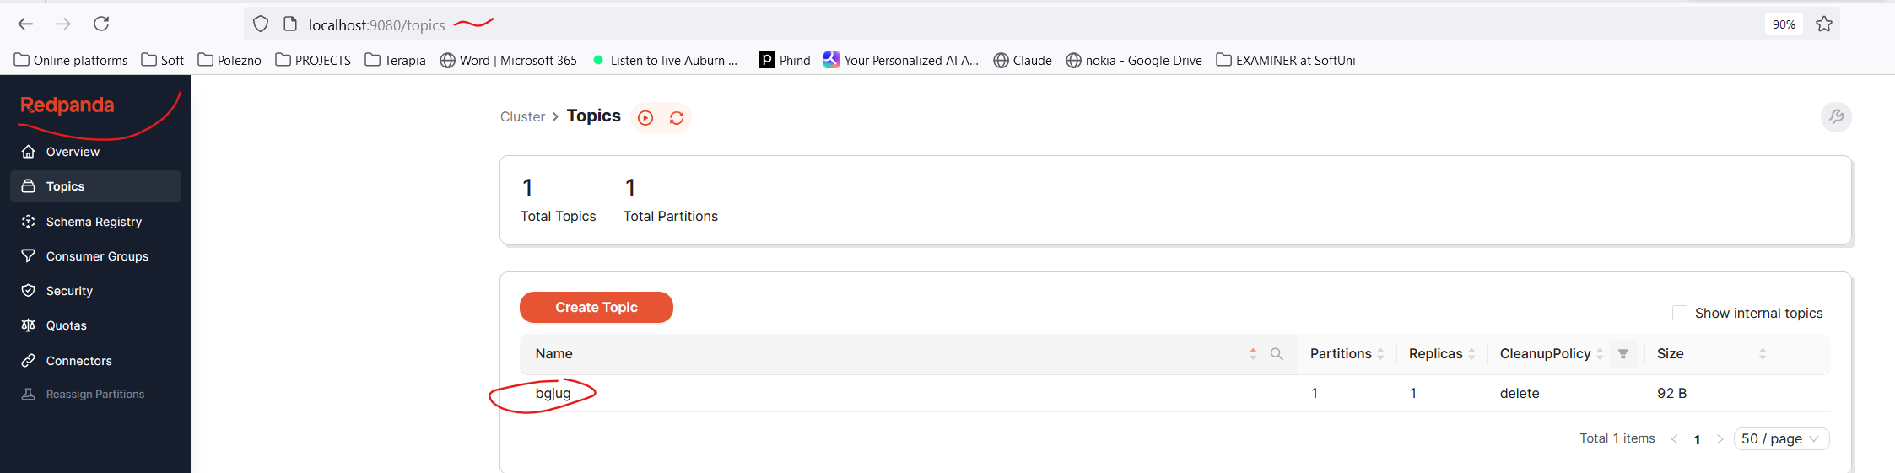

### Demo with Spring

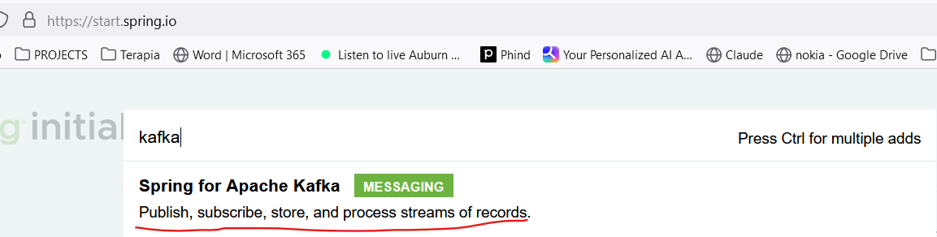

dependencies **{** implementation 'org.springframework.boot:spring-boot-starter-web'  
 implementation **'org.springframework.kafka:spring-kafka'**  
  
 testImplementation 'org.springframework.boot:spring-boot-starter-test'  
 testImplementation **'org.springframework.kafka:spring-kafka-test'**  
 testRuntimeOnly 'org.junit.platform:junit-platform-launcher'  
**}**

<https://spring.io/projects/spring-kafka>

<https://spring.io/projects/spring-kafka#learn>

<https://docs.spring.io/spring-kafka/reference/index.html>

<https://docs.spring.io/spring-kafka/reference/kafka/receiving-messages/listener-annotation.html>

<https://docs.spring.io/spring-kafka/reference/kafka/sending-messages.html>

Не е добре на production Кафка сама да си прави топиците – тази опция трябва да бъде настроена подходящо!!!

2024-08-12T13:36:36.054+03:00 INFO 9752 --- [live-demo] [ main] o.a.k.clients.consumer.ConsumerConfig : ConsumerConfig values:

allow.auto.create.topics = true

auto.commit.interval.ms = 5000

auto.include.jmx.reporter = true

auto.offset.reset = earliest

bootstrap.servers = [localhost:29092]

check.crcs = true

client.dns.lookup = use_all_dns_ips

client.id = consumer-application-3

client.rack =

connections.max.idle.ms = 540000

default.api.timeout.ms = 60000

enable.auto.commit = false

exclude.internal.topics = true

fetch.max.bytes = 52428800

fetch.max.wait.ms = 500

fetch.min.bytes = 1

group.id = application

group.instance.id = null

heartbeat.interval.ms = 3000

interceptor.classes = []

internal.leave.group.on.close = true

internal.throw.on.fetch.stable.offset.unsupported = false

isolation.level = read_uncommitted

key.deserializer = class org.apache.kafka.common.serialization.StringDeserializer

max.partition.fetch.bytes = 1048576

max.poll.interval.ms = 300000

max.poll.records = 500

metadata.max.age.ms = 300000

metric.reporters = []

metrics.num.samples = 2

metrics.recording.level = INFO

metrics.sample.window.ms = 30000

partition.assignment.strategy = [class org.apache.kafka.clients.consumer.RangeAssignor, class org.apache.kafka.clients.consumer.CooperativeStickyAssignor]

receive.buffer.bytes = 65536

reconnect.backoff.max.ms = 1000

reconnect.backoff.ms = 50

request.timeout.ms = 30000

retry.backoff.ms = 100

sasl.client.callback.handler.class = null

sasl.jaas.config = null

sasl.kerberos.kinit.cmd = /usr/bin/kinit

sasl.kerberos.min.time.before.relogin = 60000

sasl.kerberos.service.name = null

sasl.kerberos.ticket.renew.jitter = 0.05

sasl.kerberos.ticket.renew.window.factor = 0.8

sasl.login.callback.handler.class = null

sasl.login.class = null

sasl.login.connect.timeout.ms = null

sasl.login.read.timeout.ms = null

sasl.login.refresh.buffer.seconds = 300

sasl.login.refresh.min.period.seconds = 60

sasl.login.refresh.window.factor = 0.8

sasl.login.refresh.window.jitter = 0.05

sasl.login.retry.backoff.max.ms = 10000

sasl.login.retry.backoff.ms = 100

sasl.mechanism = GSSAPI

sasl.oauthbearer.clock.skew.seconds = 30

sasl.oauthbearer.expected.audience = null

sasl.oauthbearer.expected.issuer = null

sasl.oauthbearer.jwks.endpoint.refresh.ms = 3600000

sasl.oauthbearer.jwks.endpoint.retry.backoff.max.ms = 10000

sasl.oauthbearer.jwks.endpoint.retry.backoff.ms = 100

sasl.oauthbearer.jwks.endpoint.url = null

sasl.oauthbearer.scope.claim.name = scope

sasl.oauthbearer.sub.claim.name = sub

sasl.oauthbearer.token.endpoint.url = null

security.protocol = PLAINTEXT

security.providers = null

send.buffer.bytes = 131072

session.timeout.ms = 45000

socket.connection.setup.timeout.max.ms = 30000

socket.connection.setup.timeout.ms = 10000

ssl.cipher.suites = null

ssl.enabled.protocols = [TLSv1.2, TLSv1.3]

ssl.endpoint.identification.algorithm = https

ssl.engine.factory.class = null

ssl.key.password = null

ssl.keymanager.algorithm = SunX509

ssl.keystore.certificate.chain = null

ssl.keystore.key = null

ssl.keystore.location = null

ssl.keystore.password = null

ssl.keystore.type = JKS

ssl.protocol = TLSv1.3

ssl.provider = null

ssl.secure.random.implementation = null

ssl.trustmanager.algorithm = PKIX

ssl.truststore.certificates = null

ssl.truststore.location = null

ssl.truststore.password = null

ssl.truststore.type = JKS

value.deserializer = class org.apache.kafka.common.serialization.StringDeserializer

import lombok.RequiredArgsConstructor;  
import org.springframework.boot.CommandLineRunner;  
import org.springframework.boot.SpringApplication;  
import org.springframework.boot.autoconfigure.SpringBootApplication;  
import org.springframework.kafka.config.KafkaListenerEndpointRegistry;  
import org.springframework.kafka.core.KafkaTemplate;  
  
@SpringBootApplication  
@RequiredArgsConstructor  
public class LiveDemoApplication implements CommandLineRunner {  
  
 private final KafkaTemplate<String, String> kafkaTemplate; *//injecting it* private final KafkaListenerEndpointRegistry kafkaListenerEndpointRegistry; *//injecting it* public static void main(String[] args) {  
 SpringApplication.*run*(LiveDemoApplication.class, args);  
 }  
  
 @Override  
 public void run(String... args) throws Exception {  
*// for (int i = 0; i < 25_000_000; i++) {  
// kafkaTemplate.send("welcometokafka", "When is next Java beer in Plovdiv?");  
// }* kafkaListenerEndpointRegistry.getListenerContainer("bgjug").start(); //How to dynamically start/stop Kafka Listener  
 }  
}

--------------------

import lombok.extern.slf4j.Slf4j;  
import org.springframework.kafka.annotation.KafkaListener;  
import org.springframework.stereotype.Component;  
  
@Slf4j  
@Component  
public class KafkaConsumer {  
  
*// @KafkaListener(topics = "welcometokafka", groupId = "application", concurrency = "3")  
// @KafkaListener(topics = "welcometokafka", groupId = "application")* @KafkaListener(id = "bgjug", topics = "welcometokafka", groupId = "application", autoStartup = "false")  
 public void listen(String data) {  
 *log*.info(data);  
 }  
}

---------------------------

import org.apache.kafka.clients.consumer.ConsumerConfig;  
import org.apache.kafka.common.serialization.StringDeserializer;  
import org.springframework.context.annotation.Bean;  
import org.springframework.context.annotation.Configuration;  
import org.springframework.kafka.config.ConcurrentKafkaListenerContainerFactory;  
import org.springframework.kafka.core.ConsumerFactory;  
import org.springframework.kafka.core.DefaultKafkaConsumerFactory;  
  
import java.util.HashMap;  
import java.util.Map;  
  
@Configuration  
public class KafkaConsumerConfig {  
  
 @Bean  
 public ConsumerFactory<String, String> consumerFactory() {  
 return new DefaultKafkaConsumerFactory<>(consumerConfigs());  
 }  
  
 @Bean  
 public Map<String, Object> consumerConfigs() {  
 Map<String, Object> props = new HashMap<>();  
 props.put(ConsumerConfig.*BOOTSTRAP_SERVERS_CONFIG*, "localhost:29092");  
 props.put(ConsumerConfig.*KEY_DESERIALIZER_CLASS_CONFIG*, StringDeserializer.class);  
 props.put(ConsumerConfig.*VALUE_DESERIALIZER_CLASS_CONFIG*, StringDeserializer.class);  
  
 props.put(ConsumerConfig.*AUTO_OFFSET_RESET_CONFIG*, "earliest"); *//when app goes down and then restart* props.put(ConsumerConfig.*MAX_POLL_INTERVAL_MS_CONFIG*, 1); *//* props.put(ConsumerConfig.*MAX_POLL_RECORDS_CONFIG*, 100_000); *//* return props;  
 }  
  
 @Bean  
 ConcurrentKafkaListenerContainerFactory<String, String> kafkaListenerContainerFactory(ConsumerFactory<String, String> consumerFactory) {  
 ConcurrentKafkaListenerContainerFactory<String, String> factory = new ConcurrentKafkaListenerContainerFactory<>();  
 factory.setConsumerFactory(consumerFactory);  
  
 return factory;  
 }  
}

--------------------

import org.apache.kafka.clients.producer.ProducerConfig;  
import org.apache.kafka.common.serialization.StringSerializer;  
import org.springframework.context.annotation.Bean;  
import org.springframework.context.annotation.Configuration;  
import org.springframework.kafka.core.DefaultKafkaProducerFactory;  
import org.springframework.kafka.core.KafkaTemplate;  
import org.springframework.kafka.core.ProducerFactory;  
  
import java.util.HashMap;  
import java.util.Map;  
  
@Configuration  
public class KafkaProducerConfig {  
 @Bean  
 public KafkaTemplate<String, String> kafkaTemplate(ProducerFactory<String, String> producerFactory) { *//Injecting the producer factory* return new KafkaTemplate<String, String>(producerFactory);  
 }  
  
 @Bean  
 public ProducerFactory<String, String> producerFactory() {  
 return new DefaultKafkaProducerFactory<>(producerConfigs());  
 }  
  
 @Bean  
 public Map<String, Object> producerConfigs() {  
 Map<String, Object> props = new HashMap<>();  
 props.put(ProducerConfig.*BOOTSTRAP_SERVERS_CONFIG*, "localhost:29092");  
 props.put(ProducerConfig.*KEY_SERIALIZER_CLASS_CONFIG*, StringSerializer.class);  
 props.put(ProducerConfig.*VALUE_SERIALIZER_CLASS_CONFIG*, StringSerializer.class);  
 props.put(ProducerConfig.*COMPRESSION_TYPE_CONFIG*, "gzip");  
 *// See https://kafka.apache.org/documentation/#producerconfigs for more properties* return props;  
 }  
}

### Demos from Trayan Iliev

<https://github.com/iproduct/kafka-streams-javaland/>

<https://softuni.bg/trainings/resources/video/90522/video-2-28-10-2023-trayan-iliev-softuni-java-land-vol-2/4401>

#### Consumer with kafka-clients

dependencies **{** implementation 'org.apache.kafka:kafka_2.12:3.6.0'  
 implementation 'org.apache.kafka:kafka-clients:3.6.0'

**}**

import lombok.extern.slf4j.Slf4j;  
import org.apache.kafka.clients.consumer.ConsumerRecord;  
import org.apache.kafka.clients.consumer.ConsumerRecords;  
import org.apache.kafka.clients.consumer.KafkaConsumer;  
import org.apache.kafka.common.TopicPartition;  
  
import java.time.Duration;  
import java.util.Collections;  
import java.util.List;  
import java.util.Properties;  
  
@Slf4j  
public class DemoConsumer {  
 private Properties props = new Properties();  
 KafkaConsumer<String, String> consumer;  
  
 public DemoConsumer() {  
 props.setProperty("bootstrap.servers", "localhost:9093");  
 props.setProperty("group.id", "dmlConsumer");  
 props.setProperty("enable.auto.commit", "true");  
 props.setProperty("auto.commit.interval.ms", "1000");  
 props.setProperty("key.deserializer", "org.apache.kafka.common.serialization.StringDeserializer");  
 props.setProperty("value.deserializer", "org.apache.kafka.common.serialization.StringDeserializer");  
 consumer = new KafkaConsumer<>(props);  
  
 }  
  
 public void run() {

// kafka автоматично разпределя  
 **consumer.subscribe(Collections.*singletonList*("events"));**

// указваме топика и задаваме само partition 0 започвайки от офсет 0.   
 TopicPartition partition = new TopicPartition("events", partition 0);  
 consumer.assign(List.*of*(partition));  
 consumer.seek(partition, offset 0);  
  
 try {  
 while (true) {  
 ConsumerRecords<String, String> records = consumer.poll(Duration.*ofMillis*(100));  
 if (records.count() > 0) {  
 for (ConsumerRecord<String, String> record : records) {  
System.*out*.printf("offset = %d, key = %s, value = %s, headers = %s, topic = %s, partition = %d%n",  
record.offset(), record.key(), record.value(), record.headers(), record.topic(),record.partition());  
 }  
 }  
 }  
 } finally {  
 consumer.close();  
 }  
 }  
  
 public static void main(String[] args) {  
 DemoConsumer consumer = new DemoConsumer();  
 consumer.run();  
 }  
}

#### Producer with kafka-clients

import lombok.extern.slf4j.Slf4j;  
import org.apache.kafka.clients.producer.KafkaProducer;  
import org.apache.kafka.clients.producer.Producer;  
import org.apache.kafka.clients.producer.ProducerRecord;  
  
import java.util.Properties;  
  
@Slf4j  
public class DemoProducer {  
 private Properties props = new Properties();  
 private Producer<String, String> producer;  
  
 public DemoProducer() {  
 props.setProperty("bootstrap.servers", "localhost:9093");  
 props.setProperty("key.serializer", "org.apache.kafka.common.serialization.StringSerializer");  
 props.setProperty("value.serializer", "org.apache.kafka.common.serialization.StringSerializer");  
 producer = new KafkaProducer<>(props);  
 }  
  
 public void run() {  
 for(int i = 0; i < 10; i++){  
 ProducerRecord<String, String> record =  
 new ProducerRecord<>("events", "" + i, "IoT EVENT " + i);  
*// producer.send(record); //synchronous*

*//asynchronous with lambda* producer.send(record, (recordMetadata, exception) -> {  
 System.*out*.println(">>>" +  
 String.*format*("Topic %s, Partition: %d Offset: %d, Timestamp: %d\n",  
 recordMetadata.topic(),  
 recordMetadata.partition(),  
 recordMetadata.offset(),  
 recordMetadata.timestamp()  
 )  
 );  
 if (exception != null) {  
 *log*.error("Consumer eror: ", exception);  
 }  
 });  
 }  
 }  
  
 public static void main(String[] args) throws InterruptedException {  
 DemoProducer producer = new DemoProducer();  
 producer.run();  
 Thread.*sleep*(5000);  
 }  
}

#### Some Kafka console commands

In docs/kafka-commands.txt:

kafka-topics.bat --list --bootstrap-server localhost:9093

kafka-topics.bat --create --bootstrap-server localhost:9093 --replication-factor 1 --partitions 1 --topic my-new-topic

kafka-topics.bat --create --bootstrap-server localhost:9093 --replication-factor 1 --partitions 1 --topic events

kafka-topics.bat --list --bootstrap-server localhost:9093

kafka-topics.bat --describe --bootstrap-server localhost:9093 --topic sweepDistances

kafka-console-producer.bat --broker-list localhost:9093 --topic sweepDistances

kafka-console-producer.bat --broker-list localhost:9093 --topic sweepDistances –sync

kafka-console-consumer.bat --bootstrap-server localhost:9093 --topic sweepDistances --from-beginning

kafka-topics.bat --describe --bootstrap-server localhost:9093 --topic temperature

kafka-consumer-groups --bootstrap-server localhost:9092 -list

kafka-consumer-groups --bootstrap-server localhost:9092 --describe --group event-consumer

#### Replicated Topic Using Kafka

copy config\server.properties config\server-1.properties

copy config\server.properties config\server-2.properties

config/server-1.properties:

broker.id=1

listeners=PLAINTEXT://:9093

log.dirs=D:\\CourseKafka\\kafka_2.12-2.2.1\\kafka-logs-1

config/server-2.properties:

broker.id=2

listeners=PLAINTEXT://:9094

log.dirs=D:\\CourseKafka\\kafka_2.12-2.2.1\\kafka-logs-2

bin\windows\kafka-server-start config\server-1.properties

bin\windows\kafka-server-start config\server-2.properties

kafka-topics --describe --bootstrap-server localhost:9092 --topic my-replicated-topic

wmic process where "caption = 'java.exe' and commandline like '%server-1.properties%'" get processid

taskkill /F /PID pid_number

#### Some Spring application.properties

spring.kafka.bootstrap-servers=localhost:9093  
spring.kafka.producer.batch-size=1  
spring.kafka.producer.properties.linger.ms=0  
spring.kafka.streams.properties.commit.interval.ms=0  
spring.kafka.streams.application-id=kafka-streams-robot-demo  
spring.kafka.consumer.key-deserializer=org.apache.kafka.common.serialization.IntegerDeserializer  
spring.kafka.consumer.value-deserializer=org.apache.kafka.common.serialization.StringDeserializer

### Quarkus integration

<dependency>  
 <groupId>io.quarkus</groupId>  
 <artifactId>quarkus-smallrye-reactive-messaging-kafka</artifactId>  
</dependency>

------------

application.properties

*#########################  
## Logging configuration  
#########################*

quarkus.log.category."io.zerodt.service.KafkaEventLogProducer".level=INFO  
%dev.quarkus.log.category."io.zerodt.service.KafkaEventLogProducer".level=DEBUG  
%dev.quarkus.log.category."org.apache.kafka.clients".level=ERROR

*#########################  
## Kafka configuration  
#########################*%dev.kafka.bootstrap.servers=localhost:9092  
%prod.kafka.sasl.jaas.config=org.apache.kafka.common.security.scram.ScramLoginModule required username="${KAFKA_USER}" password="${KAFKA_PASSWORD}";  
  
mp.messaging.incoming.analytics-in.connector=smallrye-kafka  
mp.messaging.incoming.analytics-in.topic=analytics  
mp.messaging.incoming.analytics-in.key.serializer=org.apache.kafka.common.serialization.StringSerializer  
mp.messaging.incoming.analytics-in.value.serializer=org.apache.kafka.common.serialization.StringSerializer  
mp.messaging.incoming.analytics-in.group.id=wallet-service  
  
mp.messaging.outgoing.analytics.connector=smallrye-kafka  
mp.messaging.outgoing.analytics.topic=analytics  
mp.messaging.outgoing.analytics.key.serializer=org.apache.kafka.common.serialization.StringSerializer  
mp.messaging.outgoing.analytics.value.serializer=org.apache.kafka.common.serialization.StringSerializer

----------------------------

import io.smallrye.reactive.messaging.annotations.Blocking;  
import **io.smallrye.reactive.messaging.kafka.KafkaRecord**;  
import io.zerodt.bonus.dto.CancelBonusDTO;  
import io.zerodt.dto.AccountStatusChangedDTO;  
import io.zerodt.dto.UserProfileDTO;  
import io.zerodt.exception.BadDataException;  
import io.zerodt.service.WalletService;  
import io.zerodt.util.ExcludeCodeCoverageGenerated;  
import io.zerodt.util.JsonUtils;  
import org.apache.kafka.common.header.Header;  
import **org.eclipse.microprofile.reactive.messaging.Incoming**;  
import org.jboss.logging.Logger;  
import org.jboss.logging.MDC;  
  
import jakarta.enterprise.context.ApplicationScoped;  
import jakarta.inject.Inject;  
import jakarta.transaction.Transactional;  
import java.nio.charset.StandardCharsets;  
import java.util.concurrent.CompletionStage;  
  
@ApplicationScoped  
public class KafkaEventListener {  
  
 private static final Logger *LOGGER* = Logger.*getLogger*(KafkaEventListener.class);  
  
 @Inject  
 WalletService walletService;  
  
  
 @Incoming("analytics-in")  
 @Blocking  
 @Transactional  
 public CompletionStage<Void> updateProfileStatus(KafkaRecord<String, String> message) {  
 final String eventType = getHeaderAsString(message, "eventType");  
 if (!"ACCOUNT_STATUS_CHANGED".equals(eventType)) {  
 *LOGGER*.debugf("Received different type of event - %s. Skipping", eventType);  
 return message.ack();  
 }  
  
 *LOGGER*.infof("Received new user status changed event. Updating wallet status");  
 final AccountStatusChangedDTO statusChange = JsonUtils.*readJsonFromString*(message.getPayload(), AccountStatusChangedDTO.class);  
 if (statusChange == null) {  
 *LOGGER*.warnf("Received invalid profile JSON: %s", message.getPayload());  
 return message.ack();  
 }  
  
 MDC.*put*("profileId", statusChange.playerId());  
 try {  
 walletService.updateProfileWalletsStatus(statusChange.playerId(), statusChange.newStatus(), statusChange.previousStatus());  
 } finally {  
 MDC.*clear*();  
 }  
 return message.ack();  
 }

}

--------------------

import **io.smallrye.reactive.messaging.kafka.OutgoingKafkaRecord**;  
import **org.eclipse.microprofile.reactive.messaging**.Channel;  
import **org.eclipse.microprofile.reactive.messaging.Emitter**;  
  
import jakarta.enterprise.context.ApplicationScoped;  
import jakarta.inject.Inject;  
  
@ApplicationScoped  
public class **KafkaEventLogEmitter** {  
  
 @Inject  
 **@Channel("analytics")**  
 Emitter<String> analyticsEmitter;  
  
 public void **emmitAnalyticsEvent**(**OutgoingKafkaRecord**<String, String> message) {  
 analyticsEmitter**.send**(message);  
 }  
}

----------------------

public class OutgoingKafkaRecord<K, T> implements KafkaRecord<K, T>

public interface **KafkaRecord**<K, T> extends Message<T>, ContextAwareMessage<T> {  
  
 static <K, T> OutgoingKafkaRecord<K, T> from(Message<T> message) {  
 return OutgoingKafkaRecord.*from*(message);  
 }  
  
 */**  
 * Creates a new outgoing Kafka record.  
 *  
 * @param key the key, can be {@code null}  
 * @param value the value / payload, must not be {@code null}  
 * @param <K> the type of the key  
 * @param <T> the type of the value  
 * @return the new outgoing Kafka record  
 */* static <K, T> OutgoingKafkaRecord<K, T> **of**(K key, T value)

------------

import io.smallrye.reactive.messaging.kafka.KafkaRecord;  
import io.smallrye.reactive.messaging.kafka.OutgoingKafkaRecord;

import jakarta.enterprise.context.ApplicationScoped;  
import jakarta.enterprise.event.Observes;

import jakarta.inject.Inject;

import static jakarta.enterprise.event.TransactionPhase.*AFTER_COMPLETION*;

@ApplicationScoped  
@ExcludeCodeCoverageGenerated  
public class KafkaEventLogProducer {  
  
 private static final Logger *LOGGER* = Logger.*getLogger*(KafkaEventLogProducer.class);  
  
 @Inject  
 **KafkaEventLogEmitter** emitter;  
  
 public void publishLoyaltyLevelChangeEvent(@Observes(during = *AFTER_COMPLETION*) LoyaltyStatusChangeDTO loyaltyStatusChange) {  
 Long profileId = loyaltyStatusChange.profileId();  
  
 final String loyaltyStatusChangeMessage = JsonUtils.*toJsonString*(loyaltyStatusChange);  
 final var loyaltyStatusChangeRecord = **KafkaRecord.*of***(profileId.toString(), loyaltyStatusChangeMessage)  
 .withHeader("id", UUID.*randomUUID*().toString())  
 .withHeader("eventType", "LOYALTY_STATUS_CHANGE");

*LOGGER*.debugf("Publishing the following message to analytics topic: %s", loyaltyStatusChangeRecord);  
 **emitter.emmitAnalyticsEvent**(loyaltyStatusChangeRecord);  
 }

### Kafka on Windows 10

Kafka is a message broker exchanging messages in two or more external microservices

<https://kafka.apache.org/quickstart>

<https://www.youtube.com/watch?v=aKDWWICgfA0>

#### [STEP 1: GET KAFKA](https://kafka.apache.org/quickstart#quickstart_download)

server.properties файла  log.dirs=/tmp/kafka-logs

запиши в основната директория на kafka, в случая отбелязано с   /tmp

C:/SYSTEM/kafka_2.13-3.2.1/kafka-logs

zookeeper.properties   dataDir= /tmp/zookeeper-data   запиши в основната директория на kafka, в случая отбелязано с   /tmp

C:/SYSTEM/kafka_2.13-3.2.1/zookeeper-data

#### [STEP 2: START THE KAFKA ENVIRONMENT](https://kafka.apache.org/quickstart#quickstart_startserver)

Отваряме cmd в директория kafka_2.13-3.2.1

.\  e текущата директория

C:\SYSTEM\kafka_2.13-3.2.1>.\bin\windows\zookeeper-server-start.bat .\config\zookeeper.properties

C:\SYSTEM\kafka_2.13-3.2.1>.\bin\windows\kafka-server-start.bat .\config\server.properties

#### [STEP 3: CREATE A TOPIC TO STORE YOUR EVENTS](https://kafka.apache.org/quickstart#quickstart_createtopic)

C:\SYSTEM\kafka_2.13-3.2.1>.\bin\windows\kafka-topics.bat --create --topic mynewprofessiontopic --bootstrap-server localhost:9092

Created topic mynewprofessiontopic.

C:\SYSTEM\kafka_2.13-3.2.1>.\bin\windows\kafka-topics.bat --describe --topic mynewprofessiontopic --bootstrap-server localhost:9092

Topic: mynewprofessiontopic     TopicId: qwAyRYs3Tj2gBW3BKlNJSA PartitionCount: 1       ReplicationFactor: 1    Configs: segment.bytes=1073741824

        Topic: mynewprofessiontopic     Partition: 0    Leader: 0       Replicas: 0     Isr: 0

#### [STEP 4: WRITE SOME EVENTS INTO THE TOPIC](https://kafka.apache.org/quickstart#quickstart_send)

C:\SYSTEM\kafka_2.13-3.2.1>.\bin\windows\kafka-console-producer.bat --topic mynewprofessiontopic --bootstrap-server localhost:9092

>Hello world

>My first topic event

>demo1

>demo2

>

>Terminate batch job (Y/N)? Y

#### [STEP 5: READ THE EVENTS](https://kafka.apache.org/quickstart#quickstart_consume)

C:\SYSTEM\kafka_2.13-3.2.1>.\bin\windows\kafka-console-consumer.bat --topic mynewprofessiontopic --from-beginning --bootstrap-server localhost:9092

Hello world

My first topic event

demo1

demo2

Processed a total of 2 messages

C:\SYSTEM\kafka_2.13-3.2.1>.\bin\windows\kafka-console-consumer.bat --topic mynewprofessiontopic --from-beginning --bootstrap-server localhost:9092

Hello world

My first topic event

demo1

demo2

#### STEP 6: TRACE WHEN A NEW TOPIC/MESSAGE APPEAR in the consumer console

**How to see all current topics**

.\bin\windows\kafka-topics.bat --bootstrap-server localhost:9092 --describe

.\bin\windows\kafka-topics.bat  --bootstrap-server localhost:9092 --list

**How to see/read the events of each topic (i.e. the messages of each topics)**

.\bin\windows\kafka-console-consumer.bat --topic po-write --from-beginning --bootstrap-server localhost:9092

Значи създаваме си топик, в него се записват event-и/ message-и - чрез producer. А когато искаме да ги прочетем/достъпим тези message-и, то използваме consumer.

#### STEP 7: - Run Kafka Commands inside the Docker container

Starting the KAFKA from Docker-compose.yaml file

От текущата директория

docker-compose up -d

**docker-compose.yaml**

version: '2'

services:

 zookeeper:

   image: quay.io/strimzi/kafka:0.29.0-kafka-3.1.1

   command: [

     "sh", "-c",

     "bin/zookeeper-server-start.sh config/zookeeper.properties"

   ]

   ports:

     - "2181:2181"

   environment:

     LOG_DIR: /tmp/logs

 kafka:

   image: quay.io/strimzi/kafka:0.29.0-kafka-3.1.1

   command: [

     "sh", "-c",

     "bin/kafka-server-start.sh config/server.properties --override listeners=$${KAFKA_LISTENERS} --override advertised.listeners=$${KAFKA_ADVERTISED_LISTENERS} --override zookeeper.connect=$${KAFKA_ZOOKEEPER_CONNECT}"

   ]

   depends_on:

     - zookeeper

   ports:

     - "9092:9092"

   environment:

     LOG_DIR: "/tmp/logs"

     KAFKA_ADVERTISED_LISTENERS: PLAINTEXT://localhost:9092

     KAFKA_LISTENERS: PLAINTEXT://0.0.0.0:9092

     KAFKA_ZOOKEEPER_CONNECT: zookeeper:2181

**docker ps**

да видим контейнерите, които вървят в момента



**docker exec -it <kafka_conatiner_id> sh**

docker exec -it fc33cf454631 sh

Now we are inside our Docker container.

**cd /opt/kafka_<version>**

cd /opt/kafka/bin

We are moving to the folder where all the executives are located.

**Дебъгване на kafka**

./bin/kafka-topics.sh --create --topic quickstart --bootstrap-server localhost:9092

./bin/kafka-topics.sh --bootstrap-server localhost:9092 --list

./kafka-topics.sh --bootstrap-server localhost:9092 --list

./bin/windows/kafka-topics.bat --bootstrap-server localhost:9092 --list    това не работи съвсем

### Kafka streams

For many more info – see the *KafkaStreams_JavaLand.pdf* file.

dependencies {

implementation 'org.apache.kafka:kafka-clients:3.6.0'

implementation 'org.apache.kafka:**kafka-streams**:3.6.0‘

…

}

public static void main(String[] args) {

*// Use the builders to define the actual processing topology, e.g. to specify from which input topics to read, // which stream operations (filter, map, etc.) should be called, and so on.*

StreamsBuilderbuilder = ...; *// when using the DSL*

Topology topology= builder.build();

*//*

*// OR*

*//*

Topology topology= ...; *// when using the Processor API*

*// Use the configuration to tell your application where the Kafka cluster is,// which Serializers/Deserializers to use by default, to specify security settings, and so on.*

Properties props = ...;KafkaStreamsstreams = new KafkaStreams(topology, props);

*// Add shutdown hook to stop the Kafka Streams threads. You can optionally provide a timeout to`close`.*

Runtime.*getRuntime*().addShutdownHook(new Thread(streams::close));

}

### Conclusion

Всеки път/за всяка задача трябват да настройваме ръчно Kafka producer и kafka consumer настройките! Никога да не разчитаме на дефаултните конфигурации!

# 8. UBUNTU as WSL

Installing Ubuntu from Microsoft store

<https://apps.microsoft.com/store/detail/ubuntu-22041-lts/9PN20MSR04DW?hl=en-us&gl=us>

Отиди на C:\ директорията

cd /mnt/c

### Installing Java on Ubuntu/WSL

[https://kontext.tech/article/621/install-open-jdk-on-ws](https://kontext.tech/article/621/install-open-jdk-on-wsl)

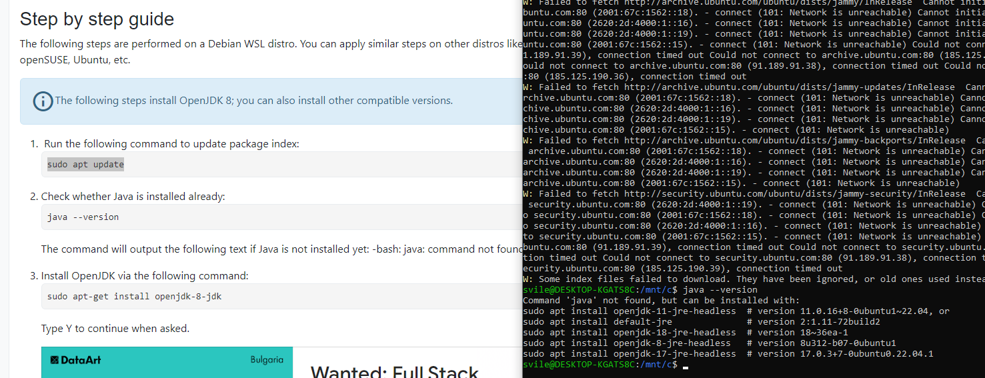

sudo apt install openjdk-11-jre-headless  # version 11.0.16+8-0ubuntu1~22.04, or

sudo apt install default-jre              # version 2:1.11-72build2

sudo apt install openjdk-18-jre-headless  # version 18~36ea-1

sudo apt install openjdk-8-jre-headless   # version 8u312-b07-0ubuntu1

sudo apt install openjdk-17-jre-headless  # version 17.0.3+7-0ubuntu0.22.04.1

/usr/lib/jvm/java-11-openjdk-amd64/bin/

### Configuring JAVA_HOME

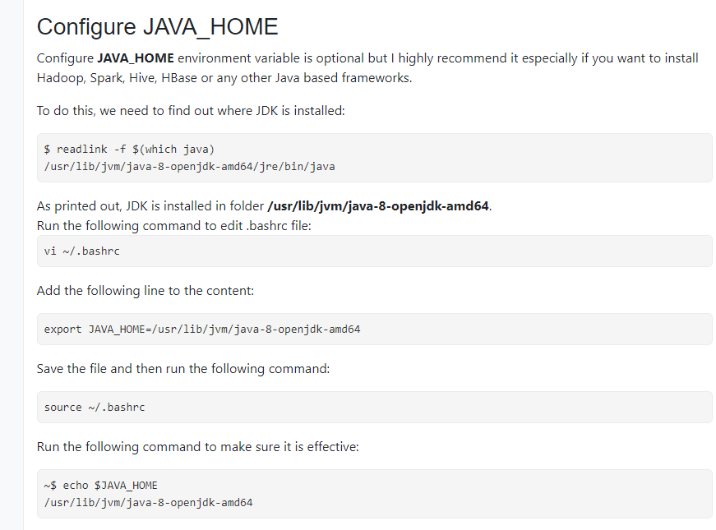

Insert

Cancel

Basic Linux commands

<https://gitlab.com/vv-b-s/operating-systems/-/blob/master/docs/7-LinuxIntroductionBaseCommands-en.adoc>

<https://maker.pro/linux/tutorial/basic-linux-commands-for-beginners>

Type :wq to exit

: denotes that you are going to run a command

w means you want to write the file

q means you want to quit the editor

Другият вариант за изход е Shift + ZZ

### Installing Kafka on Ubuntu/WSL

Следвам стъпките от Apache Kafka, като трябва да ползвам и **sudo** ("SuperUser Do") в началото на командата

От която и да е директория, през cmd-то като достъпим, и след като напишем bash и то можем да подаваме linux командите, но тук няма java инсталирана

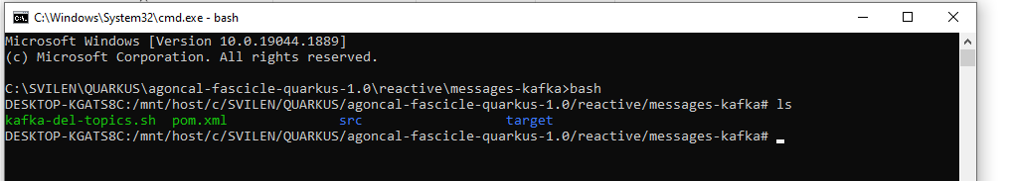

<https://stackoverflow.com/questions/63006982/add-kafka-path-to-etc-environment-file-for-kafka-to-be-accessed-globally-add-k>

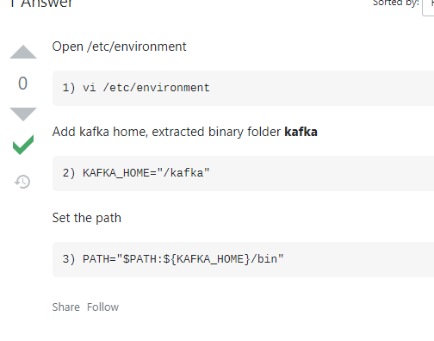

Executing a shell script in Linux

<https://www.cyberciti.biz/faq/how-to-execute-a-shell-script-in-linux/>

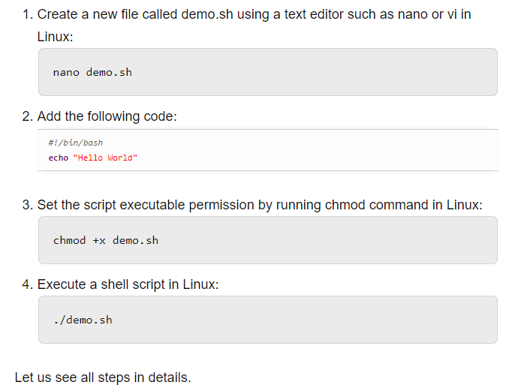

kafka-del-topics.sh

**#!/bin/bash**

echo "Hello $USER"

echo "Today is $(date)"

echo "Bye for now"

TOPICS=$(kafka-topics.sh --bootstrap-server localhost:2181 --list )

for T in $TOPICS

do

 if [ "$T" != "__consumer_offsets" ]; then

   kafka-topics.sh --bootstrap-server localhost:2181 --delete --topic $T

 fi

Done

kafka-del-topics.sh

**#!/bin/bash**

echo "Hello $USER"

echo "Today is $(date)"

echo "Bye for now"

TOPICS=$(kafka-topics --bootstrap-server localhost:2181 --list )

for T in $TOPICS

do

 if [ "$T" != "__consumer_offsets" ]; then

   kafka-topics --zookeeper-server localhost:2181 --delete --topic $T

 fi

done

# 9. Docker and containerization

## I. Containers, Docker, Images

### Containerization and images

OS-level virtualization refers to an operating system paradigm in which the kernel allows the existence of **multiple isolated** user **space instances** known as **containers, zones, jails, …**

Работят в изолация /Standalone/.

Не може единия апп да източи паметта на другия апп. Ако единия апп му свърши паметта, то другия апп продължава да работи.

Цял сървър е доста скъпо също.

Затова използваме контейнеризация.

Container:

* + A sandboxed process that is isolated from all other processes on a host machine
  + Should contain only a single application and its dependencies
  + **Portable and lightweight**

Image:

* + Standalone executable package
  + The specification of a container

### VMs (виртуални машини) vs Containers



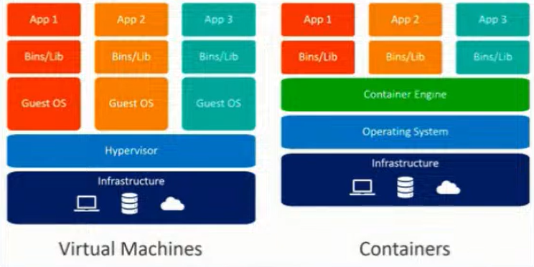

Първоначално е имало само виртуални машини.

Виртуална машина означава на даден хост машина/сървър да има изолирана операционна система, която можем да я ползваме без достъп до някакви други неща.

Идеята, ако има тази хост машина досттъчно ресурси, то да пуснем две незасивими изолирани виртуално операционни системи. Идеята е на всяка виртуална машина да се пуска един application.

Hypervisor – да дистрибутира и менъджира всички виртуални операционни системи и техните ресурси.

**Един Docker container е процес, а не цяла виртуална машина!** Една хост машина, една операционна система, различни процеси като един от тях е Docker cointainer!

В самият Docker container се казва също че има инсталирана малка операционна система – това всъщност не е съвсем вярно! Има файлова операционна система.

Docker Daemon(Docker engine) менъджира отделните контейнери.

* VMs virtualize the hardware
* Complete isolation
* Complete OS installation. Requires more resources
* Runs almost any OS
* Containers virtualize the OS
* Lightweight isolation
* Shared kernel among all the containers. Requires fewer resources
* Runs on the same OS == Linux

### Solutions

* **rkt** by CoreOS
  + Application container engine
  + <https://coreos.com/rkt>
* **Docker** byDocker Inc
  + Application container engine
  + <https://www.docker.com/>

### Containers Concepts (Docker View)

* **Container image** shows the state of a container, including registry or file system changes = все едно **container image** e нещо клас, а самия **контейнер** е нещо като клас. Самият container image e работещ container.
* **Container OS image** is the first layer of potentially many image layers that make up a container = основния image, върху който се гради контейнера
* **Container repository** stores container images and their dependencies = мястото, където се пазят тези container images

### Definitions

* Container
  + Containers are processes with much more isolation
* Image
  + Images provide a way for simpler software distribution

### Container layers



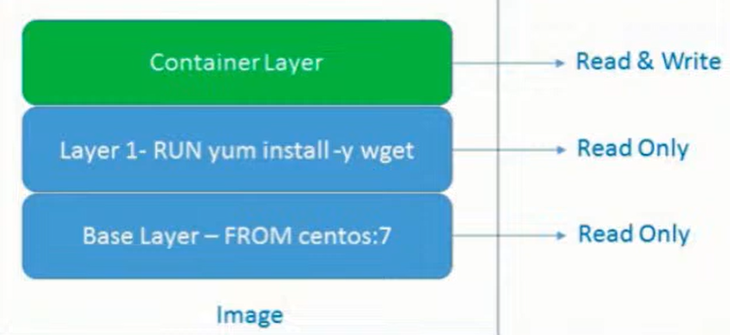

docker pull nginx

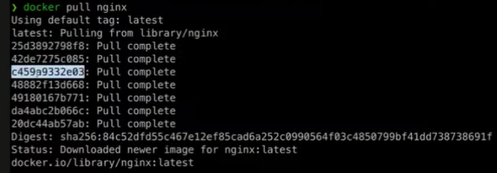

Като дръпнем един докер image, той сваля няколко слоя/layers с няколко id-та, като всеки layer е една от следните команди: FROM, MAINTAINER, RUN, COPY, ADD, EXPOSE, ENTRYPOINT, CMD.

Ако имаме едно и също начало на два докер файла за изпичане на image то при pull-ване на 2 различни Image-a, то те ще се преизползват – няма да ги дърпа два пъти! Т.е. всеки един layer се кешира поотделно и представлява определена част от тази lightweight файлова система. Това също означава, че image-те се оптимизират. Всички layer-и се кешират, с изключение на последния Read & Write layer.

Когато създадем нов контейнер от image, то само тогава се създава и то **наново Read & Write layer-a**.

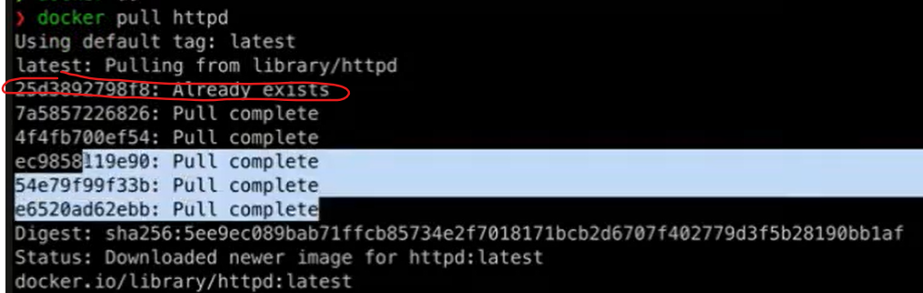

## II. Docker

### Docker Engine

* Docker Mission – **Build**, **Ship**, **Deploy**
* Client-server application
* Components
  + dockerd daemon
  + REST API
  + docker CLI



### Registries – мястото, където се пазят тези images

* Provided by Docker
  + Cloud
    - Docker Hub (<https://hub.docker.com/explore/>)
    - Docker Store (<https://store.docker.com/>)
  + On-premise
* Provided by 3rd parties
  + Quay.io, Artifactory, Google Container Registry

### Workflow

**docker build** – създаване на docker image

**docker pull –** дърпане на image от регистри

**docker run** – стартирай ми контейнер

**docker push** – ако локално ние направим update и искаме нашия image да го дистрибутираме към регистрито.



Client – Docker CLI (Docker Command Line Interface)

Docker host – това реално е Docker engine-a == Docker daemon

Не е задължително CLI и Docker host да са на една и съща машина. Но в прости дема – това е една и съща машина.

Docker платформата върви само на Линукс. С други думи на Windows и на MacOS пуска виртуална машина на Линукс, за да може да запали Докера.

Registry – място където се споделят images – нещо като MVN repository

<https://hub.docker.com/>

## III. Docker Installation

### What We Need to Know?

* **Two Editions** (Community and Enterprise)
* **Native Options**
  + Docker for Linux – без Desktop 😊
  + Docker Desktop for MAC
  + Docker Desktop for Windows
* **Docker Toolbox** (deprecated) - All-in-one solution
  + For Mac and Windows



## IV. Working with Docker

Docker е оптимизиран откъм бързина, но не и откъм дисково пространство

### Pull / Image Pull

* Purpose
  + Pull an image or a repository from a registry
* Old syntax

docker pull [OPTIONS] NAME[:TAG|@DIGEST]

* New syntax

docker image pull [OPTIONS] NAME[:TAG|@DIGEST]

* Example

docker image pull ubuntu:latest

### Run / Container Run

* Purpose
  + Run a command in a new container
* Old syntax

docker run [OPTIONS] IMAGE [COMMAND] [ARG]

docker run -it ubuntu :latest //-it идва от interactive TTY – да имаме достъп отвън до контейнера отвътре

docker run -it ubuntu :latest /bin/bash стартирай ми контейнера с имидж Ubuntu, и стартирай отвътре bash-a

docker run -it nginx самият nginx може да пуска web приложение

docker run -p 8080:80 nginx **-p** опция за forwarding of traffic (port forwarding)

**Лявата страна на порта “8080:8080” е на нашата линукс сървърна машина, а дясната страна на порта е каквото е вътре в пуснатия един или няколко контейнера от image nginx.**

docker run -d -p 8080:80 nginx **-d** опция за пускане на процеса в background/long run – като се изпълни процеса, то процеса остава и не се самоизчиства!

docker run -d -p 8081:80 nginx



* New syntax

docker container run [OPTIONS] IMAGE [COMMAND] [ARG]

* Example

docker container run -it ubuntu

### Exec

Ако имаме няколко контейнера активни, то в нов терминал да си достъпим отвътре някой действащ контейнер примерно.

Runs a new command in a running container.



docker exec -it hardcore_torvalds bash

docker exec -it 5bd bash само с част от container id-то стават доста от докер командите

### Kill



docker kill 5bd само с част от container id-то стават доста от докер командите

### Prune

Deletes both containers and images

**docker system prune -a**

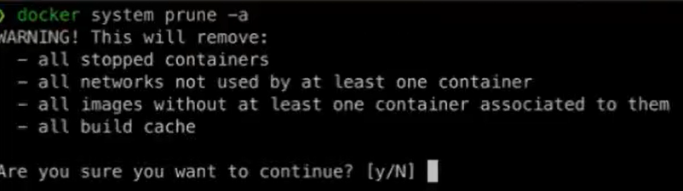

### Run container with a specific volume / Bind Mount

docker run -d -p 8080:80 **-v** /tmp/nginx:/user/share/nginx/html nginx

Рънни контейнер от nginx имидж, като копирай всичко от папка /tmp/nginx вътре в контейнера на път /user/share/nginx/html – като **-v** указва, че един вид това е volume. В случая този ред означава **Bind Mount** – директна връзка между външния свят и контейнра вътре, и е по-различно от volume. Volume заема произволно място на хост машината, докато в нашия случай ние сме си направили папка отвън, която да се копира вътре в контейнера.

### Images / Image Ls

* Purpose
  + List locally available images
* Old syntax

docker images [OPTIONS] [REPOSITORY[:TAG]]

* New syntax

docker image ls [OPTIONS] [REPOSITORY[:TAG]]

* Example

docker image ls fedora

### Image inspect

**docker image inspect my-java-app**

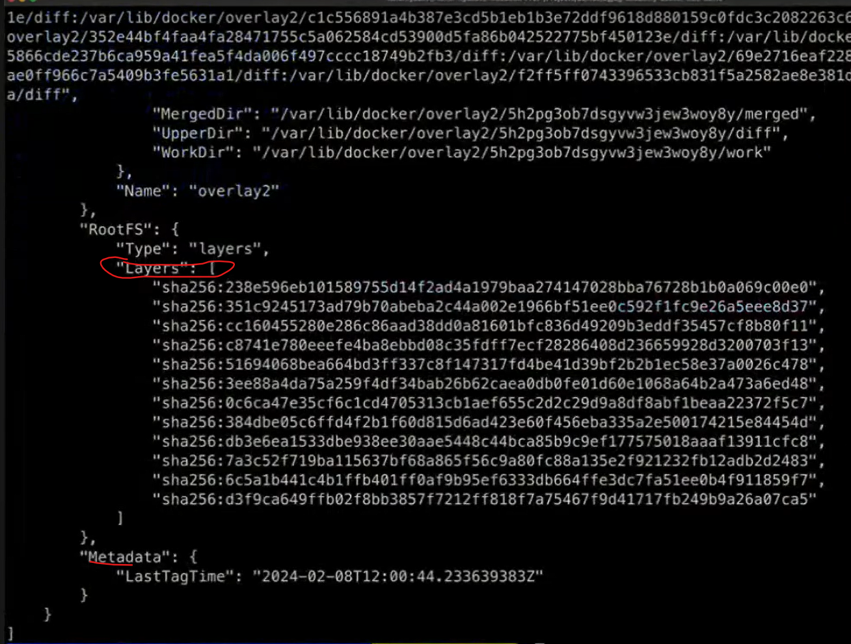

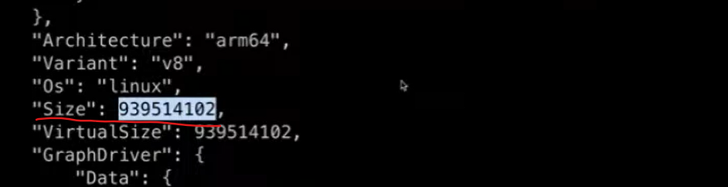

### Ps / Container Ls

* Purpose
  + List containers
* Old syntax

docker ps [OPTIONS]

* New syntax

docker container ls [OPTIONS]

* Example

docker container ls –a -q

### Rm / Container Rm

* Purpose
  + Remove one or more containers
* Old syntax

docker rm [OPTIONS] CONTAINER [CONTAINER]

* New syntax

docker container rm [OPTIONS] CONTAINER [CONTAINER]

* Example

docker container rm weezy_snake

### Rmi / Image Rm

* Purpose
  + Remove one or more images
* Old syntax

docker rmi [OPTIONS] IMAGE [IMAGE]

* New syntax

docker image rm [OPTIONS] IMAGE [IMAGE]

* Example

docker image rm ubuntu fedora

### Start / Container Start

* Purpose
  + Start one or more stopped containers
* Old syntax

docker start [OPTIONS] CONTAINER [CONTAINER]

* New syntax

docker container start [OPTIONS] CONTAINER [CONTAINER]

* Example

docker container start -a -i 0cbf27183

### Restart / Container Restart

* Purpose
  + Restart a one or more containers
* Old syntax

docker restart [OPTIONS] CONTAINER [CONTAINER]

* New syntax

docker container restart [OPTIONS] CONTAINER [CONTAINER]

* Example

docker container restart 0cbf27183

### Stop / Container Stop

* Purpose
  + Stop one or more running containers
* Old syntax

docker stop [OPTIONS] CONTAINER [CONTAINER]

* New syntax

docker container stop [OPTIONS] CONTAINER [CONTAINER]

* Example

docker container stop 0cbf27183

### Unpause / Container Unpause

* Purpose
  + Unpause all processes within one or more containers
* Old syntax

docker unpause CONTAINER [CONTAINER]

* New syntax

docker container unpause CONTAINER [CONTAINER]

* Example

docker container unpause 0cbf27183

### Attach / Container Attach

* Purpose
  + Attach to a running container
* Old syntax

docker attach [OPTIONS] CONTAINER

* New syntax

docker container attach [OPTIONS] CONTAINER

* Example

docker container attach 0cbf27183

docker -exec ……

### Push / Image Push

* Purpose
  + Push an image or repository to a registry
* Old syntax

docker push [OPTIONS] NAME[:TAG]

* New syntax

docker image push [OPTIONS] NAME[:TAG]

* Example

docker image push repo-name/test:latest

### Login to Docker registry

* Purpose
  + Log into a Docker registry
* Old syntax

docker login [OPTIONS] [SERVER]

* New syntax

docker login [OPTIONS] [SERVER] като стария синтаксис

* Example

docker login

### Logout from Docker registry

* Purpose
  + Log out from a Docker registry
* Old syntax

docker logout [SERVER]

* New syntax

docker logout [SERVER] като стария синтаксис

* Example

docker logout

## V. Image from DockerFile – изпичане на docker файл

### General Structure (Dockerfile)

* Script, composed of commands and arguments
* Always begins with FROM instruction

*# Set the base image*

FROM nginx Comment

*# Set the maintainer*

MAINTAINER John Smith Command (Instruction)

*# Copy files*

COPY index.html /usr/share/nginx/html/

### FROM

* Purpose
  + Defines the base image to use to start the build process
* Syntax

FROM <image>[:<tag>] [AS <name>]

* Example

*# it is a good practice to state a version (tag)*

FROM ubuntu:18.04

*# for the latest version the tag could be skipped*

FROM ubuntu

### MAINTAINER

* Purpose
  + Sets the author field of the image. It is deprecated
* Syntax

MAINTAINER <name>

* Example

*# deprecated*

MAINTAINER John Smith

*# newer variant is this:*

LABEL maintainer="John Smith"

### RUN

* Purpose
  + Used during build process to add software (forms another layer)
* Syntax

RUN <command>

* Example

*# single command*

RUN apt-get -y update

*# more than one command*

RUN apt-get -y update && apt-get -y upgrade

### COPY

* Purpose
  + Copy files between the host and the container
* Syntax

COPY [--chown=<user>:<group>] <src>... <dest>

* Example

*# Copy single file*

COPY readme.txt /root

*# Copy multiple files*

COPY *.html /var/www/html/my-web-app

### ADD

* Purpose
  + Copy files to the image
* Syntax

ADD [--chown=<user>:<group>] <src>... <dest>

* Example

*# Add single file from URL*

ADD https://softuni.bg/favicon.ico /www/favicon.ico

*# Add tar file content*

ADD web-app.tar /var/www/html/my-web-app

### EXPOSE

* Purpose
  + Informs Docker that the container listens on the specified ports
* Syntax

EXPOSE <port> [<port>/<protocol>...]

* Example

*# single port*

EXPOSE 80

*# multiple ports*

EXPOSE 80 8080

### ENTRYPOINT

* Purpose
  + Allows configuration of container that will run as an executable
  + **Задължителната команда, която ще се изпълни в началото**
* Syntax

*# exec form, this is the preferred form*

ENTRYPOINT ["executable", "param1", "param2"]

*# shell form*

ENTRYPOINT command param1 param2

### CMD

* Purpose
  + Main purpose is to provide defaults for an executing container
  + **Дефаултната команда, която ще се изпълни в началото**
* Syntax

*# exec form, this is the preferred form*

CMD ["executable","param1","param2"]

*# as default parameters to ENTRYPOINT*

CMD ["param1","param2"]

*# shell form*

CMD command param1 param2

### CMD vs ENTRYPOINT

* Both **define** what **command** gets **executed** when **running** a container
* **Dockerfile** should specify at **least** **one** of them
* **ENTRYPOINT** should be defined when using the **container** as an **executable**
* **CMD** should be used as a way of defining **default** **arguments** for an **ENTRYPOINT** command or for **executing** an **ad-hoc** command in a container
* **CMD** will be overridden when **running** the container with **alternative** arguments
* Both have **exec** and shell **form**
* When used **together** **always** use their **exec** form

Когато се използват заедно или поотделно:

CMD командата може да заема няколко аргумента



### Build / Image Build

* Purpose
  + Build an image from a Dockerfile
* Old syntax

docker build [OPTIONS] PATH | URL | -

* New syntax

docker image build [OPTIONS] PATH | URL | -

* Example - **-t** означава сложи му таг, а точката е текущата директория

**docker image build -t new-image** **.**

Ако създаваме локално docker image на M1, M2, M3 MacOS компютър (ARM или ARM64 процесорна архитектура), то би имало проблем този имидж като го качим в регистрито и други потребители си го изтеглят и пуснат контейнер на обикновен Линукс. Затова ако сме на MacOS пускаме следната команда и тогава е доста голям шанса да работи:

**docker build buildx –platform linux/amd64 my-java-app .**

Доста често в практиката тези docker images се билдват от Jenkins/GitHub actions агенти, и тъй като се билдват (чрез buildАаА.yml) на Линукс сървър, тогава го нямаме този проблем с ARM64! T.e. преместваме създаването/ изпичането на докер image в CI/CD pipeline-a.

### Dockerfile example workflow

#### Example 1:

Dockerfile-build

# We start from openjdk17 base image to have JDK installed

FROM eclipse-temurin:17-jdk  
WORKDIR /app   
  
COPY build/libs/petclinic-0.0.1-SNAPSHOT.jar app.jar //копирай jar файла като app.jar вътре в контейнера  
  
CMD [”java”, ”-jar”, ”app.jar”] //Read & Write layer

In the terminal:

**docker build -t my-java-app . -t** означава сложи му таг, а точката е текущата директория

docker run -p -d 8080:8080 **my-java-app**

#### Example 2:

Dockerfile-build

# We start from openjdk17 base image to have JDK installed

FROM eclipse-temurin:17-jdk  
WORKDIR /app //same as RUN mkdir app && cd app

//организираме layers по честота на промяна – т.е. src ще се променя често, тогава измести копиранията за gradle по-горе – това ще ги сложи в кеша за следващ image build ще се изпълнява по-бързо   
COPY gradlew . //копирай gradlew файла вътре в контейнера  
COPY gradle gradle/ //копирай съдържанието на gradle папката вътре в контейнера в директория gradle/  
COPY build.gradle.kts .  
COPY settings.gradle.kts .  
  
COPY src src/ //копирай съдържанието на src папката вътре в контейнера в директория src/  
RUN ./gradlew **bootJar**  
  
EXPOSE 8080  
  
CMD sh -c 'java -jar build/libs/*.jar' //Read & Write layer

In the terminal:

**docker build -t my-java-app . -t** означава сложи му таг, а точката е текущата директория

След като image-a e изпечен/създаден, то може да пуснем container от него:

**docker run -it my-java-app /bin/bash**

#### Example 3 – with maven offline:

Dockerfile-build

# We start from openjdk17 base image to have JDK installed

FROM eclipse-temurin:17-jdk  
WORKDIR /app //same as RUN mkdir app && cd app

COPY maven???*** .

# 3 layers runs

RUN apt update

RUN apt install java

RUN apt install python

# preferable to be only 1 layer instead of 3 layers!!!

RUN apt update && apt install java && apt install python

RUN mvn dependencies:go-offline

COPY src src/

RUN ./mvnw **package**  
  
EXPOSE 8080  
  
CMD sh -c 'java -jar build/libs/*.jar'

#### Example 4 – multistage

Заема по-малко място самият готов изпечен image

Dockerfile-multistage

# phase 1

FROM eclipse-temurin:**17-jdk** AS *build*WORKDIR /app  
  
COPY gradlew .  
COPY gradle gradle/  
COPY build.gradle.kts .  
COPY settings.gradle.kts .  
  
COPY src src/  
RUN ./gradlew bootJar

# phase 2 – run the jar file

FROM eclipse-temurin:**17-jre**  
WORKDIR /app  
  
COPY --from=*build* /app/build/libs/*.jar app.jar  
  
EXPOSE 8080  
CMD sh -c 'java -jar app.jar'

docker build -t "petclinic" -f Dockerfile-multistage .

### Recommendations

* Don’t create large images
* Don’t use only the “latest” tag
* Don’t run more than one process in a single container
* Don’t rely on IP addresses
* Put information about the author

### Local docker image to docker hub

How to push a local docker image to docker hub

<https://docs.docker.com/get-started/workshop/04_sharing_app/>

**mvn clean package**

**docker build -t computer_store:v3 .**

D:\_GitHub locale\PROJECTS\computer_store> **docker login -u svilenvelikov**

Password:

Login Succeeded

**docker tag computer_store:v3 svilenvelikov/computer_store:v3**

**docker push svilenvelikov/computer_store:v3**

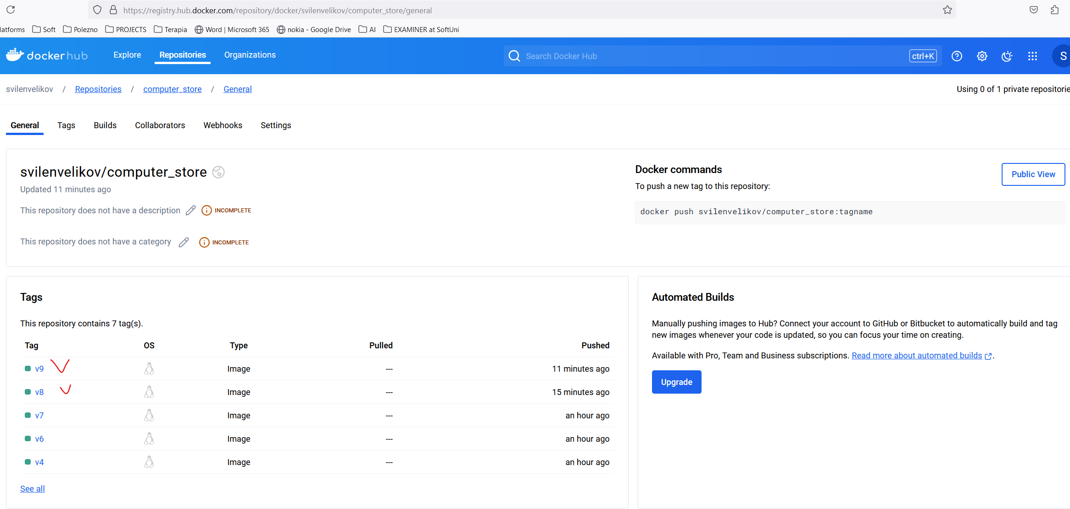

## VI. Demo summary + Gradle Wrapper and Gradle for Windows

### Gradle

<https://tomgregory.com/what-is-the-gradle-wrapper-and-why-should-you-use-it/>

The Gradle wrapper is a script you add to your Gradle project and use to execute your build. The advantages are:

you don’t need to have Gradle installed on your machine to build the project

the wrapper guarantees you’ll be using the version of Gradle required by the project

you can easily update the project to a newer version of Gradle, and push those changes to version control so other team members use the newer version





gradle init

Running a build

gradle build

**gradle clean build**

When you run the **build** command you’ll see output like this.

This means that your application was assembled and any tests passed successfully. Gradle will have created a build directory if it didn’t already exist, containing some useful outputs you should be aware of.

1. **the *classes*directory**contains compiled .class files, as a result of running the Java compiler against your application Java source files
2. **the *libs* directory**contains a generated jar file, an archive with all your compiled classes inside **ready to be executed or published** – ако махнем версията от build.gradle, то .jar файловете ще са с по-кратки имена.
3. 
4. **the *reports*directory**contains an HTML report summarising your test results. If your build fails, then consult this report to see what went wrong.

You now know that running the Gradle build command is equivalent to running the build task, which you do in Windows with gradlew build and on Linux/Mac with ./gradlew build. The build task depends on other tasks, and in some situations it may make sense to run a more specific task.

След което можем да го пуснем/run-нем този jar

**java -jar ./build/libs/docker.jar**

За да създадем .jar файл с Gradle, то тестовете трябва да минават

### Maven

За да създадем .jar файл с Maven, то тестовете трябва да минават

### Файлът /deployment/**Dockerfile**:



**FROM** openjdk:11-jre

**VOLUME /**tmp  
**COPY build/libs/**docker.jar app.jar  
**ENTRYPOINT** [**"java"**,**"-Djava.security.egd=file:/dev/./urandom -Xms256m -Xmx512m"**, **"-jar"**,**"/app.jar"**]

Ако използваме Maven, тези думички били различни

**build/libs**

От основната директория на проекта ни, под CMD на Windows пускаме следната команда

C:\Temp projects\Spring Advanced\12 Containerization & Documentation\docker_example>

**docker build -t svilenvelikov/demo1:v1 -f deployment/Dockerfile .**

създай от .jar файла **image** с име demo1 версия 1 на user svilenvelikov и от текущата директория която е точка, изпълни Dockerfile.

### docker images

в терминала показва всички имиджи качени на докер към момента



Можем да ги видим и от приложението DockerDesktop



### I) Пускане на docker image-а

C:\Temp projects\Spring Advanced\12 Containerization & Documentation\docker_example>

**docker run -p 8080:8080 svilenvelikov/demo1:v1**

Когато image-а се run-не, то той става контейнер.

### docker ps

покажи текущо активни контейнери

### Kaчи image-a на облака **docker repositories**

**docker push svilenvelikov/demo2:v2**

останалите images са част от jdk и няма нужда да се пушват



### Remove-ване на спрян контейнер

При опит да изтрием docker image:

Error response from daemon: conflict: unable to delete **5d4cfe7396db** (must be forced) - image is being used by stopped container **d61b2cca0024**

PS C:\Temp projects\Spring Advanced\12 Containerization & Documentation\docker_example> **docker rm d61b2cca0024**

### Remove-ване на самия docker image

PS C:\Temp projects\Spring Advanced\12 Containerization & Documentation\docker_example> **docker rmi 5d4cfe7396db**

Untagged: svilenvelikov/demo2:v2

Untagged: svilenvelikov/demo2@sha256:3232e698c894f814aea10bb0e5ecbd61af3562e9b8bdea73dab5cb4d49acc547

Deleted: sha256:5d4cfe7396db1e26c28c46c664427ad0041b8afa23c23aeb5c8f4b28091e9ac6

### Търси първо локално, след това търси от облака

Ако пуснем команда за рънване на изтрития локално image, то първо търси локално, след това търси на облака docker repositories

**docker run -p 8080:8080 svilenvelikov/demo2:v2**

PS C:\Temp projects\Spring Advanced\12 Containerization & Documentation\docker_example> docker run -p 8080:8080 svilenvelikov/demo2:v2

Unable to find image 'svilenvelikov/demo2:v2' locally

v2: Pulling from svilenvelikov/demo2

001c52e26ad5: Already exists

d9d4b9b6e964: Already exists

2068746827ec: Already exists

8510da692cda: Already exists

b6d84395b34d: Already exists

bf03fea6c3ad: Already exists

7ac2c538825b: Already exists

Digest: sha256:3232e698c894f814aea10bb0e5ecbd61af3562e9b8bdea73dab5cb4d49acc547

Status: Downloaded newer image for svilenvelikov/demo2:v2

### II) Пускане на повече docker images - как 2 image-а си говорят когато са качени на Docker

PS C:\Temp projects\Spring Advanced\12 Containerization & Documentation\docker_example>

Docker Compose is **a tool that was developed to help define and share multi-container applications**. With Compose, we can create a YAML file to define the services and with a single command, can spin everything up or tear it all down.

**docker-compose -f ./local/local.yaml up**

**docker-compose -f ./local/local.yaml down**

**Ако нямаме локално инсталиран MySQL например**



**version**: **'3.3'  
services**:  
 **db**:  
 **image**: arm64v8/mysql:oracle  
 **ports**:  
 - **"3306:3306"  
 command**: [**'--character-set-server=utf8mb4'**, **'--collation-server=utf8mb4_bin'**, **'--default-authentication-plugin=mysql_native_password'**]  
 **environment**:  
 - MYSQL_ALLOW_EMPTY_PASSWORD="yes"  
 - MYSQL_DATABASE=intro  
 **docker-demo**:  
 **image**: svilenvelikov/docker-demo:v3  
 **ports**:  
 - **"8080:8080"** *# web ui* **environment**:  
 - **MYSQL_HOST**=db  
 - MYSQL_USER=root  
 - MYSQL_PASSWORD=



**application.yml**

**spring**:  
 **datasource**:  
 **driverClassName**: com.mysql.cj.jdbc.Driver  
 **url**: **"jdbc:mysql://${MYSQL_HOST:localhost}:3306/demodocker?useSSL=false&createDatabaseIfNotExist=true&serverTimezone=UTC"  
 username**: **"${MYSQL_USER:root}"  
 password**: **"${MYSQL_PASSWORD:}"**

### III) Пускане на docker image с CMD опция

При стартиране на docker image-а да прави ping

При първата команда ping-ва от локалния сървър localhost/от локалния компютър.

При втората команда овъррайдваме CMD-то да бъде google.com и сега ping-ва от google.com

ENTRYPOINT не може да се override-не



# 10. Kubernetes and orchestration

## History Overview

* At the beginning software was mostly installed **on prem** (on physical hardware)
* Then the cloud paradigm started emerging and **hypervisors** like VirtualBox and HyperV became important players in that area
* However virtualization posed significant limitations due to the strict isolation of VMs in terms of resources (CPU and memory)
* The evolution of hardware and operating systems provided the better possibilities to run applications as separate isolated processes
* An example of such possibilities are **namespaces** and **cgroups** in the Linux Kernel – изолираме ресурсите като памет и процесор за всеки процес без да е нужно външно приложение като **hypervisor**
* This enabled the implementation of container solutions like Docker
* However, the use of container technology like Docker still implied a lack of good tooling to automate the process of management and orchestration of the containers:
  + How do we manage configuration of containers?
  + How do we scale up/down using containers? (i.e. Docker Swarm)
  + How do we automate deployment of a group of containers? (i.e. Ansible scripts or Docker compose)
  + How do we manage the administrative aspects of a container (i.e. networking, traffic redirection, security, resource allocation, etc…)
* Due to the increasing needs to optimize resources utilization and management aspects of containers Google developed Borg as an internal large-scale cluster management system
* Borg allowed Google to run thousands of jobs from a number of applications
* Borg was later succeeded by Omega as a second generation cluster management system which emerged at about the same time as Docker
* Thus Kubernetes was born out of the idea to combine the possibilities of a container technology like Docker with a scalable cluster management system like Borg….

## Architecture

<https://kubernetes.io/docs/concepts/architecture/>

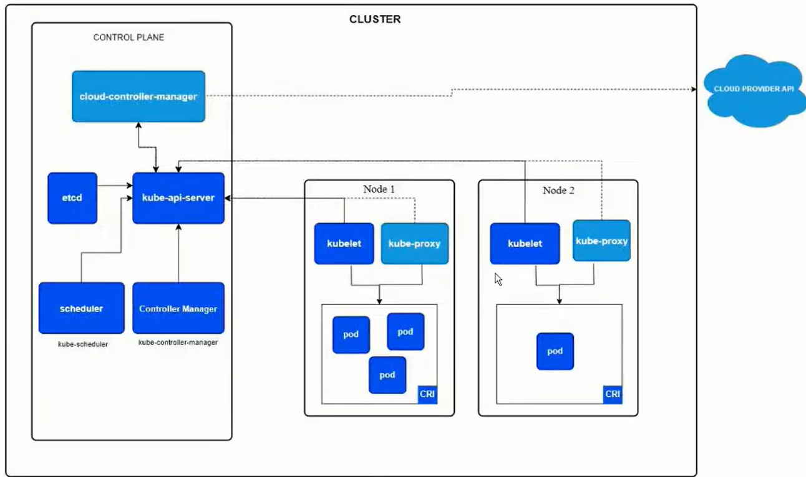

**Control Plane** – на отделна физическа машина

**etcd** – разпределена файлова система, която се използва за да persist-ва цялата информация в Kubernetes cluster-а.

**kube-api-server** – rest interface, с който можем да менъджираме различните елементи в Kubernetes клъстера. На Java, C#, Python, и т.н. Този kube-api-server менъджира също node-вете.

**node** – виртуална машина или физическа машина или набор от няколко мощни сървъра - машина на която да се деплойват **pod**-вете

**kubelet** – комуникира двустранно – с kube-api-server и с pod-вете. Като менъджира pod-вете. С други думи kube-api-server казва на kubelet-a стартирай ми pod с тези и тези контейнери на този node в клъстера.

**kube-proxy** – се грижи да ротира трафика към pod-овете в рамките на node-a.

**scheduler** – се грижи за стартирването на pod-вете в node-вете – като например кой node има достатъчно ресурси в момента да стартира дадения pod.

**Controller Manager** – се грижи да изпълнява различни процеси/задачи – като си минава по пътя kube-api-server -> kubelet:

* + като например деплоймент на приложение – еднократни job-ве от рода на стартирай нов node и му сложи първоначални pod-ве.
  + Ако даден node не е reachable, то да го маркира да не се деплойват на него pod-ве в момента.
  + Replicaset-controller – да се погрижи да има поне една инстанция например за nginx **pod**-a

**Cloud-controller-manager** – API, което може да се имплементира от различни Cloud providers (GoogleCloudProvider, AmazonWebServices). Дава възможност да се менъджират различни дейности в рамките на съответния cloud provider, последния който деплойва Kubernetes cluster.

### Pod

* The basic unit of operation in Kubernetes is a **pod**
* A **pod** may contain one or more containers (Docker containers for example)
* **Pods** are logically grouped in Kubernetes **namespaces** – не е задължително да използваме namespaces, но когато организацията е голяма определни хора или тиймове да имат определени права свързани с този namespace
* **Namespaces** provide isolation of resources, users and permissions
* За всеки един pod се алокира отделен IP address

### Workload

* Workloads are a logical grouping of pods that form an application
* Workloads in Kubernetes can be different types – in yaml syntaxis:
  + ReplicaSets – как да репликираме даден pod
  + Deployments – описание как можем да деплойваме pod
  + StatefulSets
  + DaemonSets

### Services

Контейнерите на всеки pod могат да стартирват на определени портове. Но за всеки отделен pod се алокира отделен IP address.

Всички pod-s от даден node са организирани в т.нар. клъстерна мрежа.

За да може един pod да достъпи сървиси от друг pod, то не е видимо как да стане от самите контейнери! За да може това нещо да се реализира, то имаме т.нар. сървиси/services.

* As the name implies: provides the possibility to define a ‘service’ on top of pods
* The service has an IP address, port and a DNS name
* The service provides the possibility to route traffic to pods either from inside the Kubernetes cluster or from outside
* A service is also described in yaml file

### Ingress

Ако искаме да ротираме трафик между подовете на базата на конкретни правила.

* Ingress elements provide the possibility to route traffic to pods
* It can be configured on a rule-basis specifying how traffic coming to the cluster can be routed to pods
* Ingress routes traffic to services – тези правила са вече декларирани в **service** yaml файловете.

### ConfigMaps

* ConfigMaps are the main mechanism used to supply configuration to pods
* That configuration can be passed in either of two ways from a ConfigMap to a pod:
  + As environment variables
  + Mounted on a pod container’s file system

### Secrets

* Secrets like ConfigMaps can be used to store configuration data
* Secrets are intended to store **sensitive data (such as passwords and certificates)**
* Data stored as Kubernetes secrets is not encrypted-at-rest by default
* Secrets can also be derived from external access management applications like HashiCorp Vault or Keycloak, etc.

Имаме няколко различни механизма, с които можем да интегрираме Keycloak в Kubernetes:

* + Ако сме на Spring/Quarkus проект – самият проект ни дава възможност да се интегрираме с Keycloak
  + Kubernetеs може да извлича данни от Keycloak и да ги записва като Kubernetes secrets

### Volumes

* Containers provide by default temporary storage that is wiped out on container restart (in the case of Kubernetes – a pod restart)
* Kubernetes provides the possibility to create and manage persistent volumes used by the pods
* Volumes can be mounted to the file system on a pod container – например да пазим данни в база данни

## Deployment and tools

### One local instance of Kubernetes

* Deploying a Kubernetes cluster form scratch is not a trivial task…
* For that purpose for local development there are a number of options available like:
  + **minikube – една инстанция на една виртуална машина или на един докер контейнер**
  + Kind
  + K3s
  + MicroK8s
  + Kubeadm
  + DockerDesktop with installed also Kubernetes plugin run in a docker container

### API clients

* **kubectl** – standard (and most used) CLI client for Kubernetes

kubectl create deployment nginx --image nginx //create deployment е по-скоро за локално тестване

kubectl apply -f deployment.yaml

kubectl get pods -n somenamespace

kubectl describe pod pod_id -n somenamespace какви контейнери и други неща в дадения под

kubectl logs pod_id -n somenamespace по подразбиране се листват логовете на първия контейнер от пода

kubectl logs pod_id -c containerid -n somenamespace

* language API clients (i.e. for Java)
* other tools – like **k9s**

### Web UIs

Different third party web interfaces for managing Kubernetes:

* + **Kubernetes Dashboard** (standard and most popular)
  + Kubernetes Lens (IDE for Kubernetes)
  + Octant
  + others

### Package management

* **Helm** is a widely used package manager for Kubernetes
* It is used to build distributable **charts** that are packages of Kubernetes resources
* Charts са група от Kubernetes ресурси – например deploy.yaml, който деплойва **pod** с nginx и Spring приложение с/на 3 инстанции, services, ConfigMaps, и т.н.
* Тези **charts** можем да ги създаваме, да ги качваме в централно Helm хранилище, и да бъдат преизползвани в различни Kubernetes клъстери.
* Charts can be stored in a central repository and used by applications

Инсталираме първо helm.

След това:

**helm install petclinic k8s/charts**

values.yaml

namespace: petclinic  
app:  
 name: petclinic  
 image: petclinic  
 tag: latest  
 pullPolicy: IfNotPresent  
 port: 8080  
 serviceType: LoadBalancer  
 replicas: 4  
db:  
 name: postgres  
 image: postgres  
 tag: latest  
 port: 5432  
 serviceType: ClusterIP  
 replicas: 1  
 username: petclinic  
 password: petclinic  
 database: petclinic

apiVersion: apps/v1  
kind: Deployment  
metadata:  
 name: {{ .Values.app.name }}-deployment  
 namespace: {{ .Values.namespace }}  
spec:  
 replicas: {{ .Values.app.replicas }}  
 selector:  
 matchLabels:  
 app: {{ .Values.app.name }}  
 template:  
 metadata:  
 labels:  
 app: {{ .Values.app.name }}  
 spec:  
 containers:  
 - image: "{{ .Values.app.image }}:{{ .Values.app.tag }}"  
 imagePullPolicy: {{ .Values.app.pullPolicy }}  
 name: {{ .Values.app.name }}  
 env:  
 - name: SPRING_PROFILES_ACTIVE  
 value: {{ .Values.db.name }}  
 - name: SPRING_DATASOURCE_URL  
 value: jdbc:postgresql://{{ .Values.db.name }}-service:{{ .Values.db.port }}/{{ .Values.db.database }}  
 ports:  
 - name: http  
 containerPort: {{ .Values.app.port }}  
 protocol: TCP  
 restartPolicy: Always

## Installing

### Combination 1

1) DockerEngine Или DockerDesktop

2) kubectl

<https://kubernetes.io/docs/tasks/tools/>

kubectl version –client

3) minikube

<https://minikube.sigs.k8s.io/docs/start/>

Add the minikube.exe binary to your PATH.  
*Make sure to run PowerShell as Administrator.*

$oldPath = [Environment]::GetEnvironmentVariable('Path', [EnvironmentVariableTarget]::Machine)

if ($oldPath.Split(';') -inotcontains 'C:\minikube'){

[Environment]::SetEnvironmentVariable('Path', $('{0};C:\minikube' -f $oldPath), [EnvironmentVariableTarget]::Machine)

}

K8S === Kubernetes //8 букви между K и S

### Combination 2

Use DockerDesktop with Kubernetes plugin enabled

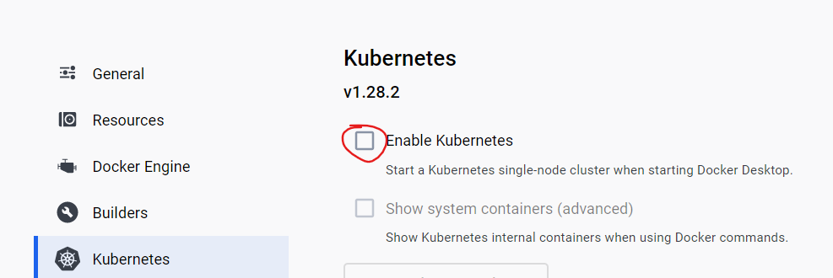

minikube not needed in this option

## Some commands:

minikube start –driver=docker

docker ps

kubectl get pods

kubectl get pods -A all including system

kubectl create deployment nginx --image nginx

Основната разлика между Kubernetes и Docker(и Docker compose) е, че вече минаваме към декларативен начин на работа – чрез въпросните yaml файлове за Kubernetes:

C:\Windows\System32>**kubectl run nginx --image nginx** //създава си служебен yaml файл

pod/nginx created

C:\Windows\System32>**kubectl get pods**

NAME READY STATUS RESTARTS AGE

nginx 1/1 Running 0 84s

C:\Windows\System32>**kubectl delete pod nginx**

pod "nginx" deleted

C:\Windows\System32>**kubectl delete pod/nginx**

pod "nginx" deleted

C:\Windows\System32>**kubectl run nginx --image nginx -o yaml** //-o принтни служебно създадения yaml файл

**apiVersion: v1**

**kind: Pod**

metadata:

creationTimestamp: "2024-08-15T11:38:32Z"

labels:

run: nginx

name: nginx

namespace: default

resourceVersion: "14000"

uid: 67bb5e2b-f0cd-482c-9663-196c6fef2a0e

spec:

containers:

- image: nginx

imagePullPolicy: Always

name: nginx

resources: {}

terminationMessagePath: /dev/termination-log

terminationMessagePolicy: File

volumeMounts:

- mountPath: /var/run/secrets/kubernetes.io/serviceaccount

name: kube-api-access-knh6t

readOnly: true

dnsPolicy: ClusterFirst

enableServiceLinks: true

preemptionPolicy: PreemptLowerPriority

priority: 0

restartPolicy: Always

schedulerName: default-scheduler

securityContext: {}

serviceAccount: default

serviceAccountName: default

terminationGracePeriodSeconds: 30

tolerations:

- effect: NoExecute

key: node.kubernetes.io/not-ready

operator: Exists

tolerationSeconds: 300

- effect: NoExecute

key: node.kubernetes.io/unreachable

operator: Exists

tolerationSeconds: 300

volumes:

- name: kube-api-access-knh6t

projected:

defaultMode: 420

sources:

- serviceAccountToken:

expirationSeconds: 3607

path: token

- configMap:

items:

- key: ca.crt

path: ca.crt

name: kube-root-ca.crt

- downwardAPI:

items:

- fieldRef:

apiVersion: v1

fieldPath: metadata.namespace

path: namespace

status:

phase: Pending

qosClass: BestEffort

Доста от служебно създадените неща за yaml файла са излишни.

D:\_GitHub locale\BGJUG-public\bgjug-academy-docker-k8s-demo-main> **kubectl apply -f k8s/app-service.yaml**

D:\_GitHub locale\BGJUG-public\bgjug-academy-docker-k8s-demo-main> **kubectl get all**

NAME READY STATUS RESTARTS AGE

pod/nginx 1/1 Running 0 11m

NAME TYPE CLUSTER-IP EXTERNAL-IP PORT(S) AGE

service/kubernetes ClusterIP 10.96.0.1 <none> 443/TCP 3h3m

За следене на промени в терминала да се зареждат автоматично – този watch е допълнителен plug-in

**watch -kubectl get all**

**app-deployment.yaml**

apiVersion: apps/v1  
**kind: Deployment**  
metadata:  
 name: petclinic-deployment  
 namespace: petclinic  
spec:  
 **replicas: 1** //една инстанция в случая - това нещо Docker и Docker Compose не могат да го направят!   
 selector:  
 matchLabels:  
 app: petclinic  
 **template:**  
 metadata:  
 labels:  
 app: petclinic  
 spec:  
 **containers:**  
 - image: petclinic:latest  
 name: petclinic  
 imagePullPolicy: IfNotPresent  
 env:  
 - name: SPRING_PROFILES_ACTIVE  
 value: postgres  
 - name: SPRING_DATASOURCE_URL  
 value: jdbc:postgresql://postgres-service:5432/petclinic  
 ports:  
 - name: http  
 containerPort: 8080  
 protocol: TCP  
 restartPolicy: Always

**app-service.yaml**

apiVersion: v1  
**kind: Service**  
metadata:  
 name: petclinic-service  
 namespace: petclinic  
spec:  
 ports:  
 - name: http  
 port: 8080  
 targetPort: 8080  
 **selector**:  
 app: petclinic  
 **type: LoadBalancer** #ClusterIP NodePort

C:\Windows\System32>**kubectl get pods**

NAME READY STATUS RESTARTS AGE

nginx 1/1 Running 0 22m

**Логовете**

C:\Windows\System32>**kubectl logs nginx**

/docker-entrypoint.sh: /docker-entrypoint.d/ is not empty, will attempt to perform configuration

/docker-entrypoint.sh: Looking for shell scripts in /docker-entrypoint.d/

/docker-entrypoint.sh: Launching /docker-entrypoint.d/10-listen-on-ipv6-by-default.sh

10-listen-on-ipv6-by-default.sh: info: Getting the checksum of /etc/nginx/conf.d/default.conf

10-listen-on-ipv6-by-default.sh: info: Enabled listen on IPv6 in /etc/nginx/conf.d/default.conf

/docker-entrypoint.sh: Sourcing /docker-entrypoint.d/15-local-resolvers.envsh

/docker-entrypoint.sh: Launching /docker-entrypoint.d/20-envsubst-on-templates.sh

/docker-entrypoint.sh: Launching /docker-entrypoint.d/30-tune-worker-processes.sh

/docker-entrypoint.sh: Configuration complete; ready for start up

2024/08/15 11:38:33 [notice] 1#1: using the "epoll" event method

2024/08/15 11:38:33 [notice] 1#1: nginx/1.27.0

2024/08/15 11:38:33 [notice] 1#1: built by gcc 12.2.0 (Debian 12.2.0-14)

2024/08/15 11:38:33 [notice] 1#1: OS: Linux 5.15.133.1-microsoft-standard-WSL2

2024/08/15 11:38:33 [notice] 1#1: getrlimit(RLIMIT_NOFILE): 1048576:1048576

2024/08/15 11:38:33 [notice] 1#1: start worker processes

2024/08/15 11:38:33 [notice] 1#1: start worker process 29

2024/08/15 11:38:33 [notice] 1#1: start worker process 30

2024/08/15 11:38:33 [notice] 1#1: start worker process 31

2024/08/15 11:38:33 [notice] 1#1: start worker process 32

2024/08/15 11:38:33 [notice] 1#1: start worker process 33

2024/08/15 11:38:33 [notice] 1#1: start worker process 34

2024/08/15 11:38:33 [notice] 1#1: start worker process 35

2024/08/15 11:38:33 [notice] 1#1: start worker process 36

2024/08/15 11:38:33 [notice] 1#1: start worker process 37

2024/08/15 11:38:33 [notice] 1#1: start worker process 38

2024/08/15 11:38:33 [notice] 1#1: start worker process 39

2024/08/15 11:38:33 [notice] 1#1: start worker process 40

2024/08/15 11:38:33 [notice] 1#1: start worker process 41

2024/08/15 11:38:33 [notice] 1#1: start worker process 42

2024/08/15 11:38:33 [notice] 1#1: start worker process 43

2024/08/15 11:38:33 [notice] 1#1: start worker process 44

2024/08/15 11:38:33 [notice] 1#1: start worker process 45

2024/08/15 11:38:33 [notice] 1#1: start worker process 46

2024/08/15 11:38:33 [notice] 1#1: start worker process 47

2024/08/15 11:38:33 [notice] 1#1: start worker process 48

**kubectl delete deploy nginx-deployment**

**kubectl delete deployment nginx-deployment**

Идеята на контекста, е че можем да достъпваме няколкок Kubernetes клъстъра – единият клъстър може да го менъджира нашата фирма, у нас локално друг клъстър, и т.н.

C:\Windows\System32>**kubectl config get-contexts**

CURRENT NAME CLUSTER AUTHINFO NAMESPACE

* docker-desktop docker-desktop docker-desktop

C:\Windows\System32>**minikube start**

W0815 15:24:53.997133 22260 main.go:291] Unable to resolve the current Docker CLI context "default": context "default": context not found: open C:\Users\svilk\.docker\contexts\meta\37a8eec1ce19687d132fe29051dca629d164e2c4958ba141d5f4133a33f0688f\meta.json: The system cannot find the path specified.

* minikube v1.33.1 on Microsoft Windows 11 Pro 10.0.22631.3880 Build 22631.3880

* Automatically selected the docker driver. Other choices: hyperv, ssh

* Using Docker Desktop driver with root privileges

* Starting "minikube" primary control-plane node in "minikube" cluster

* **Pulling base image v0.0.44 ...**

* Downloading Kubernetes v1.30.0 preload ...

> gcr.io/k8s-minikube/kicbase...: 481.58 MiB / 481.58 MiB 100.00% 3.43 Mi

> preloaded-images-k8s-v18-v1...: 342.90 MiB / 342.90 MiB 100.00% 2.44 Mi

* **Creating docker container** (CPUs=2, Memory=8000MB) ...

* Preparing Kubernetes v1.30.0 on Docker 26.1.1 ...

- Generating certificates and keys ...

- Booting up control plane ...

- Configuring RBAC rules ...

* Configuring bridge CNI (Container Networking Interface) ...

* Verifying Kubernetes components...

- Using image gcr.io/k8s-minikube/storage-provisioner:v5

* Enabled addons: storage-provisioner, default-storageclass

* Done! kubectl is now configured to use "minikube" cluster and "default" namespace by default

Автоматично сменя контекста на kubectl да използва minikubeа, не docker-desktop

C:\Windows\System32>**kubectl config get-contexts**

CURRENT NAME CLUSTER AUTHINFO NAMESPACE

docker-desktop docker-desktop docker-desktop

* minikube minikube minikube default

C:\Windows\System32>**kubectl config use-context docker-desktop**

Switched to context "docker-desktop".

C:\Windows\System32>**kubectl config use-context minikube**

Switched to context "minikube".

C:\Windows\System32>**kubectl create namespace petclinic**

namespace/petclinic created

C:\Windows\System32>**kubectl config use-context minikube --namespace=petclinic**

Switched to context "minikube".

D:\_GitHub locale\BGJUG-public\bgjug-academy-docker-k8s-demo-main> **kubectl apply -f k8s/app-deployment.yaml**

deployment.apps/petclinic-deployment created

D:\_GitHub locale\BGJUG-public\bgjug-academy-docker-k8s-demo-main> **kubectl run petclinic --image petclinic**

pod/petclinic created

C:\Windows\System32>**minikube stop**

W0815 16:15:12.563473 4696 main.go:291] Unable to resolve the current Docker CLI context "default": context "default": context not found: open C:\Users\svilk\.docker\contexts\meta\37a8eec1ce19687d132fe29051dca629d164e2c4958ba141d5f4133a33f0688f\meta.json: The system cannot find the path specified.

* Stopping node "minikube" ...

* Powering off "minikube" via SSH ...

* 1 node stopped.

**Minikube** си има собствен контекст. Обаче за локални images, трябва да му се даде тази команда при MacOS (за Windows обаче не бачка). И след това наново билдваме image-a petclinic (D:\_GitHub locale\BGJUG-public\bgjug-academy-docker-k8s-demo-main> **docker build -t "petclinic" -f Dockerfile-multistage .**) и текущия терминал го засича вече Image-a като локален такъв.

# Set docker env

eval $(minikube docker-env) # Unix shells

minikube docker-env | Invoke-Expression # PowerShell

D:\_GitHub locale\BGJUG-public\bgjug-academy-docker-k8s-demo-main> **kubectl get all**

NAME READY STATUS RESTARTS AGE

**pod/petcliniccontainer** 0/1 ImagePullBackOff 0 22s

D:\_GitHub locale\BGJUG-public\bgjug-academy-docker-k8s-demo-main> **kubectl apply -f k8s цялата папка**

deployment.apps/petclinic-deployment created

service/petclinic-service created

deployment.apps/postgres-deployment created

service/postgres-service created

D:\_GitHub locale\BGJUG-public\bgjug-academy-docker-k8s-demo-main> **kubectl get all**

NAME READY STATUS RESTARTS AGE

pod/petclinic-deployment-85b48d56b4-sldnb 1/1 Running 2 (33s ago) 42s

pod/petcliniccontainer 0/1 ImagePullBackOff 0 2m32s

pod/postgres-deployment-6cdb694745-bskt8 1/1 Running 0 42s

NAME TYPE **CLUSTER-IP** EXTERNAL-IP PORT(S) AGE

service/petclinic-service LoadBalancer **10.108.107.116** localhost **8080:31560**/TCP 42s

service/postgres-service ClusterIP 10.102.100.199 <none> **5432**/TCP 42s

NAME READY UP-TO-DATE AVAILABLE AGE

deployment.apps/petclinic-deployment 1/1 1 1 42s

deployment.apps/postgres-deployment 1/1 1 1 42s

NAME DESIRED CURRENT READY AGE

replicaset.apps/petclinic-deployment-85b48d56b4 1 1 1 42s

replicaset.apps/postgres-deployment-6cdb694745 1 1 1 42s

Kubernetes е предвиден да работи с много сървъри с много клъстери, най-често Cloud услуги. Като му зададем LoadBalancer, то трябва да има друг Load Balancer, към който Kubernetes да се кънектва!

Kubernetes изпълнява image-те по същият начин както Docker.

Kubernetes влиза в полза особено много когато проекта ни има микросървиси.

# 11. JVM innerworkings

## I. Hotspot JVM

#### Virtual machines

A typical virtual machine for an interpreted language provides:

* Compilation of source language **into** VM specific **bytecode - компилира се до bytecode** (съвкупност от компилирани Java класове)
* Data structures to contains instructions and operations (the data the instructions process) - структури от данни за това какви са операциите и процесорните инструкции, които се поддържат от **bytecode-a** на JavaVirtualMachine (JVM)
* A **call stack** for function call operations
* An ‘**Instructor Pointer**’ (IP) pointing to the next processor instruction to execute
* A **virtual ‘CPU’** - the instruction dispatcher that:
* *Fetches* the next instruction (addressed by the instruction pointer)
* *Decodes* the operands
* *Executes* the instruction

#### The HotSpot JVM

Кода на JVM го има в интернет:

<https://github.com/openjdk/jdk/>





HotSpot is the standard JVM distribution of Oracle Corp.  that provides:

* **bytecode execution**
* using an **interpreter - bytecode here**,
* *На практика в някои случаи минаваме и през тази стъпка!!* - two **runtime compilers** (**JIT** (Just-In-Time) compilers) for optimization - например ако един метод се вика 50 000 пъти, то JVM преценява дали да го **компилира до машинен код**. Като компилирания машинен код е по-бърз от компилирания bytecode!! Client and server - C1 and C2 in JVM. Now they work together and not separately
  + **Client JIT** - важно приложението да стартира бързо, а цялото зареждане  допълнение
  + **Server JIT** - за големи сървърни приложения. JVM по време на компилиране прави много оптимизации и стартира по-бавно. Така че когато е заредило вече приложението, то логиката в него пък да се изпълнява по-бързо
* and **On-Stack Replacement** - JVM може да прецени да не изпълнява компилирания машинен код, и вместо това да изпълни компилирания bytecode. Т.нар. деоптимизация.
* **storage allocation** and **garbage collection**

Алокиране на памет за обектите, които създаваме в нашето приложение. Т.нар. HEAP памет се заделя при стартиране на нашето Java приложение.

Колко памет да използва, колко минимална и максимална памет да използва.

Бързодействието на самата JVM машина се определя от garbage collection-а - колко бързо можем да освободим памет без да нарушим изпълнението на нашата програма.

* **runtimes** - start up, shut down, class loading, threads, interaction with OS and others

#### Architecture of the HotSpot JVM



##### 1.Class-loading

Зареждане до класфайловете от .java файлове

Three phases of class-loading:

* **Loading**

С коя версия на Java compiler е компилиран дадения .java файл. Това се записва в minor и major versions.

Constant_pool - Информация/масив за всички константи, които имаме в дадения клас

Access_flags - public, private, protected

Interfaces - масив с всички интерфейси на класа

Fields - масив с всички полетата на класа

Methods - масив с всички методи на класа

Attributes - масив с допълнителни атрибути, които може да сме дефинирали в класа





* **Linking** - създават се връзки между съответните класфайлове в JVM
* **Initialization** - например инициализация на статични блокове, на константи



##### 2.Runtime data areas

###### Main info



В JVM се зареждат различни области, които се използват от приложението ни. Като например:

* Област за HEAP паметта - за алокиране на обектите от приложението
* Method area - описват се методите, които се изпълняват
* Java stacks - създават се стекови от нишките, които се стартирват в рамките на приложението
* **Program counter** **registers**
* Stacks за изпълнение на native методи - JVM отдолу в голяма степен е имплементирана на C++, така че в някои случаи може да се викат и методи на  C++



* Отделно JVM може да реши да използва и **native threads (на ниво ОС)** и за тях се създава **отделен Stack**!

За даден стек фрейм имаме:



###### Before JDK 8

**Permanent generation** -  отделна област за съхраняване на информация за string-овите константи и за методите заредени от JVM



###### As of JDK 8

Permanent generation is part of the HEAP

###### HEAP

**Young generation** - пазят се тук обекти, които живеят кратко

**Old / Tenured Generation** - например за логер, който живее през цялото време.

Обекти, за които JVM прецени че живеят по-дълго от очакваното се местят от  Young generation към Old / Tenured Generation!

Обектите от Young generation се изчистват по-лесно и бързо от garbage collector-a, без да се прави задълбочен анализ от garbage collector-a.

Чистенето на обекти от Old / Tenured Generation става чрез паузиране, което за някои приложения е ключово. Затова трябва да се стремим чистенето на обекти от Old / Tenured Generation да бъде минимално по дължина време!!!



При създаване на нов обект:

VTable = VirtualTable - при полиморфизъм влиза в употреба

Създават се няколко масива в хийпа:

 - един за инстанциирания обект

 - един за типа на обекта - от кой клас е -  from reflection .getClass

 - Class Генерик от тип нашия клас

 - Class Генерик от тип Class



И така за всеки един обект!!!

**`mark word`** contains:

* identity hash code - от нашето Java приложение
* age
* lock record address - при синхронизация
* monitor address
* state (unlocked, light-weight locked, heavy-weight locked, marked for GC GarbageCollection)
* biased / biasable (includes other fields such as thread ID) - пристрастен - скъпо е една нишка да я изпълняваме на един процесор, после да я изпълняваме на друг процесор в друг етап от изпълнението й. За тази цел JVM може да зададе дадена нишка да се изпълнява само на конкретно ядро от процесора! Т.е. не се случва т.нар. Context Switching! И това подобрява бързодействието!

##### 3.Execution engine



###### Different execution techniques:

* Interpreting - **вземаме следващата bytecode процесорна инструкция и я изпълняваме**
* Just-in-time (JIT) compilation - **вземаме** **native code процесорна инструкция и я изпълняваме**
* Adaptive optimization (determines “hot spots” by monitoring execution) - преценява дали се компилира и изпълнява впоследствие на bytecode или на native code



###### JIT compilation

* Triggered asynchronously by counter overflow for a method/loop (interpreted counts method entries and loopback branches) - всеки път проверява колко пъти би се извикал дадения метод
* Produces generated **native code (машинен код)** and relocation info (transferred on next method entry)
* In case JIT-compiled code calls not-yet-JIT-compiled code, then control is transferred to the interpreter! - когато JIT-compiled code (**native машинен код**) метод извиква друг метод от нашето приложение, който е само интерпретиран, то JIT компилатора се грижи кой метод как да го изпълни и дали да не изпълни текушия метод на принципа на **On-Stack Replacement** (да го върне текущия метод да му се изпълни байткода вместо native машинния код)
* Compiled code may be forced back into interpreted bytecode (deoptimization)
* Is complemented by On-Stack Replacement - turn dynamically interpreted to JIT compiled code and vice-versa - dynamic optimization/deoptimization
* JIT compiler is more optimized for server VM - the so called server mode - hits big start-up time compared to client VM, but executes faster the logic afterwards.

###### JIT compilation flow

To native machine code during normal bytecode execution:

1. Bytecode is turned **into a graph**
2. The graph is turned **into a linear sequence** of operations that manipulate an infinite loop of virtual registers (each node places its result in a **virtual register**)
3. **Physical registers** are allocated for virtual registers (the program stack might be used in case virtual registers exceed physical registers)
4. **Native machine code** for each operation is generated using its allocated registers

###### Tiered Compilation in JVM

Client and server - C1 and C2 in JVM. Now they work together and not separately

<https://www.baeldung.com/jvm-tiered-compilation>

A JIT compiler **compiles bytecode to native code for frequently executed sections**.

The **client compiler**, also called **C1**, is a type of a **JIT compiler optimized for faster start-up time**. It tries to optimize and compile the code as soon as possible.

The **server compiler**, also called **C2**, is a type of a **JIT compiler optimized for better overall performance**. C2 observes and analyzes the code over a longer period of time compared to C1. This allows C2 to make better optimizations in the compiled code.

The C2 compiler often takes more time and consumes more memory to compile the same methods. However, it generates better-optimized native code than that produced by C1.

The tiered compilation concept was first introduced in Java 7. Its goal was to **use a mix of C1 and C2 compilers in order to achieve both fast startup and good long-term performance**.

Compilation Levels when tiered compilation enabled

Tiered compilation is **enabled by default since Java 8**. It’s highly recommended to use it unless there’s a strong reason to disable it.

Even though the JVM works with only **one interpreter** and **two JIT compilers**, there are **five possible levels of compilation**. The reason behind this is that the C1 compiler can operate on three different levels. The difference between those three levels is in the amount of profiling done.

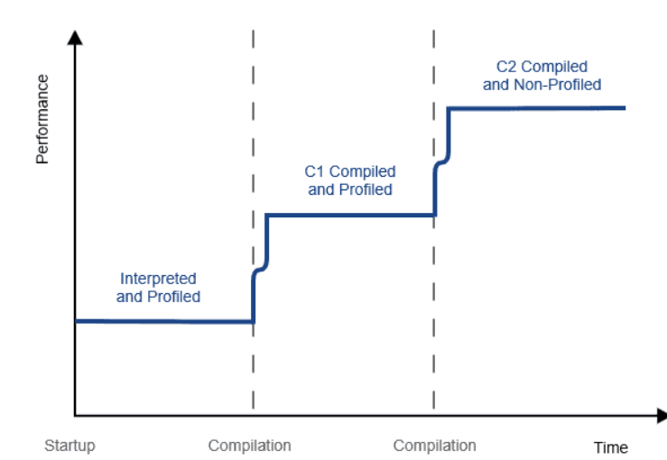

Level 0 – Interpreted Code

**Initially, JVM interprets all Java code**. During this initial phase, the performance is usually not as good compared to compiled languages.

However, the JIT compiler kicks in after the warmup phase and compiles the hot code at runtime. The JIT compiler makes use of the profiling information collected on this level to perform optimizations.

Level 1 – Simple C1 Compiled Code

On this level, the JVM compiles the code using the C1 compiler, but without collecting any profiling information. The JVM uses level 1 for **methods that are considered trivial**.

Due to low method complexity, the C2 compilation wouldn’t make it faster. Thus, the JVM concludes that there is no point in collecting profiling information for code that cannot be optimized further.

Level 2 – Limited C1 Compiled Code

On level 2, the JVM compiles the code using the C1 compiler with light profiling. The JVM uses this level **when the C2 queue is full**. The goal is to compile the code as soon as possible to improve performance.

Later, the JVM recompiles the code on level 3, using full profiling. Finally, once the C2 queue is less busy, the JVM recompiles it on level 4.

Level 3 – Full C1 Compiled Code

On level 3, the JVM compiles the code using the C1 compiler with full profiling. Level 3 is part of the default compilation path. Thus, the JVM uses it in **all cases except for trivial methods or when compiler queues are full**.

The most common scenario in JIT compilation is that the interpreted code jumps directly from level 0 to level 3.

Level 4 – C2 Compiled Code

On this level, the JVM compiles the code using the C2 compiler for maximum long-term performance. Level 4 is also a part of the default compilation path. The JVM uses this level to**compile all methods except trivial ones**.

Given that level 4 code is considered fully optimized, the JVM stops collecting profiling information. However, it may decide to deoptimize the code and send it back to level 0.

Thresholds for Levels and Method Compilation

In order to check the default thresholds used on a specific Java version, we can run Java using the -XX:+PrintFlagsFinal flag:

java -XX:+PrintFlagsFinal -version | grep CompileThreshold

intx CompileThreshold = 10000

intx Tier2CompileThreshold = 0

intx Tier3CompileThreshold = 2000

intx Tier4CompileThreshold = 15000

We should note that the **JVM doesn’t use the generic CompileThreshold parameter when tiered compilation is enabled**.

In summary, the JVM initially interprets a method until its invocations reach the Tier3CompileThreshold. Then, it **compiles the method using the C1 compiler while profiling information continues to be collected**. Finally, the JVM compiles the method using the C2 compiler when its invocations reach the Tier4CompileThreshold. Eventually, the JVM may decide to deoptimize the C2 compiled code. That means that the complete process will repeat.

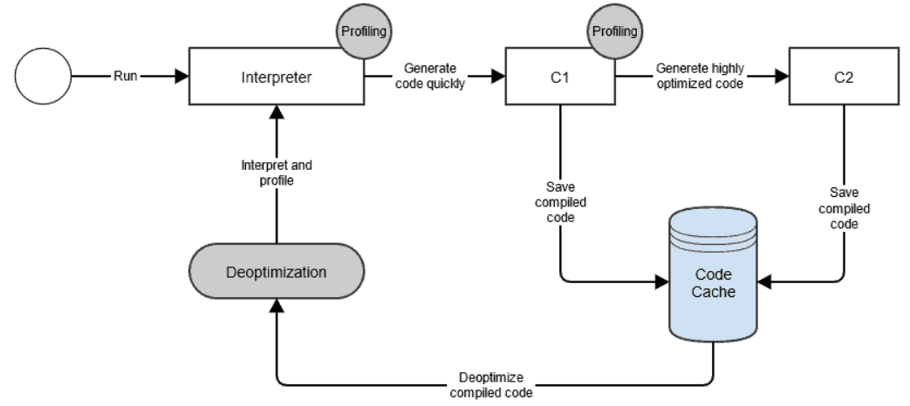

#### Typical execution flow

When using the **java/javaw** launcher:

1. Parse the command line options - като например -d
2. Establish the heap sizes and the compiler type (client or server)
3. Establish the environment variables such as **CLASSPATH** (компилираните до bytecode .java класове от нашето приложение – тоест .class видими за нас декодирани byte файлове)
4. If the java Main-Class is not specified on the command line, then fetch the Main-Class name from the JAR’s manifest
5. Create the VM using **JNI_CreateJavaVM** (Java Native Interface, на C++) in a newly created thread (non primordial thread)
6. Once the VM is created and initialized, load the Main-Class
7. Invoke the **main** method in the VM using **CallStaticVoidMethod**
8. Once the **main** method completes check and clear any pending exceptions that may have occurred and also pass back the exit status

Detach the main thread using DetachCurrentThread, by doing so we decrement the thread count so the **DestroyJavaVM** can be called safely.

## II. GraalVM

#### Some background

**Статична компилация** - когато нашия код се компилира до bytecode със **javac** компилатора/командата. И по време на изпълнение средата(JVM например) изпълнява  bytecode-a **или** машинния native code.

**Динамична компилация** - например това го прави JIT компилатора - **изпълнява само машинен код**!

* The JVM performs **static** **compilation** of Java sources to **bytecode**
* The JVM may perform **dynamic compilation** of bytecode (**from bytecode) to machine code** for various optimizations using a JIT (Just-in-Time) compiler



Essentially, **static** linking involves compiling libraries into your app or program **as part of the build process**.

Dynamic linking lets the operating system hold off and load shared libraries into memory only when the app is launched.

#### Info

* GraalVM is a new JIT compiler for the JVM
* **Brings the performance of Java to scripting languages (via the Truffle API) - възможността да се използват предимствата на Java за по-бързо интерпретиране/изпълнение на компилирания код в сравнение ако просто даден браузър само интерпретира дадено JavaScript приложение/web страница**
* Written in Java
* GraalVM е нещо средно между клиентски и сървърен JIT компилатор (при стартирване прави повече оптимизации/опреации в сравнение с клиентския JIT, но все пак по-малко оптимизации/операции в сравнение със сървърния JIT), но усъвършенстван да оптимизира още повече.
* Предназначен за скриптови езици като JS, Ruby
* Под капака GraalVM за някои оптимизации/операции си взаимодейства и с HotSport JVM
* In essence, the Graal JIT compiler generates machine code from an optimized **AST**(**abstract syntax tree**) rather than bytecode
* However, the Graal VM has both **AST**(**abstract syntax tree**) and bytecode interpreters
* The Graal VM supports the following types of compilers:

–vm server-nograal  //server compiler

–vm server  //server compiler using Graal

–vm graal  /**/Graal compiler** using Graal

–vm client-nograal  //client compiler

–vm client  //client compiler running Graal

#### The Truffle API

* is a Java API
* Provides AST (Abstract Syntax Tree) representation of source code
* Самото АПИ предоставя възможност за реализация на имплементация на даден програмен език, която имплементация да може да се изпълни от/на GraaVM. За целта различни елементи от нашия интерпретиран език се представят в рамките на една структура (предоставена от Thruffle API-то) и тази структура се използва от GraalVM за да се генерира т.нар. **AST (Abstract Syntax Tree)**
* Provides a mechanism to convert the generated AST into a **Graal IR (intermediate representation)**
* Възможно е и от bytecode-a да стигнем до **Graal IR (intermediate representation)**
* The Truffle API is declarative (uses Java annotations)
* The AST graph generated by Thruffle is a mixture of **control flow**(условни структури, for цикли, и т.н.) and **data flow graph** (местата през които да преминат данните в рамките на нашето приложение)
* Essential feature of the Truffle API is the ability to specify node specializations used in node rewriting
* The Truffle API is used in conjunction with custom annotation processor that generates code based on the Truffle annotations used in the interpreter classes.



Ruby & RubyJ пример - бекенд зарежда в пъти по-бързо през TruffleApi-то на RubyJ

А какво прави Java компилацията до bytecode и евентуално до native machine code? - като види цикъл с 5 и го прави на 5 метода. И по-бързо се изпълнява. Та и затова като мине през TruffleApi и е в пъти по-бързо отколкото ако се интерпретира. **Но тук говорим за бекенда на дадения скриптов език**.

#### General structure of GraalVM



Let’s see, for example, how a JavaScript interpreter works in Graal …

1. Run JavaScript file: app.js
2. Подаваме app.js за изпълнения от GraalVM - JavaScript Interpreter parses app.js and converts it to Truffle **AST (Abstract Syntax Tree).** Трябва да имаме интерпретатор (който сме написали), който да парсне този app.js файл до AST - графова структура
3. The Thruffle AST is converted into a new graph - т.нар. **Graal IR** AST **(intermediate representation)**
4. The Graal VM has bytecode and AST interpreter**s** along with a standard JIT compiler from HotSpot (optimizations and AST lowering is performed **to generate machine code** and perform partial evaluation)
5. When parts of app.js are compiled to machine code by the Graal compiler, then the compiled code is transferred to HotSpot for execution by means of HotSpot APIs and with the help of a **Graal-HotSpot adapter interface**
6. Compiled code can also be deoptimized and **control is transferred back to the interpreter** (from HotSpot VM back to Graal VM - e.g. when an exception occurs, an assumption fails or a guard is reached)



Optimizations done on the Graal IR (intermediate representation) include:

* Method inlining
* Partial escape analysis
* Inline caching
* Constant folding
* Arithmetic optimizations and others…

Реално такъв вид оптимизации могат да бъдат направени и от стандартното HotSpot JVM!

Currently supported languages from Graal VM include:

* JavaScript - (Graal.JS)
* Език R - за статистически изчисления се използва най-вече - (FastR)
* Ruby - (RubyTruffle)
* Experimental interpreters for C, Python, Smalltalk, LLVM IR and others
* Graal.JS - shows improvement of 1.5x in some cases with a peak of 2.6x compared to V8 (running Google Octane’s benchmark) - <https://github.com/oracle/graaljs>
* RubyTruffle - shows improvements between 1.5x and 4.5x in some cases with a peak of 14x compared to JRuby
* FastR - shows improvements between 2x and 39x in some cases with a peak of 94x compared to GnuR

#### SimpleLanguage project

<https://github.com/graalvm/simplelanguage>

The SimpleLanguage project provides a showcase on how to use the Truffle APIs



## III. Garbage collection

#### Info

* Garbage collection is the process of scanning heap memory for unused objects and cleaning them thus reclaiming memory
* Garbage collection in the JVM is implemented by means of special modules called garbage collectors
* Garbage collectors are optimized to work over different heap areas (**young and old** **generations**)
* Whenever the young generations (minor collections) fills up or the old generation (major collections) need to be cleaned **a “Stop The World” event** appears
* In a “Stop The World” event application threads are paused during garbage collection
* In that regard garbage collection might be disruptive for performance in some high-frequency applications, i.e. in fintech. **Затова за такива приложения даже се елиминира изцяло процеса по garbage collection-a!**

Обекти, за които JVM прецени че живеят по-дълго от очакваното се местят от  Young generation към Old / Tenured Generation!

Обектите от Young generation се изчистват по-лесно и бързо от garbage collector-a, без да се прави задълбочен анализ от garbage collector-a.

Чистенето на обекти от Old / Tenured Generation става чрез паузиране, което за някои приложения е ключово. Затова трябва да се стремим чистенето на обекти от Old / Tenured Generation да бъде минимално по дължина време!!!

#### Types of garbage collectors

Different types of Java collectors exist at present and **it is an area of active research and development**:

-XX:-UserSerialGC - в допълнение към основната терминална команда когато стартирваме приложението - можем да зададем какъв garbage collector да използва JVM.

* **Serial GC**: garbage collection is done **sequentially**



* **Parallel GC**: uses **multiple threads** for garbage collection (default in JDK 7 and 8):



* **Concurrent Mark Sweep (CMS)**: works concurrently along the application threads trying to minimize pauses - самият garbage collector  ползва няколко нишки  И  отделно от това тези нишки работят паралелно върху/по различните thread-ове/нишки от нашето приложение.



* **G1:** available as of JDK 7, parallel, concurrent and incrementally compacting low-pause collector (**default in JDK 9 and later**)



* **Epsilon GC:** this is a no-op/null garbage collector introduced in JDK 11 that allocates memory but does not do garbage collection - използва се например при тези fintech приложения където все пак трябва да се зададе като настройка тип колектор, и в случая колектора прави всичко останало, но без реалното събиране на боклука от паметта!!!!



* **ZGC:** also introduced in JDK 11, still experimental, tries to reduce pause times in large scale Java applications



* **Shenandoah GC:** available in JDK 13 and later (also in some earlier JDK versions), aims to reduce pause times by working concurrently with the application



Като цяло, всеки по-нов garbage collector цели да се справя по-добре в случаите когато има a “Stop The World” event.

# 12. Jenkins

* Jenkins is an open-source automation server that helps automate various tasks in software development and delivery processes
* It provides a robust and extensible platform for continuous integration (CI) and continuous delivery (CD)
* Решава същата задача като GitHub actions, CI & CD на GitLab, на GitBucket

## Key features

* **Continuous Integration (CI)**: Jenkins enables developers to integrate code changes regularly, ensuring early detection of issues and improving collaboration
* **Continuous Delivery (CD)**: Jenkins facilitates the automated deployment of applications to various environments, streamlining the release process
* **Extensibility**: Jenkins offers a vast ecosystem of plugins that extend its functionality, allowing integration with different tools and technologies.
* **Distributed Architecture:** Jenkins supports distributed builds, allowing for efficient resource utilization across multiple machines or agents - може на повече от една машина да се изпълняват тези pipelines (ако една компания има 500 човека, то не може един човек да чака 4 часа да му мине билда!)

## Use cases

* Continuous Integration and Testing: Jenkins can build, test and validate code changes automatically, ensuring a stable and reliable software product
* Continuous Delivery and Deployment: Jenkins enables the automated deployment of applications to multiple environments such as development, staging and production
* Task Automation: Jenkins can automate various repetitive tasks such as generating reports, sending notifications, and scheduling jobs.

## How Jenkins work (Master - Slave)





В случая когато ще използваме Java програмен език, то JVM машината веднъж инсталирана/конфигурирана тя работи на всяка операционна система.

Обаче ако проекта ни е с JS/ReactJS, то има в по-голяма степен значение slave-a ни на коя ОС е нагласен!

## CI & CD

### What is Continuous Integration (CI)?

* Continuous Integration **pipeline** is a development practice where developers frequently integrate their code changes into a shared repository
* The integration process is automated and accompanied by various checks and validations
* Could be executed on 1 or more Jenkin slave nodes simultaniously

Sample CI pipeline:



### What is Continuous Delivery (CD)?

* Continuous Delivery is a software development approach that focuses on automating and streamlining the software release and deployment processes
* It aims to deliver software changes more frequently, reliably, and with reduced manual effort
* Надгражда CI pipeline-a като добавя някои от следните неща: миграция на база данни, деплойване на съответния docker image на съответната среда



## How Jenkins file will look like

Sample of a Jenkins file



agent Java, Maven, etc.





## Installing Jenkins java app with maven

How to run Jenkins locally:

<https://www.jenkins.io/doc/tutorials/build-a-java-app-with-maven/>

Тази инсталация посочена в линка работи в docker контейнер, като преди да започнем да работим с този контейнер, то имаме инсталиран в него JDK and Maven.

В други записки има примери как това става даже по-лесно ако работим с JS.

## Creating Freestyle project









## Creating Multibranch pipeline

Можем да добавяме много бранчове, и даже и да включим информация за PRs.





# 13. Github actions

<https://docs.github.com/en/actions/learn-github-actions/understanding-github-actions>

<https://docs.github.com/en/actions/automating-builds-and-tests/building-and-testing-java-with-maven>

<https://docs.github.com/en/actions/automating-builds-and-tests/building-and-testing-java-with-gradle>

## What is Git Actions

GitHub Actions is a continuous integration and continuous delivery (CI/CD) platform that allows you to automate your build, test and deployment pipeline. You can create workflows that build and test every pull request to your repository, or deploy merged pull requests to production.

Също така може да си добавим/плъгнем и допълнителни actions  като например cron jobs.

## The components of GitHub Actions

Тригърване на ивента ръчно - например при Jenkins ръчно при **build**-a. Но може да става и автоматично тригърването на ивента.

Има рънъри за 3 операционни системи (за Windows, Linux and MacOS) – като при Jenkins.



## Workflows

A workflow is a configurable automated process that will run one or more jobs. Workflows are defined by a YAML file checked into your repository and will run when triggered by an event in your repository, or they can be triggered manually, or at a defined schedule.



## Events

An event is a specific activity in a repository that tirggers a workflow run. For example, activity can originate from GitHub when someone creates a pull request, opens an issue, or pushes a commit to a repository.

## Jobs

A job is a set of steps in a workflow that is executed on the same runner. Each step is either a shell script that will be executed, or an action that will be run. Steps are executed in order and are dependent on each other. Since each step is executed on the same runner, you can share data from one step to another. For example, you can have a step that builds your application followed by a step that tests the application that was built.

## Actions

There are ready pre-built actions in GitHub. They are similar to the Jenkins plugins.

An action is a custom application for the GitHub Actions platform that performs  a complex but frequently repeated task. Use an action to help reduce the amount of repetitive code that you write in your workflow files. An action can pull your git repository from GitHub, set up the correct toolchain for your build environment, or set up the authentication to your cloud provider.

## Runners

A runner is a server that runs your workflows when they are triggered. Each runner can run a single job at a time. GitHub provides Ubuntu Linux, Microsoft Windows, and MacOS runners to run your workflows. Each workflow run executes in a fresh, newly-provisioned virtual machine.

## Пример за ci или cd .yml файл:

**build-java-with-maven.yml**

name: Build with Java and Maven

run-name: Java with maven

*#on: [push]*

on:

 push:

   branches:

     - 'develop'

 pull_request:

   branches:

     - 'master'

jobs:

 build-with-maven:

   runs-on: ubuntu-latest

   steps:

     - run: echo "Starting job"

     - name: Checkout repository

       uses: actions/checkout@v3

     - uses: actions/setup-java@v3

       with:

         java-version: '11'

         distribution: 'temurin'

         cache: maven

     - name: Build with maven

       run: mvn clean install

# 14. Architecture and microservices

Cohesion - same matter at one place in the code

Coupling - interacting one another

Loose coupling and high cohesion make it a microservice.

High coupling makes it a monolith.

Eventual consistency - I ask the bank do I have money, and the bank answers don't know, maybe yes, maybe u can buy that thing. Who knows?

**Modularized architecture vs Layered architecture**

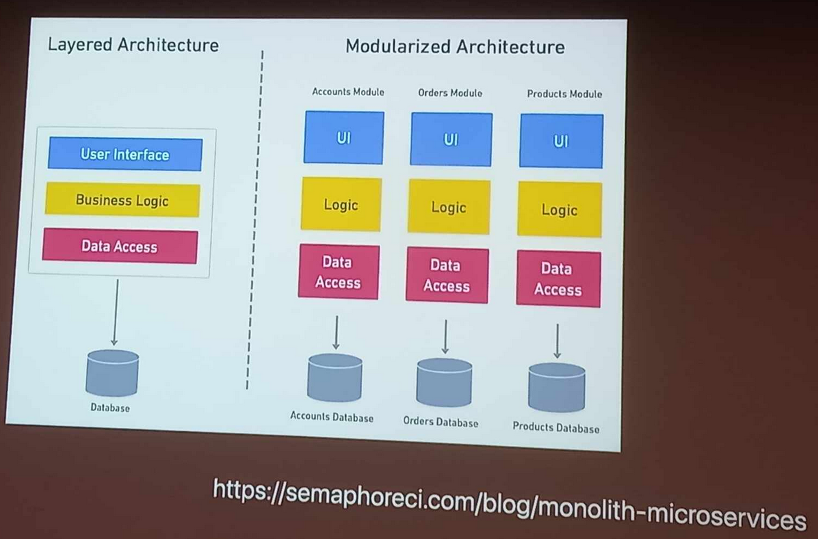

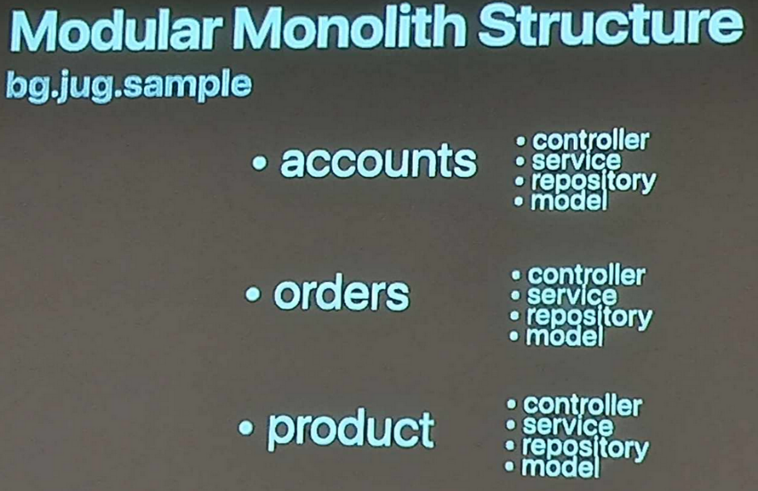

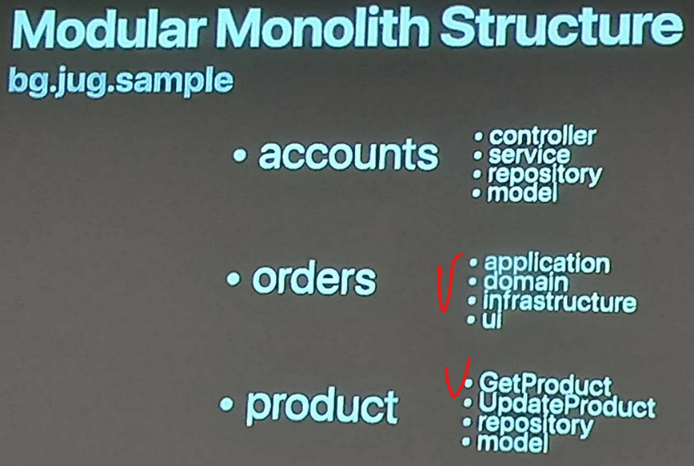

Rober “Uncle Bob” Martin: **Your architecture should tell readers about the system, not about the frameworks you used in your system!**

**Screaming architecture** - to scream what it is